Energy Price Formation Sr. Task Force
PJM Conference and Training Center
January 29, 2018
10:00 a.m. – 4:00 p.m. EPT

Administration (10:00-10:10)
Welcome, announcements, PJM meeting guidelines, roll call, Anti-trust and Code of Conduct announcements
The Senior Task Force will be asked to approve draft minutes from the January 18, 2018 Energy Price Formation Senior Task Force meeting.

Task Force Initiation (10:10-2:00)
Draft Charter (10:10-11:00)
Mr. Anders will review the draft charter for the Energy Price Formation Sr. Task Force (EPFSTF).
Workplan Update (11:00-11:30)
Mr. Anders will lead a discussion of the workplan and meeting schedule for the EPFSTF.
Break (11:30 - 11:40)
Interest Identification (11:40-12:30)
Mr. Anders will lead a discussion around interest identification for the EPFSTF.
Lunch (12:30-1:00)
Identification of Design Criteria (1:00-1:50)
Mr. Anders will lead a discussion around identification of design criteria for key work activity item 2 from the issue charge, more specifically discussing the objective of pricing.
Break (1:50 - 2:00)

Senior Task Force Education (2:00-3:00)
Senior Task Force Education
- Mr. Anders will lead a discussion around education plans for the Senior Task Force.
- Dr. Anthony Giacomoni will lead an education session around Locational Marginal Pricing calculation and uplift.

Fast-Start Resources (3:00-4:00)
FERC Docket EL18-34-000
Ms. Lisa Morelli will provide an update to the FERC Order Instituting Section 206 Proceeding and Commencing Paper Hearing Procedures and Establishing Refund Procedures issued on December 21, 2017 regarding fast-start resources.

Future Agenda Items

Future Meeting Dates
February 15, 2018 | 9:30 a.m. | PJM Conference & Training Center/ WebEx
March 5, 2018 | 10:00 a.m. | PJM Conference & Training Center/ WebEx
March 29, 2018 | 9:30 a.m. | PJM Conference & Training Center/ WebEx
April 9, 2018 | 10:00 a.m. | PJM Conference & Training Center/ WebEx
May 4, 2018 | 9:00 a.m. | The Chase Center on the Riverfront
May 23, 2018 | 9:30 a.m. | PJM Conference & Training Center/ WebEx
June 8, 2018 | 9:00 a.m. | PJM Conference & Training Center/ WebEx
June 25, 2018 | 10:00 a.m. | PJM Conference & Training Center/ WebEx
July 17, 2018 | 9:30 a.m. | PJM Conference & Training Center/ WebEx
August 6, 2018 | 10:00 a.m. | PJM Conference & Training Center/ WebEx
August 22, 2018 | 10:00 a.m. | PJM Conference & Training Center/ WebEx
September 10, 2018 | 10:00 a.m. | PJM Conference & Training Center/ WebEx

Author: Vijay Shah

Antitrust:
You may not discuss any topics that violate, or that might appear to violate, the antitrust laws including but not limited to agreements between or among competitors regarding prices, bid and offer practices, availability of service, product design, terms of sale, division of markets, allocation of customers or any other activity that might unreasonably restrain competition. If any of these items are discussed the chair will re-direct the conversation. If the conversation still persists, parties will be asked to leave the meeting or the meeting will be adjourned.

Code of Conduct:
As a mandatory condition of attendance at today's meeting, attendees agree to adhere to the PJM Code of Conduct as detailed in PJM Manual M-34 section 4.5, including, but not limited to, participants' responsibilities and rules regarding the dissemination of meeting discussion and materials.

Public Meetings/Media Participation:
Unless otherwise noted, PJM stakeholder meetings are open to the public and to members of the media. Members of the media are asked to announce their attendance at all PJM stakeholder meetings at the beginning of the meeting or at the point they join a meeting already in progress. Members of the Media are reminded that speakers at PJM meetings cannot be quoted without explicit permission from the speaker. PJM Members are reminded that "detailed transcriptional meeting notes" and white board notes from "brainstorming sessions" shall not be disseminated. Stakeholders are also not allowed to create audio, video or online recordings of PJM meetings. PJM may create audio, video or online recordings of stakeholder meetings for internal and training purposes, and your participation at such meetings indicates your consent to the same.
Participant Identification in WebEx:
When logging into the WebEx desktop client, please enter your real first and last name as well as a valid email address. Be sure to select the “call me” option.
PJM support staff continuously monitors WebEx connections during stakeholder meetings. Anonymous users or those using false usernames or emails will be dropped from the teleconference.



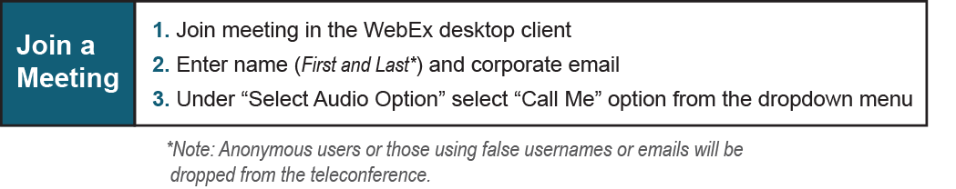

Provide feedback on the progress of this group: Facilitator Feedback Form
Visit learn.pjm.com, an easy-to-understand resource about the power industry and PJM’s role.

