Capacity Capability Senior Task Force
WebEx
May 20, 2020
9:00 a.m. – 4:00 p.m. EPT

Administration (9:00-9:30)
- Jaclynn Lukach, PJM, will provide welcome, announcements, and review of the Antitrust, Code of Conduct, and Public Meetings/Media Participation Guidelines. Stakeholders will be asked to approve draft minutes from the April 27, 2020 meeting.
Roster Update Form
Voting Application
- Thomas DeVita, PJM, will review the capability rules procedural history in the context of PJM’s planned October 30 FERC filing and the FERC condition that PJM address “a methodology or methodologies for all resources”.

Work Plan (09:30-09:50)
- Melissa Pilong, PJM, will review the updated CCSTF Work Plan, with emphasis on revisions to the polling schedule as well as scheduling for the policy analysis of high deployment of limited resources as described in key work activity #6 of the CCSTF issue charge. Note: the revised CCSTF Issue Charge will be brought to the May 28 MRC for first read and vote

CBIR (9:50 – 3:20)
- Melissa Pilong, PJM, will review interest identification and design components per the CBIR process and will solicit additional design components.
  - Andrew Levitt, PJM, will discuss proposed detailed definitions of the design components, as well as any applicable descriptions of the status quo., and provide a brief update on the status of proposed design components in the parking lot (i.e., one regarding Capacity Interconnection Rights and another regarding Capacity Performance performance assessment)
  - Melissa Pilong, PJM, will lead the group in a discussion on the CBIR process for identifying solution options for ‘ELCC for ALL’.
  - Andrew Levitt and Patricio Rocha, PJM, will present potential solution options for ‘ELCC for All’ that PJM has been evaluating and will seek stakeholder feedback.
Break for Lunch (12:00-12:30)
- Melissa Pilong, PJM, will lead the group in a discussion on the CBIR process for identifying solution options for ‘Intermittent Resources’ and ‘Limited Duration Resources’ from stakeholders.
  - Andrew Levitt, PJM, will present potential solution options for ‘Intermittent Resources’ that PJM has been evaluating and will seek stakeholder feedback.

Future Agenda Items (3:20-4:00)
- Ms. Jaclynn Lukach, PJM, will review meeting action items and discuss future agenda items.

Future Meeting Dates
June 4, 2020 | 1pm – 4pm | Teleconference
June 22, 2020 | 9am – 4pm | Teleconference
July 10, 2020 | 9am – 4pm | Teleconference
July 28, 2020 | 9am – 4pm | Teleconference
August 7, 2020 | 9pm – 4pm | Teleconference
August 31, 2020 | 1pm – 4pm | Teleconference
September 11, 2020 | 9am – 4pm | Teleconference
September 24, 2020 | 9am – 4pm | Teleconference
October 14, 2020 | 9am – 4pm | Teleconference

Author: Jaclynn Lukach

Antitrust:
You may not discuss any topics that violate, or that might appear to violate, the antitrust laws including but not limited to agreements between or among competitors regarding prices, bid and offer practices, availability of service, product design, terms of sale, division of markets, allocation of customers or any other activity that might unreasonably restrain competition. If any of these items are discussed the chair will re-direct the conversation. If the conversation still persists, parties will be asked to leave the meeting or the meeting will be adjourned.

Code of Conduct:
As a mandatory condition of attendance at today's meeting, attendees agree to adhere to the PJM Code of Conduct as detailed in PJM Manual M-34 section 4.5, including, but not limited to, participants' responsibilities and rules regarding the dissemination of meeting discussion and materials.

Public Meetings/Media Participation:
Unless otherwise noted, PJM stakeholder meetings are open to the public and to members of the media. Members of the media are asked to announce their attendance at all PJM stakeholder meetings at the beginning of the meeting or at the point they join a meeting already in progress. Members of the Media are reminded that speakers at PJM meetings cannot be quoted without explicit permission from the speaker. PJM Members are reminded that "detailed transcriptional meeting notes" and white board notes from "brainstorming sessions" shall not be disseminated. Stakeholders are also not allowed to create audio, video or online recordings of PJM meetings. PJM may create audio, video or online recordings of stakeholder meetings for internal and training purposes, and your participation at such meetings indicates your consent to the same.
Participant Identification in WebEx:
When logging into the WebEx desktop client, please enter your real first and last name as well as a valid email address. Be sure to select the “call me” option.
PJM support staff continuously monitors WebEx connections during stakeholder meetings. Anonymous users or those using false usernames or emails will be dropped from the teleconference.

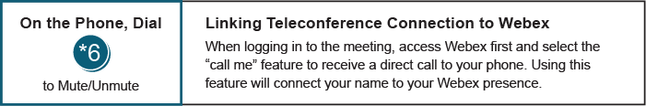

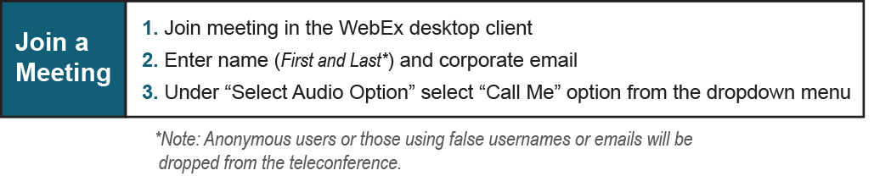
Provide feedback on the progress of this group: Facilitator Feedback Form
Visit learn.pjm.com, an easy-to-understand resource about the power industry and PJM’s role.

