Risk Management Committee

WebEx/In-Person

October 19, 2022

1:00 p.m. – 4:00 p.m. EPT

Administration (1:00-1:20)

Jim Gluck and Christina Stotesbury, PJM, will provide a welcome, announcements, and review the Antitrust, Code of Conduct, Public Meetings/Media Participation, and the WebEx Participant Identification Requirements.

The Committee will be asked to approve the draft minutes from the September 20, 2022 Risk Management Committee meeting.

1. Chrissy Stotesbury, PJM, will review the Risk Management Committee work plan.
2. Chrissy Stotesbury, PJM, will review the Risk Management Committee charter.

Voting Items (1:20-1:40)

Market Participant Default Flexibility (1:20-1:40)

Jim Gluck, PJM, will review the solution package. **The committee will be asked to endorse the solution package.**

[Issue Tracking: Market Participant Default Flexibility](https://pjm.com/committees-and-groups/issue-tracking/issue-tracking-details.aspx?Issue=bd8348bc-f0e2-4c19-8db9-0156f62c6846)

Informational Updates (1:40-2:45)

1. Energy Market Circuit Breaker Solution (1:40-2:25)
   1. Susan Kenney, PJM, will review work conducted at the Energy Price Formation Senior Task Force (EPFSTF) related to Energy Market Circuit Breaker solutions.
   2. The Joint Stakeholders will present their views on both the problem and their solution package.
2. FERC Updates (2:25-2:45)

Eric Scherling and Colleen Hicks, PJM, will provide updates on PJM’s participation in the joint IRC filing to address Credit Related Information Sharing in Organized Wholesale Electric Markets (RM22-13-000) and the FTR Credit Requirement Paper Hearing treatment of confidential information.

Working Items (2:45-3:15)

1. Peak Market Activity Credit Requirement – Matrix (2:45-3:15)
   1. Gwen Kelly, PJM, will present data requested related to collateral calls over the last two years.
   2. Yong Hu, PJM, will discuss updates from PJM’s perspective related to this issue charge.
   3. Jim Gluck, PJM, will lead a discussion around design options and solution packages. All participants are encouraged to provide their input.

[Issue Tracking: Peak Market Activity Credit Requirement](https://www.pjm.com/committees-and-groups/issue-tracking/issue-tracking-details.aspx?Issue=94cf6d7f-df09-4965-aa57-8108f42df9b9)

Additional Items (3:15-3:30)

1. Key Risk Metrics (3:15-3:30)

Gwen Kelly, PJM, will review key risk metrics for the committee’s consideration and feedback.

Informational Section

Energy Price Formation Senior Task Force (EPFSTF)

Meeting materials and upcoming meeting dates are available on the [EPFSTF website](https://pjm.com/committees-and-groups/task-forces/epfstf). Discussions involving risk may occur at the EPFSTF.

Operating Committee Special Session – Outage Coordination

Meeting materials and upcoming meeting dates are available on the [OC website](https://www.pjm.com/committees-and-groups/committees/oc).

Bankruptcy Protections

Information related to bankruptcy protections solution package has been posted with the July R0MC materials. The solution package will be voted at the October Members Committee (MC) meeting.

[Issue Tracking: Bankruptcy Protections](https://pjm.com/committees-and-groups/issue-tracking/issue-tracking-details.aspx?Issue=686f7356-146b-4fa8-8417-7ba0f8e9ba7c)

|  |
| --- |
| **Future Topics** |
|  |

|  |  |  |  |  |  |
| --- | --- | --- | --- | --- | --- |
| **Future Meeting Dates and Materials** | | | | **Materials Due  to Secretary** | **Materials Published** |
| Date | Time | Location |  | |  |
| November 15, 2022 | 1:00 p.m. | PJM Conference & Training Center/Webex | November 3, 2022 | | November 8, 2022 |
| December 20, 2022 | 1:00 p.m. | PJM Conference & Training Center/Webex | December 8, 2022 | | December 13, 2022 |
| January 24, 2023 | 1:00 p.m. | PJM Conference & Training Center/Webex | January 12, 2023 | | January 17, 2023 |
| February 22, 2023 | 1:00 p.m. | PJM Conference & Training Center/Webex | February 13, 2023 | | February 15, 2023 |
| March 21, 2023 | 1:00 p.m. | PJM Conference & Training Center/Webex | March 9, 2023 | | March 14, 2023 |
| April 25, 2023 | 1:00 p.m. | PJM Conference & Training Center/Webex | April 13, 2023 | | April 18, 2023 |
| May 30, 2023 | 1:00 p.m. | PJM Conference & Training Center/Webex | May 19, 2023 | | May 23, 2023 |
| June 21, 2023 | 1:00 p.m. | PJM Conference & Training Center/Webex | June 12, 2023 | | June 14, 2023 |

Author: Christina Stotesbury

Antitrust:

You may not discuss any topics that violate, or that might appear to violate, the antitrust laws including but not limited to agreements between or among competitors regarding prices, bid and offer practices, availability of service, product design, terms of sale, division of markets, allocation of customers or any other activity that might unreasonably restrain competition. If any of these items are discussed the chair will re-direct the conversation. If the conversation still persists, parties will be asked to leave the meeting or the meeting will be adjourned.

Code of Conduct:

As a mandatory condition of attendance at today's meeting, attendees agree to adhere to the PJM Code of Conduct as detailed in PJM Manual M-34 section 4.5, including, but not limited to, participants' responsibilities and rules regarding the dissemination of meeting discussion and materials.

Public Meetings/Media Participation:

Unless otherwise noted, PJM stakeholder meetings are open to the public and to members of the media. Members of the media are asked to announce their attendance at all PJM stakeholder meetings at the beginning of the meeting or at the point they join a meeting already in progress. Members of the Media are reminded that speakers at PJM meetings cannot be quoted without explicit permission from the speaker. PJM Members are reminded that "detailed transcriptional meeting notes" and white board notes from "brainstorming sessions" shall not be disseminated. Stakeholders are also not allowed to create audio, video or online recordings of PJM meetings. PJM may create audio, video or online recordings of stakeholder meetings for internal and training purposes, and your participation at such meetings indicates your consent to the same.

Participant Identification in Webex:

When logging into the Webex desktop client, please enter your real first and last name as well as a valid email address. Be sure to select the “call me” option.

PJM support staff continuously monitors Webex connections during stakeholder meetings. Anonymous users or those using false usernames or emails will be dropped from the teleconference.

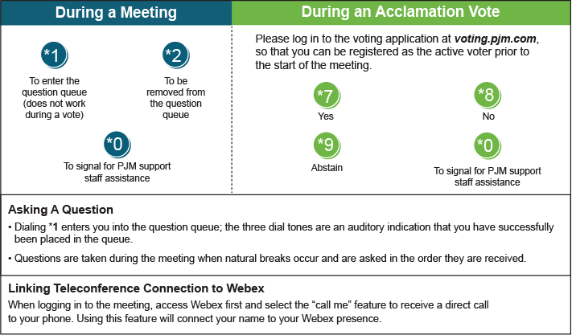

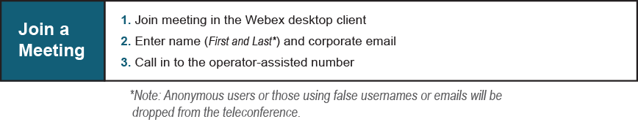

Provide feedback on the progress of this group: [*Facilitator Feedback Form*](https://www.pjm.com/committees-and-groups/committees/form-facilitator-feedback.aspx)   
Visit [*learn.pjm.com*](https://learn.pjm.com/), an easy-to-understand resource about the power industry and PJM’s role.