October Planning Committee

**Teleconference / WebEx**

October 5, 2021

9:00 a.m. – 12:00 p.m. EPT

Administration (9:00 – 9:15)

1. Welcome, announcements and review of the Anti-trust, Code of Conduct, and Media Participation Guidelines.
2. Approve Planning Committee (PC) Agenda for this meeting.
3. Approve draft minutes from the August 31, 2021 PC meeting.
4. Review of the PC Work Plan

Endorsements (9:15 – 9:45)

1. 2021 Reserve Requirement Study Results Patricio Rocha Garrido, PJM, will review the 2021 Reserve Requirement Study results (IRM, FPR). **The committee will be requested to endorse the study results today’s meeting.**

First Reads (9:45 – 10:30)

X. 2021 Reserve Requirement Study Results – Winter Weekly Reserve Target

Patricio Rocha Garrido, will review the Winter Weekly Reserve Target (WWRT). The Committee will be requested to endorse the Winter Weekly Reserve Target at next month’s meeting.

1. Manual 14B: PJM Region Transmission Planning Process Update

Michael Herman, PJM, will provide a first read of Manual 14B regarding the biennial cover to cover review. The committee will be asked to vote on the manual changes at next month’s meeting.

1. Manual 19: Load Forecasting and Analysis Update

John Reynolds, PJM, will provide a first read of Manual 19 regarding the biennial cover to cover review. The committee will be asked to vote on the manual changes at next month’s meeting.

1. Manual 14F: Competitive Planning Process Update

Joseph Hay, PJM, will provide a first read of Manual 14F changes to the proposal fee structure to conform to the PJM Operating Agreement. The committee will be asked to vote on the manual changes at next month’s meeting.

1. ~~Manual 14A: New Services Request Process & Manual 14B: PJM Region Transmission Planning Updates~~

~~Jonathan Kern, PJM, will provide a first read of Manual 14A and 14B to reflect changes to generator deliverability test and related procedures. The committee will be asked to approve the issue charge and endorse the proposed solution (manual changes) as part of the Quick Fix process outlined in Section 8.6.1 of Manual 34 at next month’s meeting.~~

Informational Updates (10:30 – 12:00)

1. Manual 14A: New Services Request Process & Manual 14B: PJM Region Transmission Planning Updates

Jonathan Kern, PJM, will provide an update to Manual 14A and 14B to reflect changes to generator deliverability test and related procedures.

1. Market Efficiency Process Enhancement - Carbon Impact Reporting

Nicolae Dumitriu, PJM, will present an initiative to include carbon impact reporting, for information only purposes, as an enhancement to the current Market Efficiency Process.

1. Capacity Interconnection Rights for ELCC Resoures Update

Brian Chmielewski, PJM, will provide an update on work being done during the PC special session on Capacity Interconnection Rights (CIR) for ELCC Resources.

Materials and upcoming meeting dates for special sessions can be found [here](https://www.pjm.com/committees-and-groups/committees/pc).

1. Interconnection Process Reform

Jack Thomas, PJM, will provide an update on the Interconnection Process Reform Task Force.

Materials and upcoming meeting dates for task force can be found [here](https://www.pjm.com/committees-and-groups/task-forces/iprtf)

1. Reliability Compliance Update  
   Becky Davis, PJM, will provide an update on the activities, issues and items of interest at NERC, SERC, and RF.

Informational Posting

Model Build Activity Update

* MMWG
  + Loadflow
    - PowerTech will post the final cases by October 1, 2021
    - PJM sends out request for 2022SUM study case updates by October 21, 2021
    - Transmission Owners to provide 2022SUM study case updates by October 28, 2021
* RTEP
  + Loadflow
    - PJM sends out request to Transmission Owners for tie line data by October 6, 2021
    - PJM sends out Trial 1 cases to Transmission Owners by October 15, 2021
  + Short circuit
    - Transmission Owners to provide updated 2024 case and files by October 21, 2021

Manual 03 Updates

Updates to PJM Manual 03, Revision 60 – Transmission Operations are posted as informational only with meeting materials

|  |  |  |  |  |
| --- | --- | --- | --- | --- |
| **Future Meeting Dates and Materials** | | | **Materials Due  to Secretary** | **Materials Published** |
| Date | Time | Meeting (Location) |
| Tuesday, October 5, 2021 | 9:00 a.m. – 12:00 p.m. | Planning Committee (WebEx) | Thursday, September 23, 2021 | Tuesday, September 28, 2021 |
| Thursday, October 7, 2021 | 2:00 p.m. – 5:00 p.m. | Interconnection Process Reform Task Force (Webex) | Wednesday, September 29, 2021 | Monday, October 4, 2021 |
| Tuesday, October 19, 2021 | 9:00 a.m. – 12:00 p.m. | Interconnection Process Reform Task Force (Webex) | Monday, October 11, 2021 | Thursday, October 14, 2021 |
| Monday, October 25, 2021 | 1:00 p.m. – 4:00 p.m. | Interconnection Policy Workshop #7 (WebEx) | Friday, October 15, 2021 | Wednesday, October 20, 2021 |
| Tuesday, November 2, 2021 | 9:00 a.m. – 12:00 p.m. | Planning Committee (WebEx) | Thursday, October 21, 2021 | Tuesday, October 26, 2021 |
| Thursday, November 4, 2021 | 3:00 p.m. – 5:00 p.m. | Interconnection Process Reform Task Force (Webex) | Wednesday, October 27, 2021 | Monday, November 1, 2021 |
| Thursday, November 18, 2021 | 11:00 a.m. – 1:00 p.m. | Interconnection Process Reform Task Force (Webex) | Wednesday, November 10, 2021 | Monday, November 15, 2021 |
| Tuesday, November 30, 2021 | 9:00 a.m. – 12:00 p.m. | Planning Committee (WebEx) | Thursday, November 18, 2021 | Tuesday, November 23, 2021 |

Author: Molly Mooney

Antitrust:

You may not discuss any topics that violate, or that might appear to violate, the antitrust laws including but not limited to agreements between or among competitors regarding prices, bid and offer practices, availability of service, product design, terms of sale, division of markets, allocation of customers or any other activity that might unreasonably restrain competition. If any of these items are discussed the chair will re-direct the conversation. If the conversation still persists, parties will be asked to leave the meeting or the meeting will be adjourned.

Code of Conduct:

As a mandatory condition of attendance at today's meeting, attendees agree to adhere to the PJM Code of Conduct as detailed in PJM Manual M-34 section 4.5, including, but not limited to, participants' responsibilities and rules regarding the dissemination of meeting discussion and materials.

Public Meetings/Media Participation:

Unless otherwise noted, PJM stakeholder meetings are open to the public and to members of the media. Members of the media are asked to announce their attendance at all PJM stakeholder meetings at the beginning of the meeting or at the point they join a meeting already in progress. Members of the Media are reminded that speakers at PJM meetings cannot be quoted without explicit permission from the speaker. PJM Members are reminded that "detailed transcriptional meeting notes" and white board notes from "brainstorming sessions" shall not be disseminated. Stakeholders are also not allowed to create audio, video or online recordings of PJM meetings. PJM may create audio, video or online recordings of stakeholder meetings for internal and training purposes, and your participation at such meetings indicates your consent to the same.

Participant Identification in WebEx:

When logging into the WebEx desktop client, please enter your real first and last name as well as a valid email address. Be sure to select the “call me” option.

PJM support staff continuously monitors WebEx connections during stakeholder meetings. Anonymous users or those using false usernames or emails will be dropped from the teleconference.

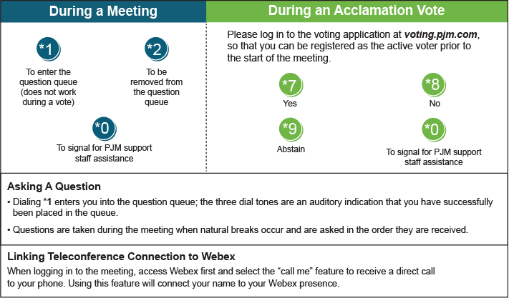

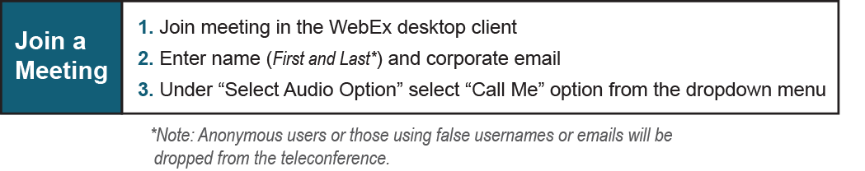

Provide feedback on the progress of this group: *Facilitator Feedback Form*   
Visit [*learn.pjm.com*](http://learn.pjm.com/), an easy-to-understand resource about the power industry and PJM’s role.