March Planning Committee
Teleconference / WebEx
March 9, 2021
9:00 a.m. – 12:00 p.m. EPT

Administration (9:00 – 9:15)
- Welcome, announcements and review of the Anti-trust, Code of Conduct, and Media Participation Guidelines.
- Approve Planning Committee (PC) Agenda for this meeting.
- Approve draft minutes from the February 9, 2021 PC meeting.

Endorsements ( )

First Reads (9:15 – 11:15)
- CIR Problem Statement/Issue Charge
Jonathan Kern, PJM, will provide a second first read to review a problem statement and issue charge to address the Capacity Interconnection Rights of variable resources. The committee will be asked to vote on the issue charge at next month’s meeting.

- Manual 14F and Manual 14B Updates
Nick Dumitriu, PJM, will provide a first read of Manual 14F and Manual 14B conforming language for MEPETF capacity driver docket (ER21-162). The committee will be asked to vote on the manual changes at next month’s meeting.

- Interconnection Process Reform
Jason Connell, PJM, will provide a first read of a Problem Statement, Issue Charge to address Interconnection Process Reform. The committee will be asked to approve the issue charge at the April PC meeting.

- New Service Requests Deficiency Review Requirements
Jason Connell, PJM, will provide a first read of a Problem Statement, Issue Charge and proposed solution to address new service requestes deficiency review requirements. Draft versions of associated Tariff language are posted with meeting materials for informational purposes. The committee will be asked to approve the issue charge and endorse the proposed solution as part of the Quick Fix process outlined in Section 8.6.1 of Manual 34 at the April PC meeting.

- Interconnection Construction Service Agreement Superseding Language and Automatic Termination Provision
Mark Sims, PJM, will provide a first read of a Problem Statement, Issue Charge and proposed solution to address concerns associated with the pro forma Interconnection Construction Service Agreement’s (a) lack of superseding language and (b) current automatic termination provision. Draft versions of associated Tariff language are posted with meeting materials for informational purposes. The committee will be asked to approve the issue charge and endorse the proposed solution as part of the Quick Fix process outlined in Section 8.6.1 of Manual 34 at the April PC meeting.

Informational Updates (11:15 – 12:00)
- Attachment M3 Process Update
Aaron Berner, PJM, will provide an Attachment M-3 update and facilitate a discussion with stakeholders.
- Reliability Compliance Update
Becky Davis, PJM, will provide an update on the activities, issues and items of interest at NERC, SERC, and RF.
- TPL-001-5 Implementation
Aaron Berner, PJM, will provide an update and discuss proposed review of implementation methodologies for TPL-001-5 at the Reliability Standards & Compliance Subcommittee on February 18, 2021. A link to the standard is here: TPL-001-5

Informational Posting
Model Build Activity Update
2021 Series RTEP
- Powerflow
  - PJM staff will internally review the cases through March 2021
- Short Circuit
  - Transmission Owners are to provide their feedback to the Trial 2 RTEP case by February 26,2021
  - PJM is currently building Trial 3 2023 case and Trial 1 2026 case to be delivered on March 12th,2021

Friday, March 5, 2021 | 9:00 a.m. – 4:00 p.m. | Interconnection Process Workshop #4 | WebEx
Tuesday , March 9, 2021 | 9:00 a.m. – 12:00 p.m. | Planning Committee | WebEx
Tuesday, April 6, 2021 | 9:00 a.m. – 12:00 p.m. | Planning Committee | WebEx
Tuesday, May 11, 2021 | 9:00 a.m. – 12:00 p.m. | Planning Committee | WebEx
Tuesday, June 8, 2021 | 9:00 a.m. – 12:00 p.m. | Planning Committee | WebEx
Tuesday, July 13, 2021 | 9:00 a.m. – 12:00 p.m. | Planning Committee | TBD
Tuesday, August 10, 2021 | 9:00 a.m. – 12:00 p.m. | Planning Committee | TBD
Tuesday, August 31, 2021 | 9:00 a.m. – 12:00 p.m. | Planning Committee | TBD
Wednesday, September 8, 2021 | 9:00 a.m. – 12:00 p.m. | Planning Committee | TBD
Tuesday, October 5, 2021 | 9:00 a.m. – 12:00 p.m. | Planning Committee | TBD
Tuesday, November 2, 2021 | 9:00 a.m. – 12:00 p.m. | Planning Committee | TBD
Tuesday, November 30, 2021 | 9:00 a.m. – 12:00 p.m. | Planning Committee | TBD
Author: Molly Mooney

Antitrust:
You may not discuss any topics that violate, or that might appear to violate, the antitrust laws including but not limited to agreements between or among competitors regarding prices, bid and offer practices, availability of service, product design, terms of sale, division of markets, allocation of customers or any other activity that might unreasonably restrain competition. If any of these items are discussed the chair will re-direct the conversation. If the conversation still persists, parties will be asked to leave the meeting or the meeting will be adjourned.

Code of Conduct:
As a mandatory condition of attendance at today's meeting, attendees agree to adhere to the PJM Code of Conduct as detailed in PJM Manual M-34 section 4.5, including, but not limited to, participants' responsibilities and rules regarding the dissemination of meeting discussion and materials.

Public Meetings/Media Participation:
Unless otherwise noted, PJM stakeholder meetings are open to the public and to members of the media. Members of the media are asked to announce their attendance at all PJM stakeholder meetings at the beginning of the meeting or at the point they join a meeting already in progress. Members of the Media are reminded that speakers at PJM meetings cannot be quoted without explicit permission from the speaker. PJM Members are reminded that "detailed transcriptional meeting notes" and white board notes from "brainstorming sessions" shall not be disseminated. Stakeholders are also not allowed to create audio, video or online recordings of PJM meetings. PJM may create audio, video or online recordings of stakeholder meetings for internal and training purposes, and your participation at such meetings indicates your consent to the same.
Participant Identification in WebEx:
When logging into the WebEx desktop client, please enter your real first and last name as well as a valid email address. Be sure to select the “call me” option.
PJM support staff continuously monitors WebEx connections during stakeholder meetings. Anonymous users or those using false usernames or emails will be dropped from the teleconference.

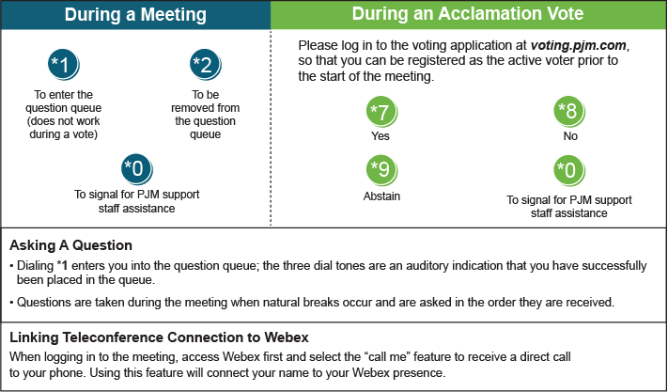

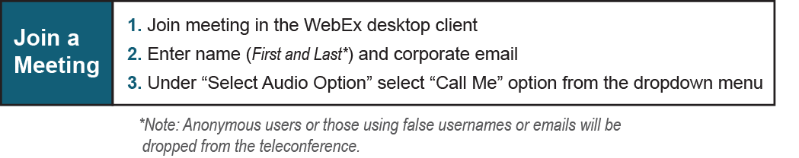

Provide feedback on the progress of this group: Facilitator Feedback Form
Visit learn.pjm.com, an easy-to-understand resource about the power industry and PJM’s role.

