Operating Committee
PJM Conference & Training Center, Audubon, PA
November 3, 2022
9:00 a.m. – 2:00 p.m. EDT

*Operator assisted phone lines will be opened 30 minutes prior to the start of the meeting. Due to the high volume of remote participation, stakeholders are asked to connect early to allow additional time for operator queue processing.

Administration (9:00-9:15)
Lauren Strella Wahba, PJM, will provide announcements; review the Antitrust, Code of Conduct, Public Meetings/Media Participation, and the WebEx Participant Identification Requirement.
  - Review and approve draft minutes from the October 7 OC meeting.
  - Review of the OC work plan.

Review of Operations (9:15 - 9:30)
Review of Operating Metrics (9:15 – 9:25)
Stephanie Schwarz, PJM, will review the October 2022 PJM operating metrics slides. Metrics will include PJM’s load forecast error, BAAL performance, and transmission / generation outage statistics.

- Security Update (9:25 – 9:30)
Steve McElwee, PJM, will provide a security briefing.

Endorsements/Approvals (9:30 – 11:00)
- Winter Weekly Reserve Target Update (9:30 – 9:40)
Patricio Rocha Garrido, PJM, will review the results of the 2022/23 Winter Weekly Reserve Target (WWRT) analysis.
The Operating Committee will be asked to endorse the results at today’s meeting.

- Manual 03: Transmission Operations (9:40 – 9:55)
Dean Manno, PJM, will review Manual 03 changes as a part of the periodic review.
The Operating Committee will be asked to endorse these changes at today’s meeting.

- Manual 10: Pre-Scheduling Operations (9:55 – 10:10)
Darrell Frogg, PJM, will review Manual 10 changes as a part of the periodic review.
The Operating Committee will be asked to endorse these changes at today’s meeting.

- Manual 14D: Generator Operational Requirements (10:10 – 10:25)
Darrell Frogg, PJM, will review Manual 14D changes as a part of the periodic review.
The Operating Committee will be asked to endorse these changes at today’s meeting.

- Manual 13: Emergency Operations (10:25 – 10:40)
Chris Pilong, PJM, will review conforming changes to Manual 13 associated with the Max Emergency Changes for Resource Limitation Reporting issue endorsed by the OC on September 8, 2022.
The Operating Committee will be asked to endorse these changes at today’s meeting.
Issue Tracking: Max Emergency Changes for Resource Limitation Reporting

- Synchronized Reserve Event Actions and Expectations Issue Charge (10:40 – 11:00)
Mike Zhang, PJM, will provide a brief review of the update on the recent FERC rejection of the filed
IRD proposal presented at the October OC, and a first read of the modified Issue Charge for the
Synchronized Reserve Event Actions and Expectations issue.
The Operating Committee will be asked to approve the Issue Charge upon first read at today’s
meeting.

First Reading (11:00 – 11:45)
- Manual 02: Transmission Service Request (11:00 – 11:10)
Jeff McLaughlin, PJM, will review proposed revisions to Manual 02. These are clarifying changes related to the Internal Network Integration Transmission Service (NITS) Process issue, as well as administrative cleanup.
The Operating Committee will be asked to endorse these changes at its next meeting.

- PJM’s Regional Transmission and Energy Scheduling Practices document (11:10 – 11:20)
Jeff McLaughlin, PJM, will review proposed revisions to the Regional Transmission and Energy Scheduling Practices document. These changes are in support of the NAESB version 3.3 Business Practice Standards, as well as administrative cleanup.
The Operating Committee will be asked to endorse these changes at its next meeting.

- IROL-CIP Cost Recovery Issue Charge (11:20 – 11:40)
Joe Bowring, Monitoring Analytics, will review proposed amendments to the IROL-CIP Issue Charge.
The Operating Committee will be asked to approve the Issue Charge at its next meeting.
Issue Tracking: IROL-CIP Cost Recovery

- System Operation Subcommittee Charter (11:40 – 11:45)
Lagy Mathew, PJM, will review proposed revisions to the SOS Charter as a part of the periodic review.
The Operating Committee will be asked to approve these changes at its next meeting.

Additional Items (11:45 – 12:30)
- Fuel and Energy Security Update (11:45 – 11:55)
Natalie Furtaw, PJM, will provide an update on the Fuel and Energy Security initiative.

- OATF Review (11:55 – 12:05)
Todd Bickel, PJM, will review the results of the winter 2022 Operations Assessment Task Force
study.
- Fuel Supply Overview (12:05 – 12:20)
Brian Fitzpatrick, PJM, will provide an overview of current fuel supply issues.

- Load Management Performance Summary (12:20 – 12: 30)
Jack O’Neill, PJM, will review the Load Management and PRD Performance Report for 2021/2022.

Working Items

Informational Only Postings
- Reliability Compliance Update
Informational posting on NERC, SERC, RF, and NAESB standards, and other pertinent regulatory and compliance information, and solicit feedback from the members on Reliability Compliance efforts.

- System Operations Subcommittee (SOS)
Informational posting of the summary of the most recent SOS meeting.

- Manual 03 Attachment E
The Manual 03 Attachment E: Automatic Sectionalizing Schemes Pending Approval and Recent Changes document has been posted on OASIS as of Friday, October 14.

OC Subcommittee/ Task Force Informational Section
System Operations Subcommittee (SOS): SOS Website
Data Management Subcommittee (DMS): DMS Website
DER & Inverter-Based Resources Subcommittee (DIRS): DIRS Website
Fuel Requirements for Black Start Resources: Fuel Reqt. for Black Start Resources Issue Tracker
Synchronous Reserve Deployment Task Force: SRDTF Website
Dynamic Line Rating Task Force: DLRTF Website
IROL – CIP Cost Recovery: IROL – CIP Cost Recovery Issue Tracker

Future Meeting Dates and Materials |  |  | Materials Due  to Secretary | Materials Published
Date | Time | Location | 5 p.m. | 4 p.m.
December 8, 2022 | 9 a.m. | PJM Conference & Training Center and WebEx | November 28, 2022 | December 1, 2022

Author: Lauren Strella Wahba

Antitrust:
You may not discuss any topics that violate, or that might appear to violate, the antitrust laws including but not limited to agreements between or among competitors regarding prices, bid and offer practices, availability of service, product design, terms of sale, division of markets, allocation of customers or any other activity that might unreasonably restrain competition. If any of these items are discussed the chair will re-direct the conversation. If the conversation still persists, parties will be asked to leave the meeting or the meeting will be adjourned.

Code of Conduct:
As a mandatory condition of attendance at today's meeting, attendees agree to adhere to the PJM Code of Conduct as detailed in PJM Manual M-34 section 4.5, including, but not limited to, participants' responsibilities and rules regarding the dissemination of meeting discussion and materials.
Public Meetings/Media Participation:
Unless otherwise noted, PJM stakeholder meetings are open to the public and to members of the media. Members of the media are asked to announce their attendance at all PJM stakeholder meetings at the beginning of the meeting or at the point they join a meeting already in progress. Members of the Media are reminded that speakers at PJM meetings cannot be quoted without explicit permission from the speaker. PJM Members are reminded that "detailed transcriptional meeting notes" and white board notes from "brainstorming sessions" shall not be disseminated. Stakeholders are also not allowed to create audio, video or online recordings of PJM meetings. PJM may create audio, video or online recordings of stakeholder meetings for internal and training purposes, and your participation at such meetings indicates your consent to the same.
Participant Identification in WebEx:
When logging into the WebEx desktop client, please enter your real first and last name as well as a valid email address. Be sure to select the “call me” option.
PJM support staff continuously monitors WebEx connections during stakeholder meetings. Anonymous users or those using false usernames or emails will be dropped from the teleconference.

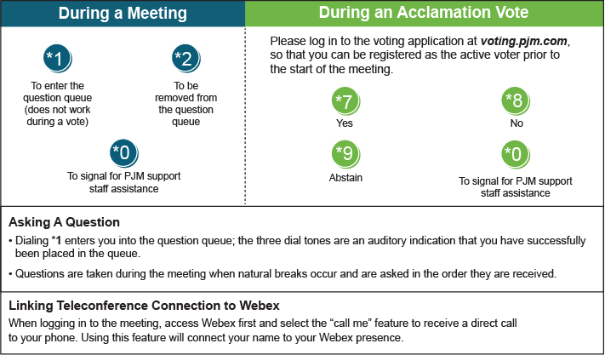

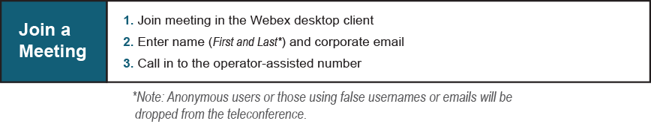

Provide feedback on the progress of this group: Facilitator Feedback Form
Visit learn.pjm.com, an easy-to-understand resource about the power industry and PJM’s role.

