Operating Committee
Webex Only
January 13, 2020
9:00 a.m. – 11:30 a.m. EPT

Administration (9:00-9:15)
Danielle Croop, PJM, will provide announcements; review the Antitrust, Code of Conduct, Public Meetings/Media Participation, and the WebEx Participant Identification Requirement.
  - Review and approve draft minutes December 3rd OC meeting.
  - Review of the OC work plan.

Review of Operations (9:15-9:30)
PJM COVID-19 Update
Paul McGlynn, PJM, will provide an update on PJM’s operations plan in response to COVID-19. https://pjm.com/committees-and-groups/pandemic-coordination.aspx

Review of Operating Metrics
Stephanie Monzon, PJM, will review the December 2020 PJM operating metrics slides. Metrics will include PJM’s load forecast error, BAAL performance, and transmission / generation outage statistics.

Endorsements (9:30-10:00)
- Manual 12: Balancing Operations
Kevin Hatch, PJM, will review Manual 12 changes. The Operating Committee will be asked to endorse the changes to Manual 12 at today’s meeting.
- Manual 13: Emergency Operations
Kevin Hatch, PJM, will review Manual 13 changes. The Operating Committee will be asked to endorse the changes to Manual 13 at today’s meeting.

- Manual 38: Operations Planning
Liem Hoang, PJM, will review Manual 38 changes. The Operating Committee will be asked to endorse the changes to Manual 38 at today’s meeting.

- System Operations Subcommittee (SOS) Charter Review
Paul Dajewski, PJM, will review the proposed charter update for the System Operations Subcommittee (SOS). The Operating Committee will be asked to approve the SOS Charter at today’s meeting.

- System Restoration Coordinators Subcommittee (SRCS) Sunset Proposal
Brian Lynn, PJM, will review a proposal to sunset the System Restoration Coordinators Subcommittee (SRCS). The Operating Committee will be asked to approve the SRCS Sunset proposal at today’s meeting.

First Reading (10:00-10:15)
- Manual 40: Training and Certification Requirements
Michael Hoke, PJM, will review Manual 40 changes. The Operating Committee will be asked to endorse these changes at its next meeting.
- TO/TOP Matrix Review
Mark Kuras, PJM, will review Version 15 of the TO/TOP Matrix. The Operating Committee will be asked to recommend the TOA-AC approve the TO/TOP Matrix at its next meeting.

Informational Update (10:15-11:00)
- System Operations Subcommittee (SOS) Report
Rebecca Carroll, PJM, will provide a summary of the most recent SOS meeting.

- PPL Dynamic Line Ratings
David Quier, PPL, will present PPL’s Dynamic Line Ratings (DLR) implementation plan.

- Unit Specific Parameter 2021/2022 DY Update
Tom Hauske, PJM, will provide an update on Unit Specific Parameters for the 2021/2022 DY.

- Reliability Compliance Update
Becky Davis, PJM, will provide an update on NERC, SERC and RFC standards, and other pertinent regulatory and compliance information, and solicit feedback from the members on Reliability Compliance efforts.

OC Subcommittee/ Task Force Informational Section
System Operations Subcommittee (SOS): SOS Website

Data Management Subcommittee (DMS): DMS Website

DER & Inverter-Based Resources Subcommittee (DIRS): DIRS Website

System Restoration Coordinators Subcommittee (SRCS): SRCS Website

Fuel Requirements for Black Start Resources: Fuel Reqt. for Black Start Resources Issue Tracker

Future Meeting Dates
February 11, 2021 | 9:00 a.m. | WebEx
March 11, 2021 | 9:00 a.m. | WebEx
April 08, 2021 | 9:00 a.m. | WebEx
May 14, 2021 | 9:00 a.m. | WebEx
June 10, 2021 | 9:00 a.m. | WebEx
July 15, 2021 | 9:00 a.m. | TBD/ WebEx
August 12, 2021 | 9:00 a.m. | TBD/ WebEx
September 10, 2021 | 9:00 a.m. | TBD / WebEx
October 07, 2021 | 9:00 a.m. | TBD / WebEx
November 04, 2021 | 9:00 a.m. | TBD / WebEx
December 02, 2021 | 9:00 a.m. | TBD / WebEx

Author: D. Croop

Antitrust:
You may not discuss any topics that violate, or that might appear to violate, the antitrust laws including but not limited to agreements between or among competitors regarding prices, bid and offer practices, availability of service, product design, terms of sale, division of markets, allocation of customers or any other activity that might unreasonably restrain competition. If any of these items are discussed the chair will re-direct the conversation. If the conversation still persists, parties will be asked to leave the meeting or the meeting will be adjourned.

Code of Conduct:
As a mandatory condition of attendance at today's meeting, attendees agree to adhere to the PJM Code of Conduct as detailed in PJM Manual M-34 section 4.5, including, but not limited to, participants' responsibilities and rules regarding the dissemination of meeting discussion and materials.

Public Meetings/Media Participation:
Unless otherwise noted, PJM stakeholder meetings are open to the public and to members of the media. Members of the media are asked to announce their attendance at all PJM stakeholder meetings at the beginning of the meeting or at the point they join a meeting already in progress. Members of the Media are reminded that speakers at PJM meetings cannot be quoted without explicit permission from the speaker. PJM Members are reminded that "detailed transcriptional meeting notes" and white board notes from "brainstorming sessions" shall not be disseminated. Stakeholders are also not allowed to create audio, video or online recordings of PJM meetings. PJM may create audio, video or online recordings of stakeholder meetings for internal and training purposes, and your participation at such meetings indicates your consent to the same.
Participant Identification in WebEx:
When logging into the WebEx desktop client, please enter your real first and last name as well as a valid email address. Be sure to select the “call me” option.
PJM support staff continuously monitors WebEx connections during stakeholder meetings. Anonymous users or those using false usernames or emails will be dropped from the teleconference.

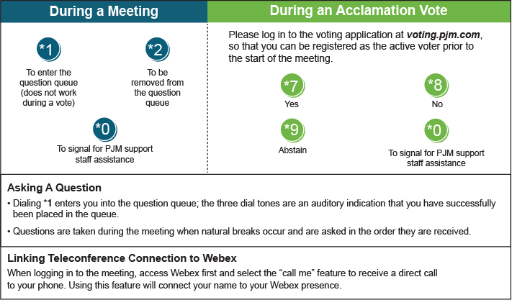
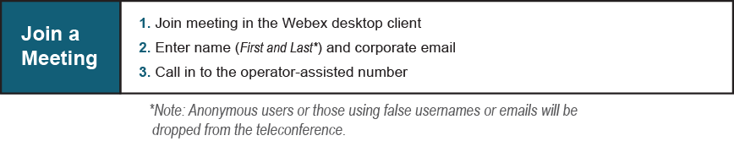
Provide feedback on the progress of this group: Facilitator Feedback Form
Visit learn.pjm.com, an easy-to-understand resource about the power industry and PJM’s role.

