Operating Committee
Webex Only
October 8, 2020
9:00 a.m. – 2:00 p.m. EPT

Administration (9:00-9:15)
Danielle Croop, PJM, will provide announcements; review the Antitrust, Code of Conduct, Public Meetings/Media Participation, and the WebEx Participant Identification Requirement.
  - Review and approve draft minutes of the September 3rd, 2020 OC meeting.
  - Review of the OC work plan.

Review of Operations (9:15-9:30)
PJM COVID-19 Update
Paul McGlynn, PJM, will provide an update on PJM’s operations plan in response to COVID-19. https://pjm.com/committees-and-groups/pandemic-coordination.aspx

Review of Operating Metrics
Stephanie Monzon, PJM, will review the September 2020 PJM operating metrics slides. Metrics will include PJM’s load forecast error, BAAL performance, and transmission / generation outage statistics.

Endorsements (9:30-10:15)
- Black Start Unit Testing, CRF, Involuntary Termination, and Substitution Rules
Becky Davis, PJM, will provide review the solution packages (PJM solution package and IMM solution package). The Operating Committee will be asked to endorse a proposed solution package at today’s meeting.

Manual 14D Changes
Darrell Frogg, PJM, will review updates to Manual 14D: Generator Operational Requirements. The Operating Committee will be asked to endorse these changes at today’s meeting.

Manual 10 Changes
Vince Stefanowicz, PJM, will review updates to Manual 10: Pre-Scheduling Operations. The Operating Committee will be asked to endorse these changes at today’s meeting.

First Reading (10:15-10:45)
- Manual 3A: EMS Model Updates & Quality Assurance Changes
Maria Baptiste, PJM, will review updates to Manual 3A: EMS Model Updates & QA. The Operating Committee will be asked to endorse these changes at the next OC meeting.

- Manual 3: Transmission Operations Changes
Lagy Mathew, PJM, will review updates to Manual 3: Transmission Operations. The Operating Committee will be asked to endorse these changes at the next OC meeting.

- Manual 12: Balancing Operations Change
Kevin Hatch, PJM, will review updates to Manual 12: Balancing Operations to address change from the 5 minute pricing and dispatch MIC special sessions. The Operating Committee will be asked to endorse these changes at the next OC meeting.

- Day Ahead Schedule Reserve (DASR) Update
David Kimmel, PJM, will review preliminary proposed changes to the 2021 Day Ahead Scheduling Reserve (DASR) requirement. The Operating Committee will be asked to endorse these changes at the next OC meeting.

- Winter Weekly Reserve Target Update
Patricio Rocha Garrido, PJM, will review the results of the 2020/21 Winter Weekly Reserve Target (WWRT) analysis. The Operating Committee will be asked to endorse these results at the next OC meeting.

Informational Update (10:45-14:00)
- System Operations Subcommittee (SOS) Report
Rebecca Carroll, PJM, will provide a summary of the most recent SOS meeting.

- Intelligent Reserve Deployment (IRD) Rollout Education
This item has been deferred to the November 2020 Operating Committee Meeting.

- PJM Response to Show Cause Order
Steve Pincus, PJM, will provide an overview of FERC Show Cause Order in EL20-30 & EL20-56 pertaining to PJM’s station power tariff provisions and review PJM’s plan for compliance filing.

- Pre-Winter Generation Preparedness
Ray Lee, PJM, will provide a review of PJM’s generation-related winter preparation efforts.

- Extended Winter 2020-21 Transmission Outage Review
Marilyn Jayachandran, PJM, will review the 500/230 kV Transformer outage at Susquehanna through the winter peak 2020/21.

- Unit Specific Parameter 2021/2022 DY Update
Lauren Strella Wahba, PJM, will provide an update on Unit Specific Parameters for the 2021/2022 DY.

- Fuel Requirements for Black Start Resources Update
David Schweizer, PJM, will provide an update on the Fuel Requirements for Black Start Resource activities.

Informational Only
- PJM Manual 03: Transmission Operations, Attachment E: Automatic Sectionalizing Schemes Automatic Sectionalizing Schemes Pending Approval and Recent Changes have been posted with today’s meeting materials.

OC Subcommittee/ Task Force Informational Section
System Operations Subcommittee (SOS): SOS Website

Data Management Subcommittee (DMS): DMS Website

DER & Inverter-Based Resources Subcommittee (DIRS): DIRS Website

System Restoration Coordinators Subcommittee (SRCS): SRCS Website

Fuel Requirements for Black Start Resources: Fuel Reqt. for Black Start Resources Issue Tracker

Future Meeting Dates
November 6, 2020 | 9:00 a.m. | PJM Conference & Training Center/ WebEx
December 3, 2020 | 9:00 a.m. | PJM Conference & Training Center/ WebEx

Author: D. Croop

Antitrust:
You may not discuss any topics that violate, or that might appear to violate, the antitrust laws including but not limited to agreements between or among competitors regarding prices, bid and offer practices, availability of service, product design, terms of sale, division of markets, allocation of customers or any other activity that might unreasonably restrain competition. If any of these items are discussed the chair will re-direct the conversation. If the conversation still persists, parties will be asked to leave the meeting or the meeting will be adjourned.

Code of Conduct:
As a mandatory condition of attendance at today's meeting, attendees agree to adhere to the PJM Code of Conduct as detailed in PJM Manual M-34 section 4.5, including, but not limited to, participants' responsibilities and rules regarding the dissemination of meeting discussion and materials.

Public Meetings/Media Participation:
Unless otherwise noted, PJM stakeholder meetings are open to the public and to members of the media. Members of the media are asked to announce their attendance at all PJM stakeholder meetings at the beginning of the meeting or at the point they join a meeting already in progress. Members of the Media are reminded that speakers at PJM meetings cannot be quoted without explicit permission from the speaker. PJM Members are reminded that "detailed transcriptional meeting notes" and white board notes from "brainstorming sessions" shall not be disseminated. Stakeholders are also not allowed to create audio, video or online recordings of PJM meetings. PJM may create audio, video or online recordings of stakeholder meetings for internal and training purposes, and your participation at such meetings indicates your consent to the same.
Participant Identification in WebEx:
When logging into the WebEx desktop client, please enter your real first and last name as well as a valid email address. Be sure to select the “call me” option.
PJM support staff continuously monitors WebEx connections during stakeholder meetings. Anonymous users or those using false usernames or emails will be dropped from the teleconference.

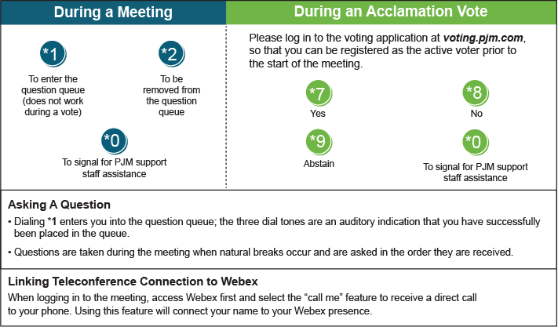

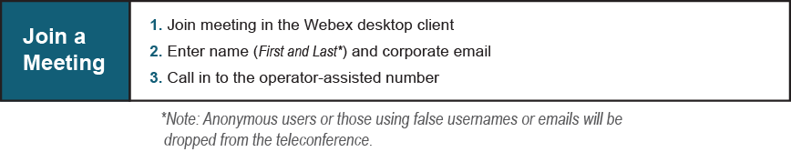
Provide feedback on the progress of this group: Facilitator Feedback Form
Visit learn.pjm.com, an easy-to-understand resource about the power industry and PJM’s role.

