Markets & Reliability Committee
Webex Only
October 20, 2021
9:00 a.m. – 1:15 12:55 p.m. EPT
*Operator assisted phone lines will be opened 30 minutes prior to the start of the meeting. Due to the high volume of remote participation, stakeholders are asked to connect early to allow additional time for operator queue processing.

Administration (9:00-9:05)
Welcome, announcements and Anti-trust, Code of Conduct, and Public Meetings/Media Participation – Stu Bresler and Dave Anders

Consent Agenda (9:05-9:10)
- Approve minutes of the September 29, 2021 meeting of the Markets and Reliability Committee (MRC).
- Endorse the 2021 Reserve Requirement Study results (IRM, FPR).
- Endorse proposed updates addressing behind the meter generation business rules on status changes and corresponding Manual and Tariff revisions.
Issue Tracking: Behind the Meter Generation Business Rules on Status Changes
- Endorse/Approve proposed revisions in Manual 15: Cost Development Guidelines, the Operating Agreement, and the Tariff to address incremental and no load energy offers.
- Endorse proposed solution and Manual revisions to address the calculation of the EE Addback.
Issue Tracking: Energy Efficiency Addback

Endorsements (9:10-11:15 10:55)
- Resource Adequacy Senior Task Force Charter (9:10-9:35)
Dave Anders will review a proposed Charter addressing resource adequacy topics discussed in the Capacity Workshops. The committee will be asked to approve the proposed Charter.
- Solar-Battery Hybrid Resources (9:35-9:55)
Andrew Levitt will review a proposed solution package to address various aspects of market participation by solar-battery hybrid resources. The committee will be asked to endorse the proposed solution and corresponding Tariff revisions.
Issue Tracking: Solar-Battery Hybrid Resources
- Undefined Regulation Mileage Ratio Calculation (9:55-10:20 9:35-10:00)
- Michael Olaleye will review the PJM proposal addressing the undefined regulation mileage ratio calculation.
- Adrien Ford, ODEC, will offer the IMM Proposal for alternative consideration.
The committee will be asked to endorse a proposed solution and corresponding Manual, Tariff, and Operating Agreement (OA) revisions. Same day endorsement may be sought at the Members Committee for the Tariff and OA revisions.
Issue Tracking: Undefined Regulation Mileage Ratio Calculation
- ARR/FTR Market Task Force Update (10:20-10:55 10:00-10:35)
- Brian Chmielewski will provide an overview of the PJM/Joint Stakeholder proposal.
- Erik Heinle, DC OPC, will offer the DC OPC Proposal for alternative consideration.
- Greg Poulos, on behalf of New Jersey Division of the Rate Counsel, will offer the IMM Proposal for alternative consideration.
The committee will be asked to endorse a proposed solution and corresponding Manual and Tariff revisions.
Issue Tracking: ARR/FTR Market Review
- Max Emergency Revisions (10:55-11:15 10:35-10:55)
Chris Pilong will review proposed revisions to Manual 13: Emergency Operations addressing Max Emergency. The committee will be asked to endorse the proposed revisions upon first read.

First Readings (11:15-1:15 10:55-12:55)
- Day Ahead Schedule Reserve (DASR) Update (11:15-11:30 10:55-11:10)
David Kimmel will review proposed changes to the 2022 Day Ahead Scheduling Reserve (DASR) requirement. The committee will be asked to endorse the 2022 DASR requirement at its next meeting.
- Sunset of the Carbon Pricing Senior Task Force (11:30-11:50 11:10-11:30)
Eric Hsia will review a recommendation to sunset the Carbon Pricing Senior Task Force (CPSTF). The committee will be asked to endorse sunsetting the CPSTF at its next meeting.
- Sunset of the High Voltage Direct Current Senior Task Force (11:50-12:10 11:30-11:50)
Carl Johnson, PJM Public Power Coalition on behalf of American Municipal Power, will move to sunset the High Voltage Direct Current Senior Task Force (HVDCSTF). The committee will be asked to endorse the motion to sunset the HVDCSTF at its next meeting.
- Transparency Forum (12:10-12:30 11:50-12:10)
Greg Poulos, on behalf of the New Jersey Division of the Rate Counsel, will review a proposed Charter for the creation of a new Transparency Forum. The committee will be asked to approve the proposed Charter at its next meeting.

- PJM Manuals (12:30-1:15 12:10-12:55)
- Chris Moran will review proposed revisions to Manual 01 Attachment F: Control Center and Data Exchange Requirements (MOC Remote Operations) related to Exceptional Circumstances outside of COVID-19. The committee will be asked to endorse the proposed revisions at its next meeting.
- Lagy Mathew will review proposed revisions to Manual 3: Transmission Operations resulting from its periodic review. The committee will be asked to endorse the proposed revisions at its next meeting.
- Brian Oakes will review proposed revisions to Manual 13: Emergency Operations resulting from its periodic review. The committee will be asked to endorse the proposed revisions at its next meeting.
- Joseph Hay will review proposed revisions to Manual 14F: Competitive Planning Process addressing changes to the proposal fee structure to conform to the PJM Operating Agreement. The committee will be asked to endorse the proposed revisions at its next meeting.
- Johns Reynolds will review proposed revisions to Manual 19: Load Forecasting and Analysis resulting from its biennial review. The committee will be asked to endorse the proposed revisions at its next meeting.

Future Agenda Items (1:15 12:55)

Future Meeting Dates and Materials |  |  |  | Materials Due  to Secretary | Materials Published
Date | Time | Location
November 17, 2021 | 9:00 a.m. |  | WebEx | November 5, 2021 | November 10, 2021
December 15, 2021 | 9:00 a.m. |  | WebEx | December 3, 2021 | December 8, 2021

Author: M. Greening

Antitrust:
You may not discuss any topics that violate, or that might appear to violate, the antitrust laws including but not limited to agreements between or among competitors regarding prices, bid and offer practices, availability of service, product design, terms of sale, division of markets, allocation of customers or any other activity that might unreasonably restrain competition. If any of these items are discussed the chair will re-direct the conversation. If the conversation still persists, parties will be asked to leave the meeting or the meeting will be adjourned.

Code of Conduct:
As a mandatory condition of attendance at today's meeting, attendees agree to adhere to the PJM Code of Conduct as detailed in PJM Manual M-34 section 4.5, including, but not limited to, participants' responsibilities and rules regarding the dissemination of meeting discussion and materials.

Public Meetings/Media Participation:
Unless otherwise noted, PJM stakeholder meetings are open to the public and to members of the media. Members of the media are asked to announce their attendance at all PJM stakeholder meetings at the beginning of the meeting or at the point they join a meeting already in progress. Members of the Media are reminded that speakers at PJM meetings cannot be quoted without explicit permission from the speaker. PJM Members are reminded that "detailed transcriptional meeting notes" and white board notes from "brainstorming sessions" shall not be disseminated. Stakeholders are also not allowed to create audio, video or online recordings of PJM meetings. PJM may create audio, video or online recordings of stakeholder meetings for internal and training purposes, and your participation at such meetings indicates your consent to the same.
Participant Identification in Webex:
When logging into the Webex desktop client, please enter your real first and last name as well as a valid email address. Be sure to select the “call me” option.
PJM support staff continuously monitors Webex connections during stakeholder meetings. Anonymous users or those using false usernames or emails will be dropped from the teleconference.

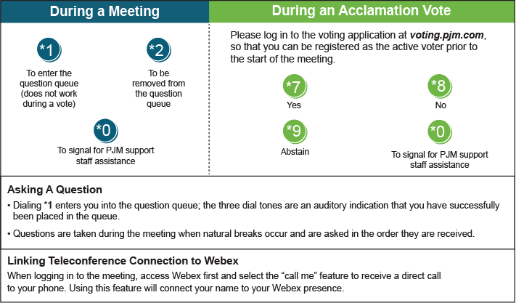

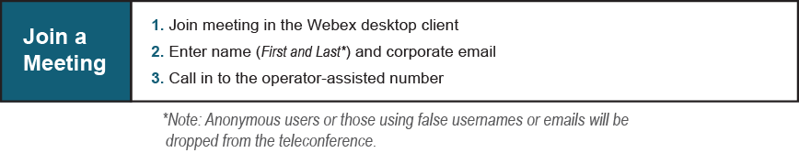
Provide feedback on the progress of this group: Facilitator Feedback Form
Visit learn.pjm.com, an easy-to-understand resource about the power industry and PJM’s role.

