Markets & Reliability Committee
Webex Only
August 25, 2021
9:00 a.m. – 1:20 p.m. EPT
*Operator assisted phone lines will be opened 30 minutes prior to the start of the meeting. Due to the high volume of remote participation, stakeholders are asked to connect early to allow additional time for operator queue processing.

Administration (9:00-9:05)
Welcome, announcements and Anti-trust, Code of Conduct, and Public Meetings/Media Participation – Stu Bresler and Dave Anders

Consent Agenda (9:05-9:10)
- Approve minutes of the July 28, 2021 meeting of the Markets and Reliability Committee (MRC).
- Endorse proposed revisions to Manual 03A: Energy Management System (EMS) Model Updates and Quality Assurance (QA) resulting from its periodic cover-to-cover review.
- Endorse proposed revisions to Manual 6: Financial Transmission Rights resulting from its periodic cover-to-cover review.
- Endorse proposed revisions to Manual 11: Energy & Ancillary Services Market Operations addressing Five Minute Long Term Changes and Transparency.
Issue Tracking: Five Minute Dispatch and Pricing
- Endorse proposed revisions to Manual 11: Energy & Ancillary Services Market Operations, Manual 18: PJM Capacity Market and Manual 28: Operating Agreement Accounting to address the implementation of Fast Start Pricing.
- Endorse proposed revisions to Manual 20: PJM Resource Adequacy Analysis resulting from its periodic cover-to-cover review.
- Endorse proposed revisions to Manual 28: Operating Agreement Accounting resulting from its periodic cover-to-cover review.

Endorsements (9:10-9:30)
- Uniform Cure Periods (9:10-9:20)
Steve Pincus will review a proposed solution to address making cure periods uniform across the Tariff and OA. The committee will be asked to endorse the proposed solution and Tariff and OA revisions.
Issue Tracking: Uniform Cure Periods

- Working Credit Limit Definitions (9:20-9:30)
Jessica Troiano will review a proposed solution to address making the definitions of working credit limits uniform across the Tariff. The committee will be asked to endorse the proposed solution and Tariff revisions.
Issue Tracking: Working Credit Limit

First Readings (9:30-11:50)
- Energy Price Formation Charter (9:30-9:55)
Susan Kenney will review proposed revisions to the EPFSTF Charter. The committee will be asked to endorse approve the proposed Charter at its next meeting.
Issue Tracking: Operating Reserve Demand Curve & Transmission Constraint Penalty Factors
- Initial Margining Solution (9:55-10:40)
- Anita Patel will provide an update on the activities of the Financial Risk Mitigation Senior Task Force (FRMSTF).
- Eric Endress will review a proposed solution endorsed by the FRMSTF to address rules related to initial margining.
The committee will be asked to endorse the proposed solution and Tariff revisions at its next meeting.
Issue Tracking: Financial Risk Mitigation
- Natural Gas and Electric Markets Issue Charge (10:40-11:05)
Jim Davis, Dominion Energy, will review a Problem Statement and Issue Charge related to natural gas and electric market coordination. The committee will be asked to endorse the proposed Issue Charge at its next meeting.
- Market Suspension (11:05-11:30)
Stefan Starkov will review a proposed solution to address rules related to market suspension. The committee will be asked to endorse/approve the proposed solution and Tariff and OA revisions at its next meeting.
Issue Tracking: Rules Related to Market Suspension
- Regional Transmission and Energy Scheduling Practices Revisions (11:30-11:50)
Chris Pacella will provide a first read of revisions to the Regional Transmission and Energy Scheduling Practices document. The committee will be asked to endorse the revisions at its next meeting.

Informational Reports (11:50-1:20)
- Overview of Relevant Provisions of US Senate-Passed Infrastructure Legislation (11:50-12:15)
Craig Glazer will provide a brief overview of those provisions of the recently passed Senate infrastructure legislation that are most relevant to the PJM community and PJM’s communications re: portions of that legislation.
- FERC Requested Remand of its Order Approving PJM’s Reserve Pricing Proposal (12:15-12:30)
Craig Glazer will provide an informational report regarding FERC’s recent request to the Court of Appeals seeking remand of its Order approving PJM’s Reserve Pricing Proposal in FERC Docket No. EL19-58, ER 19-1486.
- Fuel Security Informational Report (12:30-12:55)
Tom Falin will provide an informational report regarding fuel security analysis.
- Black Start Tariff, Schedule 6A Filing Order (12:55-1:20)
Steve Pincus will provide an overview of the Black Start Tariff, Schedule 6A Filing Order and related compliance obligation.

Informational Posting Only
- PJM Manual 03 Attachment E Automatic Sectionalizing Schemes
The PJM Manual 03 Attachment E Automatic Sectionalizing Schemes Pending Approval and Recent Changes document has been posted as an Information Only item to the August MRC meeting website.

Future Agenda Items (1:20)

Future Meeting Dates and Materials |  |  |  | Materials Due  to Secretary | Materials Published
Date | Time | Location
September 29, 2021 | 9:00 a.m. |  | WebEx | September 17, 2021 | September 22, 2021
October 20, 2021 | 9:00 a.m. |  | WebEx | October 8, 2021 | October 13, 2021
November 17, 2021 | 9:00 a.m. |  | WebEx | November 5, 2021 | November 10, 2021
December 15, 2021 | 9:00 a.m. |  | WebEx | December 3, 2021 | December 8, 2021

Author: M. Greening

Antitrust:
You may not discuss any topics that violate, or that might appear to violate, the antitrust laws including but not limited to agreements between or among competitors regarding prices, bid and offer practices, availability of service, product design, terms of sale, division of markets, allocation of customers or any other activity that might unreasonably restrain competition. If any of these items are discussed the chair will re-direct the conversation. If the conversation still persists, parties will be asked to leave the meeting or the meeting will be adjourned.

Code of Conduct:
As a mandatory condition of attendance at today's meeting, attendees agree to adhere to the PJM Code of Conduct as detailed in PJM Manual M-34 section 4.5, including, but not limited to, participants' responsibilities and rules regarding the dissemination of meeting discussion and materials.

Public Meetings/Media Participation:
Unless otherwise noted, PJM stakeholder meetings are open to the public and to members of the media. Members of the media are asked to announce their attendance at all PJM stakeholder meetings at the beginning of the meeting or at the point they join a meeting already in progress. Members of the Media are reminded that speakers at PJM meetings cannot be quoted without explicit permission from the speaker. PJM Members are reminded that "detailed transcriptional meeting notes" and white board notes from "brainstorming sessions" shall not be disseminated. Stakeholders are also not allowed to create audio, video or online recordings of PJM meetings. PJM may create audio, video or online recordings of stakeholder meetings for internal and training purposes, and your participation at such meetings indicates your consent to the same.
Participant Identification in Webex:
When logging into the Webex desktop client, please enter your real first and last name as well as a valid email address. Be sure to select the “call me” option.
PJM support staff continuously monitors Webex connections during stakeholder meetings. Anonymous users or those using false usernames or emails will be dropped from the teleconference.

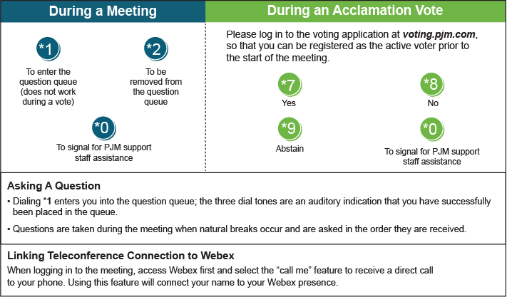

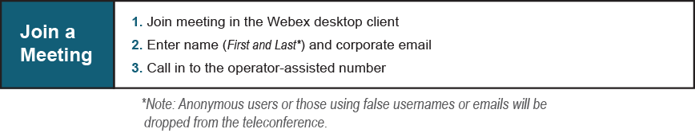
Provide feedback on the progress of this group: Facilitator Feedback Form
Visit learn.pjm.com, an easy-to-understand resource about the power industry and PJM’s role.

