Markets & Reliability Committee
Webex Only
July 28, 2021
9:00 a.m. – 10:55 a.m. EPT
*Operator assisted phone lines will be opened 30 minutes prior to the start of the meeting. Due to the high volume of remote participation, stakeholders are asked to connect early to allow additional time for operator queue processing.

Administration (9:00-9:05)
Welcome, announcements and Anti-trust, Code of Conduct, and Public Meetings/Media Participation – Stu Bresler and Dave Anders

Consent Agenda (9:05-9:10)
- Approve minutes of the June 23, 2021 meeting of the Markets and Reliability Committee (MRC).
- Endorse proposed revisions to Manual 13: Emergency Operations to address Conservative Operations and updates to the OE-417 form.
- Endorse conforming revisions to Manual 14A: New Service Request Process to address the new service requests deficiency review requirements.
Issue Tracking: New Service Requests Deficiency Review Requirements
- Endorse conforming revisions to Manual 18: PJM Capacity Market, Manual 20: PJM Resource Adequacy Analysis, Manual 21: Rules and Procedures for Determination of Generating Capability, and 21A: Determination of Accredited UCAP Using Effective Load Carrying Capability Analysis to address the Effective Load Carrying Capability (ELCC) for limited duration resources and intermittent resources.
Issue Tracking: Effective Load Carrying Capability for Limited Duration Resources and Intermittent Resources
- Endorse proposed changes to Manual 33: Administrative Services for the PJM Interconnection Operating Agreement around the Operating Reserve Demand Curve (ORDC) data in accordance with FERC transparency requirements.
- Endorse proposed revisions from the Governing Document Enhancement & Clarification Subcommittee (GDECS) addressing administrative changes and clarifications in the Tariff and Operating Agreement (OA).

Endorsements (9:10-10:00)
- Non-Firm Transmission Service Preemption (9:10-9:35)
Jeff McLaughlin will review proposed revisions to section 14.2 of the Tariff related to preemption of non-firm transmission service. The committee will be asked to endorse the proposed solution upon first read. Members Committee endorsement will be sought on the same day.
- [Item removed from agenda]

First Readings (9:35-10:55)
- Uniform Cure Periods (9:35-9:50)
Steve Pincus will review a proposed solution to address making cure periods uniform across the Tariff and OA. The committee will be asked to endorse the proposed solution and Tariff and OA revisions at its next meeting.
- Working Credit Limit Definitions (9:50-10:05)
Jessica Troiano will review a proposed solution to address making the definitions of working credit limits uniform across the Tariff. The committee will be asked to endorse the proposed solution and Tariff revisions at its next meeting.
- PJM Manuals (10:05-10:55)
  - Eliseo Carrasco will review proposed revisions to Manual 03A: Energy Management System (EMS) Model Updates and Quality Assurance (QA) resulting from its periodic cover-to-cover review. The committee will be asked to endorse the revisions at its next meeting.
  - Emmy Messina will review proposed revisions to Manual 6: Financial Transmission Rights resulting from its periodic cover-to-cover review. The committee will be asked to endorse the revisions at its next meeting.
  - Aaron Baizman will review proposed revisions to Manual 11: Energy & Ancillary Services Market Operations addressing Five Minute Long Term Changes and Transparency. The committee will be asked to endorse the revisions at its next meeting.
Issue Tracking: Five Minute Dispatch and Pricing
  - Vijay Shah and Rebecca Stadelmeyer will review proposed revisions to Manual 11: Energy & Ancillary Services Market Operations, Manual 18: PJM Capacity Market, and Manual 28: Operating Agreement Accounting to address the implementation of Fast Start Pricing. The committee will be asked to endorse the revisions at its next meeting.
  - Jason Quevada will review proposed revisions to Manual 20: PJM Resource Adequacy Analysis resulting from its periodic cover-to-cover review. The committee will be asked to endorse the revisions at its next meeting.
  - Rebecca Stadelmeyer will review proposed revisions to Manual 28: Operating Agreement Accounting resulting from its periodic cover-to-cover review. The committee will be asked to endorse the revisions at its next meeting.

Future Agenda Items (10:55)

Future Meeting Dates and Materials |  |  |  | Materials Due  to Secretary | Materials Published
Date | Time | Location
August 25, 2021 | 9:00 a.m. |  | WebEx | August 13, 2021 | August 18, 2021
September 29, 2021 | 9:00 a.m. |  | WebEx | September 17, 2021 | September 22, 2021
October 20, 2021 | 9:00 a.m. |  | WebEx | October 8, 2021 | October 13, 2021
November 17, 2021 | 9:00 a.m. |  | WebEx | November 5, 2021 | November 10, 2021
December 15, 2021 | 9:00 a.m. |  | WebEx | December 3, 2021 | December 8, 2021

Author: M. Greening

Antitrust:
You may not discuss any topics that violate, or that might appear to violate, the antitrust laws including but not limited to agreements between or among competitors regarding prices, bid and offer practices, availability of service, product design, terms of sale, division of markets, allocation of customers or any other activity that might unreasonably restrain competition. If any of these items are discussed the chair will re-direct the conversation. If the conversation still persists, parties will be asked to leave the meeting or the meeting will be adjourned.

Code of Conduct:
As a mandatory condition of attendance at today's meeting, attendees agree to adhere to the PJM Code of Conduct as detailed in PJM Manual M-34 section 4.5, including, but not limited to, participants' responsibilities and rules regarding the dissemination of meeting discussion and materials.

Public Meetings/Media Participation:
Unless otherwise noted, PJM stakeholder meetings are open to the public and to members of the media. Members of the media are asked to announce their attendance at all PJM stakeholder meetings at the beginning of the meeting or at the point they join a meeting already in progress. Members of the Media are reminded that speakers at PJM meetings cannot be quoted without explicit permission from the speaker. PJM Members are reminded that "detailed transcriptional meeting notes" and white board notes from "brainstorming sessions" shall not be disseminated. Stakeholders are also not allowed to create audio, video or online recordings of PJM meetings. PJM may create audio, video or online recordings of stakeholder meetings for internal and training purposes, and your participation at such meetings indicates your consent to the same.
Participant Identification in Webex:
When logging into the Webex desktop client, please enter your real first and last name as well as a valid email address. Be sure to select the “call me” option.
PJM support staff continuously monitors Webex connections during stakeholder meetings. Anonymous users or those using false usernames or emails will be dropped from the teleconference.

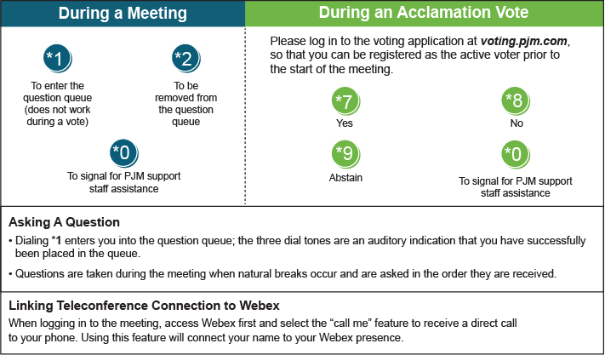

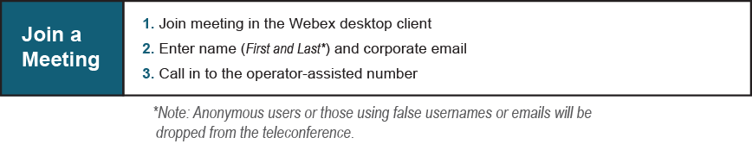
Provide feedback on the progress of this group: Facilitator Feedback Form
Visit learn.pjm.com, an easy-to-understand resource about the power industry and PJM’s role.

