Markets and Reliability Committee
Webex Only
April 21, 2021
9:00 a.m. – 11:45 a.m.
*Operator assisted phone lines will be opened 30 minutes prior to the start of the meeting. Due to the high volume of remote participation, stakeholders are asked to connect early to allow additional time for operator queue processing.

Administration (9:00-9:10)
Welcome, announcements and Anti-trust, Code of Conduct, and Public Meetings/Media Participation – Stu Bresler and Dave Anders
Dave Anders will provide an update on the voting protocols for Board elections at the May Members Committee meeting.

Consent Agenda (9:10-9:15)
- Approve minutes of the March 29, 2021 meeting of the Markets and Reliability Committee (MRC).
- Endorse proposed revisions to Manual 14D: Generator Operational Requirements, Section 5.3.7 regarding the Resource Tracker Ownership Confirmation Requirement.
Issue Tracking: Resource Tracker Ownership Confirmation Requirement

Endorsements/ Approvals (9:15-10:15)
- Long-Term 5-Minute Dispatch & Pricing (9:15-9:30)
Aaron Baizman will review the proposed solution and associated Tariff revisions addressing the Long-Term Five Minute Dispatch & Pricing changes. The committee will be asked to endorse the proposed solutions. Members Committee endorsement will be sought on the same day.
Issue Tracking: Five Minute Dispatch and Pricing
- Capital Recovery Factor for Avoidable Project Investment Cost Determinations (9:30-9:45)
Jeff Bastian will review the proposed solution and associated Tariff revisions addressing the Capital Recovery Factor for Avoidable Project Investment Cost Determinations. The committee will be asked to approve the proposed solution. Members Committee endorsement will be sought on the same day.
Issue Tracking: Capital Recover Factor (CRF) for Avoidable Project Investment Cost Determinations (APIR)
- Critical Infrastructure Stakeholder Oversight (CISO) (9:45-10:15)
  - Christina Stotesbury will provide an overview of the CISO work activities and timeline.
  - Mike Herman will review the proposed solutions to address the Mitigation and Avoidance of future CIP-014 facilities.
  - Alejandro Bautista will review Operating Agreement revisions supporting the solutions.
The committee will be asked to separately endorse the proposed Mitigation solution and the proposed Avoidance solution.
Issue Tracking: Critical Infrastructure Stakeholder Oversight

First Readings (10:15-11:35)
- New Service Requests Deficiency Review Requirements (10:15-10:40)
Jason Connell will provide a first read of a proposed solution to address new service requests deficiency review requirements. The committee will be asked to approve the proposed solution and Tariff revisions at its next meeting.
- Public Distribution Microgrids (10:40-11:05)
Natalie Tacka will review proposed revisions to Manual 11: Energy & Ancillary Services Market Operations, Manual 14D: Generator Operational Requirements and Manual 18: PJM Capacity Market addressing Public Distribution Microgrids. The committee will be asked to endorse the revisions at its next meeting.
- PJM Manuals (11:05-11:35)
- Lagy Mathew will review proposed revisions to Manual 03: Transmission Operations resulting from the periodic cover to cover review. The committee will be asked to endorse the revisions at its next meeting.
- Nicole Militello and Rebecca Stadelmeyer will review proposed revisions to Manual 11: Energy & Ancillary Services Market Operations, Manual 18: PJM Capacity Market and Manual 28: Operating Agreement Accounting to address the implementation of PJM’s Fast Start compliance filing. The committee will be asked to endorse the revisions at its next meeting.
- Jerry Bell will review proposed revisions to Manual 21: Rules and Procedures for Determination of Generating Capability resulting from its biennial cover to cover review. The committee will be asked to endorse the revisions at its next meeting.
- Rich Brown will review proposed revisions to Manual 36: System Restoration resulting from its annual update requirement. The committee will be asked to endorse the revisions at its next meeting.

Informational Reports (11:35-11:45)
- Posting Timeline Trial Period (11:35-11:45)
Michele Greening will review information related to a proposed posting timeline trial period.

Informational Only
- Manual 01: Control Center and Data Exchange
The periodic review of Manual 01: Control Center and Data Exchange was completed with no required edits identified.
- PJM Manual 03 Attachment E Automatic Sectionalizing Schemes
The PJM Manual 03 Attachment E Automatic Sectionalizing Schemes Pending Approval and Recent Changes document has been posted as an Information Only item to the April MRC meeting website.
- PKI Certificate Based Authentication
On May 4, 2021 at 4:00 p.m. EPT, PJM will be implementing a Public Key Infrastructure (PKI) certificate based authentication to PJM’s OASIS and ExSchedule applications in order to comply with the North American Energy Standards Board (NAESB) version 3.2 requirements. Please reference posted materials for more information.

Future Agenda Items (11:45)

Future Meeting Dates
May 26, 2021 | 9:00 a.m. | WebEx
June 23, 2021 | 9:00 a.m. | WebEx
July 28, 2021 | 9:00 a.m. | WebEx
August 25, 2021 | 9:00 a.m. | WebEx
September 29, 2021 | 9:00 a.m. | WebEx
October 20, 2021 | 9:00 a.m. | WebEx
November 17, 2021 | 9:00 a.m. | WebEx
December 15, 2021 | 9:00 a.m. | WebEx

Author: M. Greening

Antitrust:
You may not discuss any topics that violate, or that might appear to violate, the antitrust laws including but not limited to agreements between or among competitors regarding prices, bid and offer practices, availability of service, product design, terms of sale, division of markets, allocation of customers or any other activity that might unreasonably restrain competition. If any of these items are discussed the chair will re-direct the conversation. If the conversation still persists, parties will be asked to leave the meeting or the meeting will be adjourned.

Code of Conduct:
As a mandatory condition of attendance at today's meeting, attendees agree to adhere to the PJM Code of Conduct as detailed in PJM Manual M-34 section 4.5, including, but not limited to, participants' responsibilities and rules regarding the dissemination of meeting discussion and materials.

Public Meetings/Media Participation:
Unless otherwise noted, PJM stakeholder meetings are open to the public and to members of the media. Members of the media are asked to announce their attendance at all PJM stakeholder meetings at the beginning of the meeting or at the point they join a meeting already in progress. Members of the Media are reminded that speakers at PJM meetings cannot be quoted without explicit permission from the speaker. PJM Members are reminded that "detailed transcriptional meeting notes" and white board notes from "brainstorming sessions" shall not be disseminated. Stakeholders are also not allowed to create audio, video or online recordings of PJM meetings. PJM may create audio, video or online recordings of stakeholder meetings for internal and training purposes, and your participation at such meetings indicates your consent to the same.
Participant Identification in Webex:
When logging into the Webex desktop client, please enter your real first and last name as well as a valid email address. Be sure to select the “call me” option.
PJM support staff continuously monitors Webex connections during stakeholder meetings. Anonymous users or those using false usernames or emails will be dropped from the teleconference.

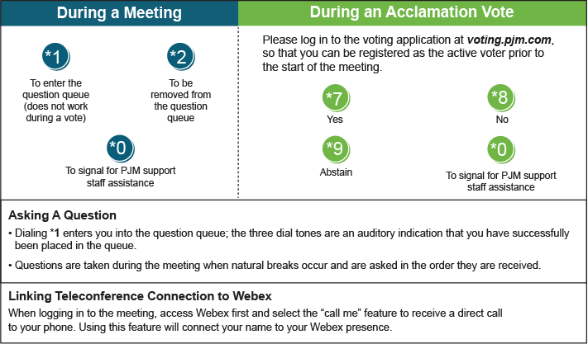

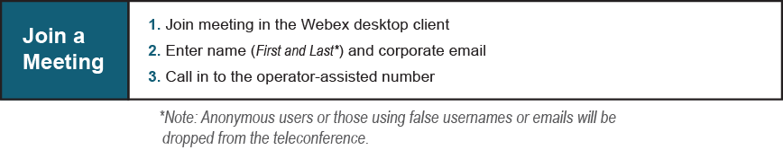
Provide feedback on the progress of this group: Facilitator Feedback Form
Visit learn.pjm.com, an easy-to-understand resource about the power industry and PJM’s role.

