Markets and Reliability Committee
Webex Only
November 19, 2020
9:00 a.m. – 10:00 a.m.
*Operator assisted phone lines will be opened 30 minutes prior to the start of the meeting. Due to the high volume of remote participation, stakeholders are asked to connect early to allow additional time for operator queue processing.

Administration (9:00-9:05)
Welcome, announcements and Anti-trust, Code of Conduct, and Public Meetings/Media Participation – Stu Bresler and Dave Anders

Consent Agenda (9:05-9:10)
- Approve minutes of the October 29, 2020 meeting of the Markets and Reliability Committee (MRC).
- Endorse updates to Manual 3: Transmission Operations to incorporate clarifying changes resulting from its periodic review.
- Endorse proposed revisions to Manual 3A: Energy Management System (EMS) Model Updates and Quality Assurance (QA) resulting from its periodic review.
- Endorse proposed revisions to Manual 10: Pre-Scheduling Operations to incorporate clarifying changes resulting from its periodic review.
- Endorse proposed revisions to Manual 11: Energy & Ancillary Services Market Operations and Manual 12: Balancing Operations to address changes related to the 5 minute dispatch and pricing MIC special sessions.
Issue Tracking: Five Minute Dispatch and Pricing
- Endorse proposed revisions to Manual 14D: Generator Operational Requirements to incorporate changes resulting from its periodic review.
- Endorse a minor correction to Manual 18: PJM Capacity Market with regards to an effective date for notifying pseudo-tied resource owners of their assigned LDA prior to each delivery year.

Endorsements/Approvals (9:10-9:20)
- Day Ahead Schedule Reserve (DASR) Update (9:10-9:20)
David Kimmel will review final proposed changes to the 2021 Day Ahead Scheduling Reserve (DASR) requirement. The committee will be asked to endorse the proposed changes.

First Readings (9:20-9:40)
- PJM Manuals (9:20-9:40)
  - Mark Sims will review proposed revisions to Manual 14C: Generation and Transmission Interconnection Facility Construction as part of the biennial cover-to-cover review. The committee will be asked to endorse the revisions at its next meeting.
  - Ray Fernandez will review proposed revisions to Manual 28: Operating Agreement Accounting conforming with the changes to FERC Order EL-14-37-000 and addressing the allocation of real-time uplift and day-ahead uplift to UTCs. The committee will be asked to endorse the revisions at its next meeting.

Informational Reports (9:40-10:00)
- 2022/2023 Base Residual Auction Schedule (9:40-10:00)
Pete Langbein will present the schedule for the 2022/2023 RPM Base Residual Auction, the implementation of which is now appropriate given FERC’s November 12 order on the forward-looking Energy and Ancillary Services Offset in FERC Docket No. EL19-58.

Informational Posting Only

Future Agenda Items (10:00)

Future Meeting Dates
December 17, 2020 | 9:00 a.m. | WebEx

Author: M. Greening

Antitrust:
You may not discuss any topics that violate, or that might appear to violate, the antitrust laws including but not limited to agreements between or among competitors regarding prices, bid and offer practices, availability of service, product design, terms of sale, division of markets, allocation of customers or any other activity that might unreasonably restrain competition. If any of these items are discussed the chair will re-direct the conversation. If the conversation still persists, parties will be asked to leave the meeting or the meeting will be adjourned.

Code of Conduct:
As a mandatory condition of attendance at today's meeting, attendees agree to adhere to the PJM Code of Conduct as detailed in PJM Manual M-34 section 4.5, including, but not limited to, participants' responsibilities and rules regarding the dissemination of meeting discussion and materials.

Public Meetings/Media Participation:
Unless otherwise noted, PJM stakeholder meetings are open to the public and to members of the media. Members of the media are asked to announce their attendance at all PJM stakeholder meetings at the beginning of the meeting or at the point they join a meeting already in progress. Members of the Media are reminded that speakers at PJM meetings cannot be quoted without explicit permission from the speaker. PJM Members are reminded that "detailed transcriptional meeting notes" and white board notes from "brainstorming sessions" shall not be disseminated. Stakeholders are also not allowed to create audio, video or online recordings of PJM meetings. PJM may create audio, video or online recordings of stakeholder meetings for internal and training purposes, and your participation at such meetings indicates your consent to the same.
Participant Identification in WebEx:
When logging into the WebEx desktop client, please enter your real first and last name as well as a valid email address. Be sure to select the “call me” option.
PJM support staff continuously monitors WebEx connections during stakeholder meetings. Anonymous users or those using false usernames or emails will be dropped from the teleconference.

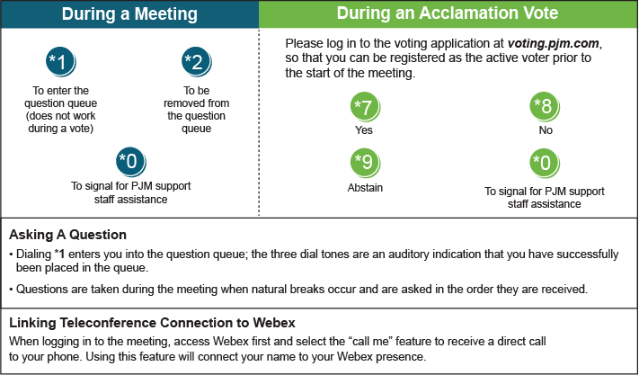

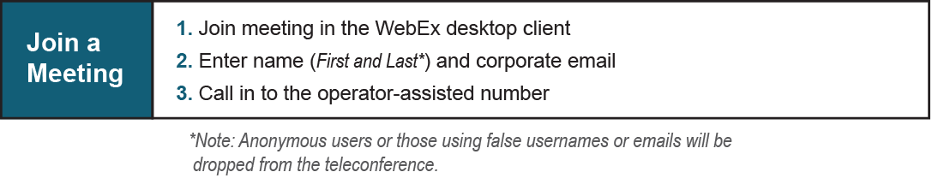
Provide feedback on the progress of this group: Facilitator Feedback Form
Visit learn.pjm.com, an easy-to-understand resource about the power industry and PJM’s role.

