Market Implementation Committee

WebEx / Conference & Training Center

November 2, 2022

9:00 a.m. – 12:00 p.m. EPT

Administration (9:00 – 9:20)

Amanda Martin will review the Antitrust, Code of Conduct, Public Meetings/Media Participation and the WebEx Participant Identification Requirements.

The Committee will be asked to approve the draft minutes from the October 6, 2022 Market Implementation Committee.

1. Matt Pennell will provide an update on select XML submissions negatively impacting Markets Gateway performance.

Endorsements/Approvals (9:20 – 10:55)

1. Manual 27 Periodic Review (9:20 – 9:35)

Rebecca Stadelmeyer will review revisions to Manual 27: Open Access Transmission Tariff Accounting as part of the periodic review.

The committee will be asked to endorse the revisions at this meeting.

1. Local Considerations in Net Cost of New Entry (CONE) (9:35 – 10:05)

Gary Helm will review a Problem Statement and Issue Charge addressing how local considerations may affect the development of Net CONE.

The committee will be asked to approve the issue charge at this meeting.

1. Demand Response Subcommittee (DRS) and DER & Inverter-based Resources Subcommittee (DIRS) Consolidation (10:05 – 10:35)

Scott Baker and Pete Langbein will review a request to sunset the DIRS and DRS and consolidate the work of the two groups under a new MIC subcommittee, Distributed Resources Subcommittee (DISRS) with a new charter.

The committee will be asked to approve the new charter and approve the sunset of the DIRS and DRS at this meeting.

1. Hybrid Resources Phase II (10:35 – 10:55)

Danielle Croop will review the package detailing the Hybrid Resources Phase II solutions.

The committee will be asked to endorse the package at this meeting.

[Issue Tracking: Solar-Battery Hybrid Resources](https://www.pjm.com/committees-and-groups/issue-tracking/issue-tracking-details.aspx?Issue=3423b18c-59c2-49dd-84c5-af42b1ba0256)

First Readings (10:55 – 11:40)

1. Day-ahead Zonal Load Bus Distribution Factors (10:55 – 11:40)
   1. Amanda Martin will present analysis of day-ahead and real-time load bus distribution factors.
   2. Amanda Martin will provide a first read of the package detailing the zonal load bus distribution factors and associated revisions to Manual 11: Energy & Ancillary Services Market Operations, Manual 28: Operating Agreement Accounting, and Tariff Section 31.7.

[Issue Tracking: Day-ahead Zonal Load Bus Distribution Factors](https://pjm.com/committees-and-groups/issue-tracking/issue-tracking-details.aspx?Issue=6657e9e9-4bca-41d3-b5a1-9468b7964475)

Additional Items (11:40 – 12:00)

1. Cost Development Subcommittee Update (11:40 – 11:45)

Nicole Scott will provide an informational update on the work to be performed at the Cost Development Subcommittee

1. Energy Offer Verification Process (11:45 – 11:50)

Phil D’Antonio will provide an informational update on the upcoming Energy Offer Verification education for offers above $1,000/MWh. Previous education materials can be found on the [Markets & Operations](https://www.pjm.com/-/media/markets-ops/energy/energy-offer-verification/pjm-energy-offer-verification-process-overview.ashx) page.

1. Renewable Dispatch (11:50 – 12:00)

Mike Zhang will review the Joint PJM/IMM package for renewable dispatch that was endorsed at the October Operating Committee.

[Issue Tracking: Renewable Dispatch](https://www.pjm.com/committees-and-groups/issue-tracking/issue-tracking-details.aspx?Issue=197f2bf2-4d61-4894-bc57-e91267bb6dce)

Informational Section

Manual 03 Attachment E

The Automatic Sectionalizing Schemes Pending Approval and Recent Changes document has been posted to the [OASIS System Information](https://www.pjm.com/markets-and-operations/etools/oasis/system-information.aspx) page as informational only.

PJM’s Regional Transmission and Energy Scheduling Practices Document

PJM’s Regional Transmission and Energy Scheduling Practices document has been posted as informational only. Revisions will be reviewed at the Operating Committee.

Interregional Coordination Update

Materials are posted as informational only.

Stability Limits in Markets and Operations

Materials are posted as informational only.

PJM Net Energy Injections Quarterly Review

Materials are posted as informational only.

ARR FTR Market Task Force (AFMTF)   
Meeting materials are posted to the [AFMTF website](https://www.pjm.com/committees-and-groups/task-forces/afmtf).

Regulation Market Design Senior Task Force (RMDSTF)

Meeting materials are posted to the [RMDSTF website](https://www.pjm.com/committees-and-groups/task-forces/rmdstf).

Reactive Power Compensation Task Force (RPCTF)   
Meeting materials are posted to the [RPCTF website.](https://www.pjm.com/committees-and-groups/task-forces/rpctf)

Cost Development Subcommittee (CDS)   
Meeting materials are posted to the [CDS website](https://www.pjm.com/committees-and-groups/subcommittees/cds).

Demand Response Subcommittee (DRS)   
Meeting materials are posted to the [DRS website](http://www.pjm.com/committees-and-groups/subcommittees/drs.aspx).

DER & Inverter-based Resources Subcommittee (DIRS)

Meeting materials are posted to the [DIRS website.](https://www.pjm.com/committees-and-groups/subcommittees/dirs.aspx)

Market Settlements Subcommittee (MSS)

Meeting materials are posted to the [MSS website](http://www.pjm.com/committees-and-groups/subcommittees/mss.aspx).

Report on Market Operations

The Report on Market Operations will be reviewed during the [MC Webinar](http://www.pjm.com/committees-and-groups/committees/mc.aspx).

|  |  |  |  |  |
| --- | --- | --- | --- | --- |
| **Future Meeting Dates and Materials** | | | **Materials Due  to Secretary** | **Materials Published** |
| Date | Time | Location | 5 p.m. | 4 p.m. |
| December 7 | 9 a.m. | WebEx / Conference & Training Center | November 23 | November 30 |

Author: Amanda Martin

Antitrust:

You may not discuss any topics that violate, or that might appear to violate, the antitrust laws including but not limited to agreements between or among competitors regarding prices, bid and offer practices, availability of service, product design, terms of sale, division of markets, allocation of customers or any other activity that might unreasonably restrain competition. If any of these items are discussed the chair will re-direct the conversation. If the conversation still persists, parties will be asked to leave the meeting or the meeting will be adjourned.

Code of Conduct:

As a mandatory condition of attendance at today's meeting, attendees agree to adhere to the PJM Code of Conduct as detailed in PJM Manual M-34 section 4.5, including, but not limited to, participants' responsibilities and rules regarding the dissemination of meeting discussion and materials.

Public Meetings/Media Participation:

Unless otherwise noted, PJM stakeholder meetings are open to the public and to members of the media. Members of the media are asked to announce their attendance at all PJM stakeholder meetings at the beginning of the meeting or at the point they join a meeting already in progress. Members of the Media are reminded that speakers at PJM meetings cannot be quoted without explicit permission from the speaker. PJM Members are reminded that "detailed transcriptional meeting notes" and white board notes from "brainstorming sessions" shall not be disseminated. Stakeholders are also not allowed to create audio, video or online recordings of PJM meetings. PJM may create audio, video or online recordings of stakeholder meetings for internal and training purposes, and your participation at such meetings indicates your consent to the same.

Participant Identification in WebEx:

When logging into the WebEx desktop client, please enter your real first and last name as well as a valid email address. Be sure to select the “call me” option.

PJM support staff continuously monitors WebEx connections during stakeholder meetings. Anonymous users or those using false usernames or emails will be dropped from the teleconference.

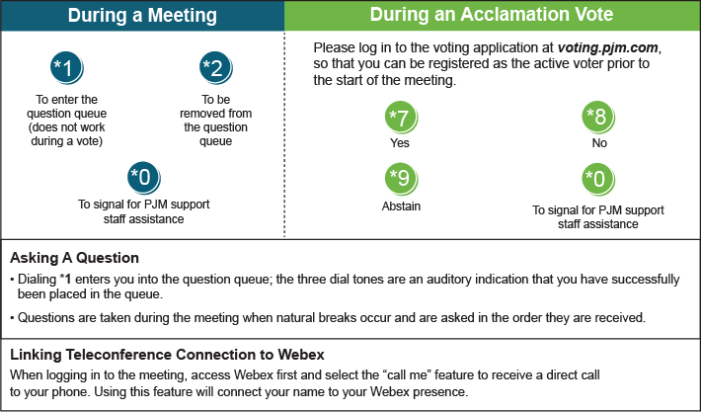

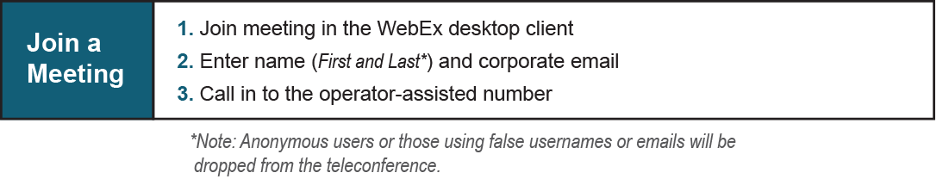

Provide feedback on the progress of this group: [*Facilitator Feedback Form*](https://www.pjm.com/committees-and-groups/committees/form-facilitator-feedback.aspx)   
Visit [*learn.pjm.com*](https://learn.pjm.com/), an easy-to-understand resource about the power industry and PJM’s role.