Market Implementation Committee

WebEx / Conference & Training Center

September 7, 2022

9:00 a.m. – 4:00 p.m. EPT

Administration (9:00 – 9:10)

Amanda Martin will review the Antitrust, Code of Conduct, Public Meetings/Media Participation and the WebEx Participant Identification Requirements.

The Committee will be asked to approve the draft minutes from the August 10, 2022 Market Implementation Committee.

1. Amanda Martin will review the MIC Work Plan.
2. Michele Greening will provide an update on the October Annual Meeting.

Endorsements/Approvals (9:10 – 11:20)

1. Fuel Requirements for Black Start Resources (9:10 – 9:55)
   1. Janell Fabiano will provide background, polling results, and an overview of the voting process for this issue.
   2. Dan Bennett will review the Package H proposal
   3. Joe Bowring, IMM, will review the IMM proposal.

The committee will be asked to vote on the proposals after this meeting via an offline vote in the PJM Voting Application which opens on September 8 and will close on September 13.

[Issue Tracking: Fuel Requirements for Black Start Resources](https://www.pjm.com/committees-and-groups/issue-tracking/issue-tracking-details.aspx?Issue=b7f726e1-9f06-414e-8516-4d69b5050af4)

1. Variable Operations & Maintenance Cost Development (9:55 – 10:20)

Roger Cao will review the PJM and Constellation proposals and poll results addressing development of variable operations and maintenance costs that was developed through the Cost Development Subcommittee

The committee will be asked to vote on the proposals at this meeting.

[Issue Tracking: Variable Operating and Maintenance Cost](https://www.pjm.com/committees-and-groups/issue-tracking/issue-tracking-details.aspx?Issue=d756f89d-17d7-4559-b1fe-b59e81049da2)

1. Residential Customer Measurement and Verification for Demand Response (10:20 – 10:35)

Ken Schisler, CPower, will review a Problem Statement and Issue Charge addressing Residential Customer Measurement and Verification for Demand Response.

**The committee will be asked to approve the Issue Charge at this meeting.**

1. Manual 18 and Manual 18B Revisions (10:35 – 10:50)

Theresa Esterly will review revisions to Manual 18: PJM Capacity Market, and Manual 18B: Energy Efficiency Measurement & Verification as part of the periodic review.

**The committee will be asked to endorse the revisions at this meeting.**

1. Reserve Price Formation Manual Revisions (10:50 – 11:20)
   1. Brian Chmielewski will provide an overview of FERC’s order approving the implementation of the Reserve Price Formation changes, effective October 1, 2022. Rebecca Stadelmeyer, Damon Fereshetian and Michael Olaleye will review conforming revisions to Manual 27: Open Access Transmission Tariff Accounting, Manual 28: Operating Agreement Accounting, Manual 29: Billing to address the Reserve Price Formation implementation, and Manual 11: Energy & Ancillary Services Market
   2. Catherine Tyler, IMM, will review the IMM’s observations of the Manual 11 revisions.

The committee will be asked to endorse the revisions at this meeting.

First Readings (11:20 – 11:45)

1. Operating Reserve Clarification for Resources Operating as Requested by PJM (11:20 – 11:30)

Lisa Morelli will review a proposal to proceed with removal of the CT Rule in Manual 28 in advance of the remainder of the work on this issue charge.

The committee will be asked to endorse the revisions to Manual 28 at its next meeting.

[Issue Tracking: Operating Reserve Clarification for Resources Operating as Requested by PJM](https://www.pjm.com/committees-and-groups/issue-tracking/issue-tracking-details.aspx?Issue=6897c7e7-d8b7-438e-9e3f-b6099f9dd7ec)

1. Critical Natural Gas Infrastructure – Demand Response Participation (11:30 – 11:45)

Pete Langbein will provide a first read of a proposal addressing prohibition of Critical Natural Gas Infrastructure load as a demand response resource.  This proposal was developed at the Demand Response Subcommittee pursuant to recommendations included in the FERC/NERC report on the severe cold weather event in Texas and South Central US in February 2021.

The committee will be asked to endorse the proposal and the associated manual revisions at its next meeting.

Lunch (11:45 – 12:40)

Working Items (12:40 – 2:40)

1. Capacity Offer Opportunities for Generation with Co-Located Load (12:40 – 1:55)
   1. Chen Lu will present PJM perspective on the federal and state jurisdictional boundaries as it applies to co-located load without service from the system.
   2. Joe Bowring will review the IMM’s proposal
   3. Lisa Morelli will facilitate a discussion to review packages for the Capacity Offer Opportunities for Generation with Co-Located Load matrix. Additional packages can be provided in advance of the meeting or during the meeting.

[Issue Tracking: Capacity Offer Opportunities for Generation with Co-Located Load](https://www.pjm.com/committees-and-groups/issue-tracking/issue-tracking-details.aspx?Issue=6897c7e7-d8b7-438e-9e3f-b6099f9dd7ec)

1. Day-ahead Zonal Load Bus Distribution Factors (1:55 – 2:40)
   1. Amanda Martin will present education on the use of zonal load bus distribution factors.
   2. Lisa Morelli will facilitate a discussion to solicit interests, design components, design component options and packages addressing Day-ahead Zonal Load Bus Distribution Factors.

[Issue Tracking: Day-ahead Zonal Load Bus Distribution Factors](https://pjm.com/committees-and-groups/issue-tracking/issue-tracking-details.aspx?Issue=6657e9e9-4bca-41d3-b5a1-9468b7964475)

Additional Items (2:40 – 4:00)

1. Quadrennial Review (2:40 – 3:10)

PJM Staff will discuss follow-up items from the recent Quadrennial Review

1. 2023 PJM Capital Budget (3:10 – 3:20)

Jim Snow will review updates to PJM’s 2023 Capital Budget.

1. Reserve Price Formation Simulations (3:20 – 3:35)

Joey Tutino will provide an overview of analysis that was conducted to simulate the impact of the pending Reserve Price Formation rule changes on the energy and reserve markets.

1. Order Directing Reports on Energy and Ancillary Service Market Reforms (3:35 – 3:50)

Rebecca Carroll will provide an update on the FERC order directing reports on energy and ancillary service market reforms (FERC Docket No. AD21-10).

1. 2024/2025 Base Residual Auction Update (3:50 – 3:55)

Pete Langbein will provide an update on the forced outages rates (EFORd) that will be used in the upcoming 2024/2025 base residual auction for the capacity market.

1. Cost Development Subcommittee Update (3:55 – 4:00)

Nicole Scott will provide an informational update on the work to be performed at the Cost Development Subcommittee.

Informational Section

Southeast/Southwest Aggregates Removal

The presentation provides an overview of updates being made to the Southeast/Southwest Aggregates. Materials are posted as informational only.

Dynamic Line Ratings Task Force (DLRSTF) Update

The DLRTF kickoff meeting will be September 30. The Task Force is assigned to the Operating Committee but will cover topics related to the MIC and PC as well. Information will be posted to the [DLRTF website](https://pjm.com/committees-and-groups/task-forces/dlrtf)

Fast Start Pricing Monthly Metrics Update

Materials are posted as informational only.

Interregional Coordination Update

Materials are posted as informational only.

Stability Limits in Markets and Operations

Materials are posted as informational only.

ARR FTR Market Task Force (AFMTF)   
Meeting materials are posted to the [AFMTF website](https://www.pjm.com/committees-and-groups/task-forces/afmtf).

Regulation Market Design Senior Task Force (RMDSTF)

Meeting materials are posted to the [RMDSTF website](https://www.pjm.com/committees-and-groups/task-forces/rmdstf).

Reactive Power Compensation Task Force (RPCTF)   
Meeting materials are posted to the [RPCTF website.](https://www.pjm.com/committees-and-groups/task-forces/rpctf)

Cost Development Subcommittee (CDS)   
Meeting materials are posted to the [CDS website](https://www.pjm.com/committees-and-groups/subcommittees/cds).

Demand Response Subcommittee (DRS)   
Meeting materials are posted to the [DRS website](http://www.pjm.com/committees-and-groups/subcommittees/drs.aspx).

DER & Inverter-based Resources Subcommittee (DIRS)

Meeting materials are posted to the [DIRS website.](https://www.pjm.com/committees-and-groups/subcommittees/dirs.aspx)

Market Settlements Subcommittee (MSS)

Meeting materials are posted to the [MSS website](http://www.pjm.com/committees-and-groups/subcommittees/mss.aspx).

OC/MIC Fuel Requirements for Black Start Resources

Meeting materials are posted to the [Operating Committee website](https://www.pjm.com/committees-and-groups/committees/oc).

Report on Market Operations

The Report on Market Operations will be reviewed during the [MC Webinar](http://www.pjm.com/committees-and-groups/committees/mc.aspx).

|  |  |  |  |  |
| --- | --- | --- | --- | --- |
| **Future Meeting Dates and Materials** | | | **Materials Due  to Secretary** | **Materials Published** |
| Date | Time | Location | 5 p.m. | 4 p.m. |
| October 6 | 9 a.m. | WebEx / Conference & Training Center | September 26 | September 29 |
| November 2 | 9 a.m. | WebEx / Conference & Training Center | October 21 | October 26 |
| December 7 | 9 a.m. | WebEx / Conference & Training Center | November 23 | November 30 |

Author: Amanda Martin

Antitrust:

You may not discuss any topics that violate, or that might appear to violate, the antitrust laws including but not limited to agreements between or among competitors regarding prices, bid and offer practices, availability of service, product design, terms of sale, division of markets, allocation of customers or any other activity that might unreasonably restrain competition. If any of these items are discussed the chair will re-direct the conversation. If the conversation still persists, parties will be asked to leave the meeting or the meeting will be adjourned.

Code of Conduct:

As a mandatory condition of attendance at today's meeting, attendees agree to adhere to the PJM Code of Conduct as detailed in PJM Manual M-34 section 4.5, including, but not limited to, participants' responsibilities and rules regarding the dissemination of meeting discussion and materials.

Public Meetings/Media Participation:

Unless otherwise noted, PJM stakeholder meetings are open to the public and to members of the media. Members of the media are asked to announce their attendance at all PJM stakeholder meetings at the beginning of the meeting or at the point they join a meeting already in progress. Members of the Media are reminded that speakers at PJM meetings cannot be quoted without explicit permission from the speaker. PJM Members are reminded that "detailed transcriptional meeting notes" and white board notes from "brainstorming sessions" shall not be disseminated. Stakeholders are also not allowed to create audio, video or online recordings of PJM meetings. PJM may create audio, video or online recordings of stakeholder meetings for internal and training purposes, and your participation at such meetings indicates your consent to the same.

Participant Identification in WebEx:

When logging into the WebEx desktop client, please enter your real first and last name as well as a valid email address. Be sure to select the “call me” option.

PJM support staff continuously monitors WebEx connections during stakeholder meetings. Anonymous users or those using false usernames or emails will be dropped from the teleconference.

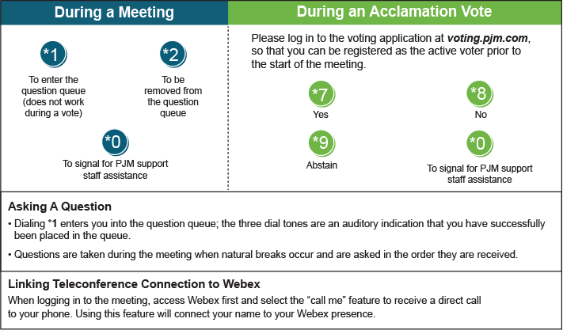

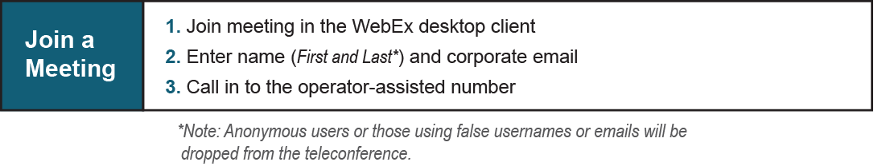

Provide feedback on the progress of this group: [*Facilitator Feedback Form*](https://www.pjm.com/committees-and-groups/committees/form-facilitator-feedback.aspx)   
Visit [*learn.pjm.com*](https://learn.pjm.com/), an easy-to-understand resource about the power industry and PJM’s role.