Market Implementation Committee

WebEx / Conference & Training Center

June 8, 2022

9:00 a.m. – 3:45 p.m. EPT

Administration (9:00 – 9:05)

Nicholas DiSciullo will review the Antitrust, Code of Conduct, Public Meetings/Media Participation and the WebEx Participant Identification Requirements.

The Committee will be asked to approve the draft minutes from the May 11, 2022 Market Implementation Committee.

Endorsements/Approvals (9:05 – 9:15)

1. **Manuals 18 and 28: Load Management / Price Responsive Demand Testing Changes (9:05 – 9:15)**

Jack O’Neill will review conforming changes to Manual 18: PJM Capacity Market and Manual 28: Operating Agreement Accounting to support the implementation of new testing requirements which were approved in Docket No. ER19-1590 and will become effective with the 2023/2023 Delivery Year.

**The committee will be asked to endorse the revisions at this meeting.**

[Issue Tracking: Load Management Testing Requirements](https://www.pjm.com/committees-and-groups/issue-tracking/issue-tracking-details.aspx?Issue=51c7a25c-4ee6-42a5-a6d6-3ca46581e9a9)

First Readings (9:15 – 11:10)

1. **Variable Environmental Costs and Credits (9:15 – 9:35)**

Melissa Pilong will provide a second first read of a proposal providing detailed guidance and updates to rules related to variable environmental charges and/or credits and their inclusion in cost-based energy offers. The committee will be asked to endorse the package at its next meeting.

[Issue Tracking: Variable Environmental Costs and Credits](https://www.pjm.com/committees-and-groups/issue-tracking/issue-tracking-details.aspx?Issue=c95724bc-c61d-4226-9772-ac411886523e)

1. **Market Suspension (9:35 – 9:55)**

Stefan Starkov will provide a second first read of the revised PJM/IMM Package addressing the treatment of long-term market suspensions. The package has been revised in response to feedback received at the May meeting. The committee will be asked to endorse the package at its next meeting.

[Issue Tracking: Rules Related to Market Suspension](https://www.pjm.com/committees-and-groups/issue-tracking/issue-tracking-details.aspx?Issue=214df9c5-db87-4a02-84be-b917c118d6ed)

1. **Manual 6 Revisions (9:55 – 10:15)**

Emmy Messina will provide a first read of revisions to Manual 6: Financial Transmission Rights as part of the periodic review and ARR FTR Market Task Force-based conforming changes (Docket No. ER22-797-000). A brief update on the implementation plans for the first phase of ARR FTR Market Task Force-based conforming changes (Docket No. ER22-797-000) will also be provided. The committee will be asked to endorse the revisions at its next meeting.

1. **Manual 18 Revisions: Hybrid Resources (10:15 – 10:30)**

Andrew Levitt will provide an update on the recent hybrids filing (Docket No. ER22-1420) and provide a first read of conforming revisions to Manual 18: PJM Capacity Market. The committee will be asked to endorse the revisions at its next meeting.

[Issue Tracking: Solar-Battery Hybrid Resources](https://www.pjm.com/committees-and-groups/issue-tracking/issue-tracking-details.aspx?Issue=3423b18c-59c2-49dd-84c5-af42b1ba0256)

1. **Manual 28 Revisions: Start-Up Cost Offer Development (10:30 – 10:40)**

Rebecca Stadelmeyer will review revisions to Manual 28: Operating Agreement Accounting to support the Startup Cost Offer Development proposal the committee approved at the April 2022 meeting.

[Issue Tracking: Start-Up Cost Offer Development](https://www.pjm.com/committees-and-groups/issue-tracking/issue-tracking-details.aspx?Issue=46ced1bf-a450-4c80-9199-08ec2be2f4cb)

1. **DR/PRD Compliance Construct for Weather Sensitive Load (10:40 – 11:00)**

Sharon Midgley, Exelon, will provide a first read of a Problem Statement and Issue Charge addressing the exploration of an alternative DR/PRD compliance construct for weather sensitive load. The committee will be asked to approve the Issue Charge at its next meeting.

Working Items – Part 1 (11:00 – 12:00)

1. **Capacity Offer Opportunities for Generation with Co-Located Load (11:00 – 12:00)**

Lisa Morelli will facilitate a discussion to gather solution options from the committee for the Capacity Offer Opportunities for Generation with Co-Located Load matrix. Additional interests, design components or solution options can be provided in advance of the meeting or during the meeting.

[Issue Tracking: Capacity Offer Opportunities for Generation with Co-Located Load](https://www.pjm.com/committees-and-groups/issue-tracking/issue-tracking-details.aspx?Issue=6897c7e7-d8b7-438e-9e3f-b6099f9dd7ec)

Lunch (12:00 – 12:45)

Working Items – Part 2 (12:45 – 3:00)

1. **Operating Reserve Clarification for Resources Operating as Requested by PJM (12:45 – 1:30)**

Nick DiSciullo will facilitate a discussion to review interests and begin developing design components for the Operating Reserve Clarification for Resources Operating as Requested by PJM Matrix.

[Issue Tracking: Operating Reserve Clarification for Resources Operating as Requested by PJM](https://www.pjm.com/committees-and-groups/issue-tracking/issue-tracking-details.aspx?Issue=6897c7e7-d8b7-438e-9e3f-b6099f9dd7ec)

1. **Quadrennial Review (1:30 – 3:00)**

Rebecca Carroll will facilitate a discussion to begin developing proposals for the Quadrennial Review matrix. Additional interests, design components and solution options can be provided in advance of the meeting or during the meeting

* 1. Melissa Pilong will provide additional design components and solution options and review PJM’s initial proposal resulting from the Quadrennial Review of the capacity market.
  2. Joe Bowring, IMM, will provide an update on the IMM Proposal resulting from the Quadrennial Review of the capacity market.

[Issue Tracking: 2022 Quadrennial Review](https://www.pjm.com/committees-and-groups/issue-tracking/issue-tracking-details-non-stakeholder.aspx?Issue=8d764b81-1e26-4ed6-98ad-0b1db80ebb08)

Additional Items (3:00 – 3:45)

1. **nGEM Project Update (3:00 – 3:15)**

Ray Fernandez will provide an update on the Next Generation Energy Market (nGEM) project.

1. **Intelligent Reserve Deployment Deficiency Notice (3:15 – 3:20)**

Ilyana Dropkin will provide an update on the deficiency notice from FERC related to the Intelligent Reserve Deployment (IRD) filing (Docket No. ER22-1200-000).

[Issue Tracking: Synchronized Reserve Event Actions and Expectations](https://pjm.com/committees-and-groups/issue-tracking/issue-tracking-details.aspx?Issue=88b492a5-1547-4558-a242-456d99b87a37)

1. Cost Development Subcommittee Update (3:20 – 3:25)

Nicole Scott will provide an informational update on the work to be performed at the Cost Development Subcommittee.

1. Order Directing Reports on Energy and Ancillary Service Market Reforms (3:25 – 3:35)

Dennis Hough and Rebecca Carroll will provide an overview of the FERC order directing reports on energy and ancillary service market reforms (FERC Docket No. AD21-10) and review the plan for soliciting stakeholder input.

1. PJM Comments on Proposed Securities & Exchange Commission Rule Changes (3:35 – 3:40)

Gary Helm will update stakeholders on PJM’s intent to file comments on the Securities and Exchange Commission’s (SEC) proposed rule changes that would require registrants to provide certain climate-related information in their registration statements and annual reports.  (SEC File No. S7-10-22).

1. Voting Application: Active Voter Registration Changes (3:40 – 3:45)

Amanda Egan will provide a demonstration of upcoming changes to the process of registering as an Active Voter within the Voting Application.

Informational Section

**Fast Start Pricing Monthly Metrics Update**

Materials are posted as informational only.

**Interregional Coordination Update**

Materials are posted as informational only.

**ARR FTR Market Task Force (AFMTF)**   
Meeting materials are posted to the [AFMTF website](https://www.pjm.com/committees-and-groups/task-forces/afmtf).

**Reactive Power Compensation Task Force (RPCTF)**   
Meeting materials are posted to the [RPCTF website.](https://www.pjm.com/committees-and-groups/task-forces/rpctf)

**Cost Development Subcommittee (CDS)**   
Meeting materials are posted to the [CDS website](https://www.pjm.com/committees-and-groups/subcommittees/cds).

**Demand Response Subcommittee (DRS)**   
Meeting materials are posted to the [DRS website](http://www.pjm.com/committees-and-groups/subcommittees/drs.aspx).

**DER & Inverter-based Resources Subcommittee (DIRS)**

Meeting materials are posted to the [DIRS website.](https://www.pjm.com/committees-and-groups/subcommittees/dirs.aspx)

**Market Settlements Subcommittee (MSS)**

Meeting materials are posted to the [MSS website](http://www.pjm.com/committees-and-groups/subcommittees/mss.aspx).

OC/MIC Fuel Requirements for Black Start Resources

Meeting materials are posted to the [Operating Committee website](https://www.pjm.com/committees-and-groups/committees/oc).

Report on Market Operations

The Report on Market Operations will be reviewed during the [MC Webinar](http://www.pjm.com/committees-and-groups/committees/mc.aspx).

|  |  |  |  |  |
| --- | --- | --- | --- | --- |
| **Future Meeting Dates and Materials** | | | **Materials Due  to Secretary** | **Materials Published** |
| Date | Time | Location | 5 p.m. | 4 p.m. |
| July 13 | 9 a.m. | WebEx / Conference & Training Center | June 30 | July 6 |
| August 10 | 9 a.m. | WebEx / Conference & Training Center | July 29 | August 3 |
| September 7 | 9 a.m. | WebEx / Conference & Training Center | August 26 | August 31 |
| October 6 | 9 a.m. | WebEx / Conference & Training Center | September 26 | September 29 |
| November 2 | 9 a.m. | WebEx / Conference & Training Center | October 21 | October 26 |
| December 7 | 9 a.m. | WebEx / Conference & Training Center | November 23 | November 30 |

Author: Nick DiSciullo

Antitrust:

You may not discuss any topics that violate, or that might appear to violate, the antitrust laws including but not limited to agreements between or among competitors regarding prices, bid and offer practices, availability of service, product design, terms of sale, division of markets, allocation of customers or any other activity that might unreasonably restrain competition. If any of these items are discussed the chair will re-direct the conversation. If the conversation still persists, parties will be asked to leave the meeting or the meeting will be adjourned.

Code of Conduct:

As a mandatory condition of attendance at today's meeting, attendees agree to adhere to the PJM Code of Conduct as detailed in PJM Manual M-34 section 4.5, including, but not limited to, participants' responsibilities and rules regarding the dissemination of meeting discussion and materials.

Public Meetings/Media Participation:

Unless otherwise noted, PJM stakeholder meetings are open to the public and to members of the media. Members of the media are asked to announce their attendance at all PJM stakeholder meetings at the beginning of the meeting or at the point they join a meeting already in progress. Members of the Media are reminded that speakers at PJM meetings cannot be quoted without explicit permission from the speaker. PJM Members are reminded that "detailed transcriptional meeting notes" and white board notes from "brainstorming sessions" shall not be disseminated. Stakeholders are also not allowed to create audio, video or online recordings of PJM meetings. PJM may create audio, video or online recordings of stakeholder meetings for internal and training purposes, and your participation at such meetings indicates your consent to the same.

Participant Identification in WebEx:

When logging into the WebEx desktop client, please enter your real first and last name as well as a valid email address. Be sure to select the “call me” option.

PJM support staff continuously monitors WebEx connections during stakeholder meetings. Anonymous users or those using false usernames or emails will be dropped from the teleconference.

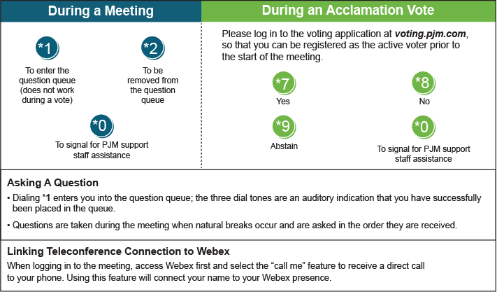

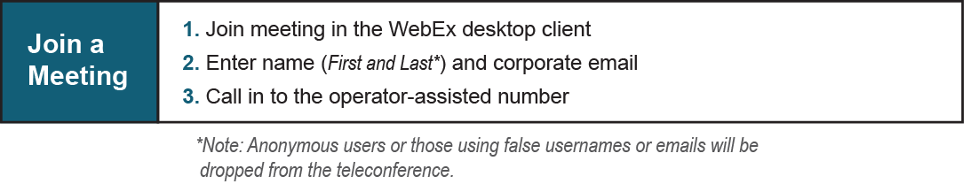

Provide feedback on the progress of this group: [*Facilitator Feedback Form*](https://www.pjm.com/committees-and-groups/committees/form-facilitator-feedback.aspx)   
Visit [*learn.pjm.com*](https://learn.pjm.com/), an easy-to-understand resource about the power industry and PJM’s role.