Market Implementation Committee
WebEx Only
September 2 2020
9:00 a.m. – 4:00 p.m. EPT

Administration (9:00-9:05)
Bhavana Keshavamurthy will review the Antitrust, Code of Conduct, Public Meetings/Media Participation and the WebEx Participant Identification Requirements.

The Committee will be asked to approve the draft minutes from the August 5, 2020 Market Implementation Committee meeting.

The Committee will be asked to approve the draft minutes from the August 14, 2020 Special Session of the Market Implementation Committee - Reserve Price Formation Order meeting.

Endorsements/Approvals (9:05 – 10:00)
- Market Suspension (9:05 – 9:25)
Stefan Starkov will review updates to the Problem Statement and Issue Charge addressing opportunities to develop enhanced business rules surrounding the event of a market suspension. The committee will be asked to approve the issue charge at this meeting.

- Stability Limits in Markets and Operations (9:25 – 10:00)
- Joe Ciabattoni will review the Capacity Constraint proposal.
- Paul Sotkiewicz, on behalf of JPower, will review the Opportunity Cost proposal.
The committee will be asked to vote on these proposals at this meeting. If any of the packages receives greater than 50%, a second non-binding vote will be taken asking whether participants prefer that package over the status quo.

Issue Tracking: Stability Limits in Markets and Operations

First Readings (10:00 - 10:55)
- Behind the Meter Generation (10:00 – 10:20)
Terri Esterly will provide a first read of the Problem Statement and Issue Charge addressing clarifications to the Behind the Meter Generation business rules related to a BTMG unit changing status from BTMG (netting against the load) to a resource participating in PJM Markets (and vice versa). The committee will be asked to approve the problem statement and issue charge at the October MIC meeting.

- Biennial Review of Manual 15 (10:20 – 10:40)
Gabrielle Genuario and Roger Cao will review updates to Manual 15 as part of the Biennial Review.

- Manual 18 Updates (10:40 – 10:55)
Jeff Bastian will provide a first read of the Problem Statement and Issue Charge addressing a minor correction to Manual 18 with regards to an effective date for notifying pseudo-tied resource owners of their assigned LDA prior to each delivery year.
The committee will be asked to approve the issue charge and endorse the proposed revisions to Manual 18 as part of the Quick Fix process outlined in Section 8.6.1 of Manual 34 at its next meeting.

Working Item (10:55 - 11:25)
- PRD Credits Disposition (10:55 – 11:25)
Pete Langbein will provide education on the history of Price Responsive Demand (PRD), the evolution of the PRD market rules, and PRD settlements.

Additional Items (11:25 - 12:30)
- 2021 PJM Project Budget (11:25 – 11:35)
Jim Snow will provide an overview of the preliminary 2021 PJM project budget.
- nGEM Project Update (11:35 – 11:45)
Todd Keech will provide an update on the Next Generation Energy Markets (nGEM) markets software replacement project.

- Long-Term 5-Minute Dispatch & Pricing Work Plan (11:45 – 12:00)
Aaron Baizman will provide an update on the work plan to address the Long-Term 5-Minute Dispatch & Pricing effort.

- Catty Corner RAS Retirement (12:00 – 12:05)
Chris Szmodis (PPL) will review the retirement of the Susquehanna Catty Corner Remedial Action Scheme (RAS).

- Capacity Capability Senior Task Force Update (12:05 – 12:20)
Andrew Levitt will provide an overview on the ELCC data submission requirements and applicable deadlines by delivery year for intermittent and limited duration resources.

- Schedule 9-2 Options (12:20 – 12:30)
Jim Snow will provide an overview of Finance Committee discussions regarding the collection of Schedule 9-2 charges.

Informational Section
Interface Pricing Points Update
This presentation provides an overview of updates being made to Interface Pricing Points. Materials are posted as informational only.

Interregional Coordination Update
Materials are posted as informational only.
Credit Subcommittee (CS)
Meeting materials will be posted to the CS website.

Demand Response Subcommittee (DRS)
Meeting materials will be posted to the DRS website.

DER & Inverter-based Resources Subcommittee (DIRS)
Meeting materials will be posted to the DIRS website.

Market Settlements Subcommittee (MSS)
Meeting materials are posted to the MSS website.

Report on Market Operations
The Report on Market Operations will be reviewed during the MC Webinar.

Future Meeting Dates
October 7, 2020 | 9:00 a.m. | WebEx
November 5, 2020 | 9:00 a.m. | WebEx
December 2, 2020 | 9:00 a.m. | WebEx

Author: Nick DiSciullo

Antitrust:
You may not discuss any topics that violate, or that might appear to violate, the antitrust laws including but not limited to agreements between or among competitors regarding prices, bid and offer practices, availability of service, product design, terms of sale, division of markets, allocation of customers or any other activity that might unreasonably restrain competition. If any of these items are discussed the chair will re-direct the conversation. If the conversation still persists, parties will be asked to leave the meeting or the meeting will be adjourned.

Code of Conduct:
As a mandatory condition of attendance at today's meeting, attendees agree to adhere to the PJM Code of Conduct as detailed in PJM Manual M-34 section 4.5, including, but not limited to, participants' responsibilities and rules regarding the dissemination of meeting discussion and materials.

Public Meetings/Media Participation:
Unless otherwise noted, PJM stakeholder meetings are open to the public and to members of the media. Members of the media are asked to announce their attendance at all PJM stakeholder meetings at the beginning of the meeting or at the point they join a meeting already in progress. Members of the Media are reminded that speakers at PJM meetings cannot be quoted without explicit permission from the speaker. PJM Members are reminded that "detailed transcriptional meeting notes" and white board notes from "brainstorming sessions" shall not be disseminated. Stakeholders are also not allowed to create audio, video or online recordings of PJM meetings. PJM may create audio, video or online recordings of stakeholder meetings for internal and training purposes, and your participation at such meetings indicates your consent to the same.
Participant Identification in WebEx:
When logging into the WebEx desktop client, please enter your real first and last name as well as a valid email address. Be sure to select the “call me” option.
PJM support staff continuously monitors WebEx connections during stakeholder meetings. Anonymous users or those using false usernames or emails will be dropped from the teleconference.
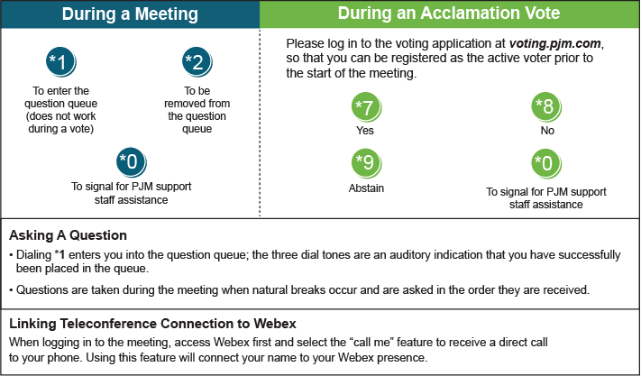

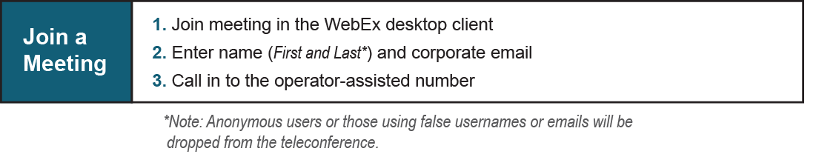
Provide feedback on the progress of this group: Facilitator Feedback Form
Visit learn.pjm.com, an easy-to-understand resource about the power industry and PJM’s role.

