Market Implementation Committee
PJM Conference & Training Center, Audubon, PA
November 13, 2019
9:00 a.m. – 4:00 p.m. EPT

Administration (9:00-9:15)
Ms. Bhavana Keshavamurthy will provide announcements; review the Antitrust, Code of Conduct, Public Meetings/Media Participation, the WebEx Participant Identification Requirement, and Issue Tracking.

The Committee will be asked to approve the draft minutes from the October 16, 2019 Market Implementation Committee meeting.

Endorsements/Approvals (9:15-9:45)
- Manual 18 Revisions Related to the RPM Must-Offer Exception Process (9:15-9:30)
Mr. Pat Bruno, PJM, will review conforming revisions to Manual 18: PJM Capacity Market related to the recent FERC Order (ER19-2417) on RPM must-offer exceptions and removal of Capacity Resource status.
The committee will be asked to endorse the manual revisions.

- Manual 15 Revisions Related to VOM Compliance Filing (9:30-9:45)
Mr. Thomas Hauske, PJM, will review conforming revisions to Manual 15: Cost Development Guidelines consistent with the May 10, 2019 VOM Compliance Filing that was recently accepted by FERC.
The committee will be asked to endorse the manual revisions.

First Readings (9:45-11:00)
- Manual 27 Revisions Related to Annual Calculation of the Border Rate (9:45-10:00)
Mr. Ray Fernandez, PJM, will provide a first read on revisions to Manual 27: Open Access Transmission Tariff Accounting addressing the implementation of the annual calculation of the Border Rate and the impact on firm point-to-point transmission service charges.

- Fuel Cost Policy (10:00-11:00)
Ms.Bhavana Keshavamurthy, PJM, will provide a summary of four packages for the first read from the MIC Special Sessions: Fuel Cost Policy.
        - Mr. Joel Luna, Monitoring Analytics, will present the IMM proposal.
        - A stakeholder representative will present the joint stakeholder proposal.
        - Ms. Melissa Pilong, PJM, will present the PJM primary and the PJM alternate proposal.
Issue Tracking: Fuel Cost Policy

Working Items (11:00-11:55)
- Stability Limits in Markets and Operations (11:00-11:45)
        - Mr. Keyur Patel, PJM, will provide education on impact of clearing of virtual bids on units with stability limitations.
        - Ms.Lisa Morelli, PJM, will lead a discussion to gather interests from the group and begin identifying design components. Interests can be provided in advance of the meeting or during the meeting.
Issue Tracking: Stability Limits in Markets and Operations

- Fuel Requirements for Black Start Resources (11:45-11:55)
Ms.Janell Fabiano, PJM, will provide a status update on the Fuel Requirements for Black Start Resources issue.
Issue Tracking: Fuel Requirements for Black Start Resources

Additional Updates (11:55-12:00)
- Member Maintenance and Account Manager update (11:55-12:00)
Ms. Amanda Egan, PJM, will provide an update on the Membership Management Community, as well as provide information on Account Manager (CAM) roles, responsibilities and requirements and the provisioning of tool access.

Lunch (12:00-1:00)

Informational Section
Review of Operational Events
Materials are posted as informational only. This report will be discussed during the Operating Committee (OC) meeting on November 12, 2019. Stakeholders interested in this discussion should register for the OC meeting at https://pjm.com/committees-and-groups/committees/oc.aspx.

Q32019 Net Energy Injections Quarterly Report
Materials are posted as informational only.

CP Unit Specific Parameter Update
Materials are posted as informational only.

Interregional Coordination Update
Materials are posted as informational only.

Credit Subcommittee (CS)
Meeting materials will be posted to the CS website.

Demand Response Subcommittee (DRS)
Meeting materials will be posted to the DRS web site.

Intermittent Resources Subcommittee (IRS)
Meeting materials will be posted to the IRS web site.

Market Settlements Subcommittee (MSS)
Meeting materials are posted to the MSS web site.

Report on Market Operations
The Report on Market Operations will be reviewed during the MC Webinar.

Future Meeting Dates
December 11, 2019 | 9:00 a.m. | PJM Conference & Training Center/ WebEx

Author: Bhavana Keshavamurthy

Antitrust:
You may not discuss any topics that violate, or that might appear to violate, the antitrust laws including but not limited to agreements between or among competitors regarding prices, bid and offer practices, availability of service, product design, terms of sale, division of markets, allocation of customers or any other activity that might unreasonably restrain competition. If any of these items are discussed the chair will re-direct the conversation. If the conversation still persists, parties will be asked to leave the meeting or the meeting will be adjourned.

Code of Conduct:
As a mandatory condition of attendance at today's meeting, attendees agree to adhere to the PJM Code of Conduct as detailed in PJM Manual M-34 section 4.5, including, but not limited to, participants' responsibilities and rules regarding the dissemination of meeting discussion and materials.

Public Meetings/Media Participation:
Unless otherwise noted, PJM stakeholder meetings are open to the public and to members of the media. Members of the media are asked to announce their attendance at all PJM stakeholder meetings at the beginning of the meeting or at the point they join a meeting already in progress. Members of the Media are reminded that speakers at PJM meetings cannot be quoted without explicit permission from the speaker. PJM Members are reminded that "detailed transcriptional meeting notes" and white board notes from "brainstorming sessions" shall not be disseminated. Stakeholders are also not allowed to create audio, video or online recordings of PJM meetings. PJM may create audio, video or online recordings of stakeholder meetings for internal and training purposes, and your participation at such meetings indicates your consent to the same.

Participant Identification in WebEx:
When logging into the WebEx desktop client, please enter your real first and last name as well as a valid email address. Be sure to select the “call me” option.
PJM support staff continuously monitors WebEx connections during stakeholder meetings. Anonymous users or those using false usernames or emails will be dropped from the teleconference.

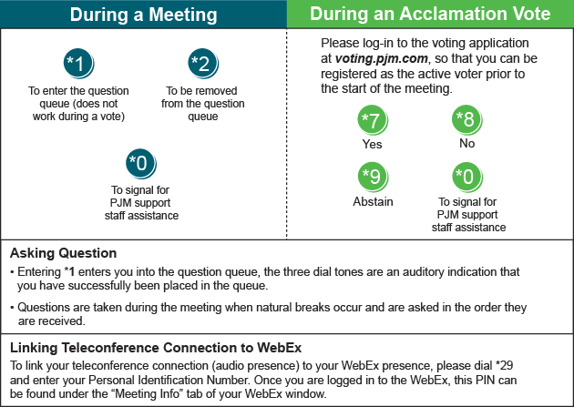

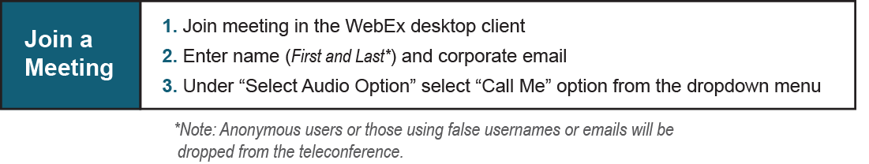

Provide feedback on the progress of this group: Facilitator Feedback Form
Visit learn.pjm.com, an easy-to-understand resource about the power industry and PJM’s role.

