Market Implementation Committee
PJM Conference & Training Center, Audubon, PA
June 12, 2019
9:00 a.m. – 12:15 p.m. EPT

Administration (9:00-9:15)
Ms. Bhavana Keshavamurthy and Ms. Chantal Hendrzak will provide announcements; review the Antitrust, Code of Conduct, Public Meetings/Media Participation, the WebEx Participant Identification Requirement, and Issue Tracking.

The Committee will be asked to approve the draft minutes from the May 15, 2019 MIC meeting.

Ms. Jennifer Tribulski, PJM, will provide an update on the recent FERC clarification order in the FTR waiver proceeding.

Endorsements/Approvals (9:15-9:30)
- Five Minute Dispatch and Pricing (9:15-9:30)
Mr. Siva Josyula, Monitoring Analytics, will present the problem statement and issue charge related to Five Minute Dispatch and Pricing.
The committee will be asked to approve the Issue Charge.

First Readings (9:30-11:20)
- Periodic Review of Manual 18 (9:30-9:45)
Ms. Terri Esterly, PJM, will provide a first read of Manual 18 revisions as part of the periodic review.

- Periodic Review of Manual 28 (9:45-10:00)
Mr. Ray Fernandez, PJM, will provide a first read of Manual 28 revisions as part of the periodic review.

- Manual 11, 15, and 18 revisions for Electric Storage Participation – FERC Order 841 (10:00-11:00)
        - Ms. Laura Walter, PJM, will provide a brief background on Order 841, and review changes to Manual 11 – Energy & Ancillary Services Market Operations & Manual 18 – PJM Capacity Market, related to the FERC Order 841 compliance filing.
        - Ms. Danielle Croop, PJM, will provide a review of Manual 15 – Cost Development Guidelines changes related to cost offers for batteries and flywheels.
Issue Tracking: Electric Storage Participation FERC Order 841

- Modeling Units with Stability Limitations – Problem Statement & Issue Charge (11:00-11:20)
Mr. Robert O’Connell, Panda Power Funds, will provide a first read of a problem statement and issue charge related to modeling units with stability limitations.

Working Issues (11:20-12:00)
- Fast Start Pricing Order (11:20-11:40)
Mr. Keyur Patel, PJM, will review updates on the fast start pricing implementation.

- Interregional Incremental Auction Revenue Rights (11:40-12:00)
Mr. Brian Chmielewski, PJM, will provide education on Interregional Incremental Auction Revenue Rights (IARR).
Issue Tracking: Interregional Incremental Auction Revenue Rights

Additional Items (12:00-12:15)
- Fuel Cost Policy Annual Review (12:00-12:15)
Ms. Melissa Pilong, PJM, will provide an overview of the Fuel Cost Policy deadlines for the upcoming annual review.

Lunch (12:15-1:00)

Informational Section
Credit Subcommittee (CS)
Meeting materials will be posted to the CS website.

Demand Response Subcommittee (DRS)
Meeting materials will be posted to the DRS web site.

Intermittent Resources Subcommittee (IRS)
Meeting materials will be posted to the IRS web site.

Interregional Coordination Update
Materials are posted as informational only.

Market Settlements Subcommittee (MSS)
Meeting materials are posted to the MSS web site.

Report on Market Operations
The Report on Market Operations will be reviewed during the MC Webinar.

Future Meeting Dates
July 10, 2019 | 9:00 a.m. | PJM Conference & Training Center/ WebEx
August 7, 2019 | 9:00 a.m. | PJM Conference & Training Center/ WebEx
September 11, 2019 | 9:00 a.m. | PJM Conference & Training Center/ WebEx
October 16, 2019 | 9:00 a.m. | PJM Conference & Training Center/ WebEx
November 13, 2019 | 9:00 a.m. | PJM Conference & Training Center/ WebEx
December 11, 2019 | 9:00 a.m. | PJM Conference & Training Center/ WebEx

Author: Bhavana Keshavamurthy

Antitrust:
You may not discuss any topics that violate, or that might appear to violate, the antitrust laws including but not limited to agreements between or among competitors regarding prices, bid and offer practices, availability of service, product design, terms of sale, division of markets, allocation of customers or any other activity that might unreasonably restrain competition. If any of these items are discussed the chair will re-direct the conversation. If the conversation still persists, parties will be asked to leave the meeting or the meeting will be adjourned.

Code of Conduct:
As a mandatory condition of attendance at today's meeting, attendees agree to adhere to the PJM Code of Conduct as detailed in PJM Manual M-34 section 4.5, including, but not limited to, participants' responsibilities and rules regarding the dissemination of meeting discussion and materials.

Public Meetings/Media Participation:
Unless otherwise noted, PJM stakeholder meetings are open to the public and to members of the media. Members of the media are asked to announce their attendance at all PJM stakeholder meetings at the beginning of the meeting or at the point they join a meeting already in progress. Members of the Media are reminded that speakers at PJM meetings cannot be quoted without explicit permission from the speaker. PJM Members are reminded that "detailed transcriptional meeting notes" and white board notes from "brainstorming sessions" shall not be disseminated. Stakeholders are also not allowed to create audio, video or online recordings of PJM meetings. PJM may create audio, video or online recordings of stakeholder meetings for internal and training purposes, and your participation at such meetings indicates your consent to the same.

Participant Identification in WebEx:
When logging into the WebEx desktop client, please enter your real first and last name as well as a valid email address. Be sure to select the “call me” option.
PJM support staff continuously monitors WebEx connections during stakeholder meetings. Anonymous users or those using false usernames or emails will be dropped from the teleconference.

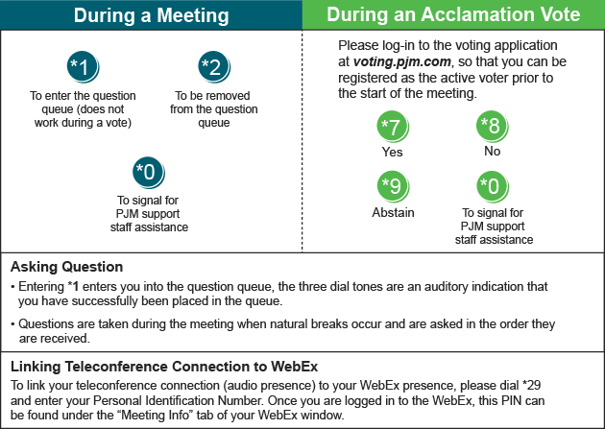

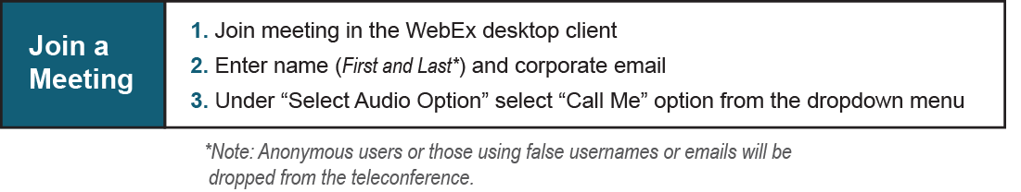

Provide feedback on the progress of this group: Facilitator Feedback Form
Visit learn.pjm.com, an easy-to-understand resource about the power industry and PJM’s role.

