Market Implementation Committee
PJM Conference & Training Center, Audubon, PA
August 8, 2018
9:00 a.m. – 3:00 p.m. EPT

Administration (9:00-9:45)
Ms. Bhavana Keshavamurthy and Ms. Chantal Hendrzak will provide announcements; review the Antitrust, Code of Conduct, Public Meetings/Media Participation, the WebEx Participant Identification Requirement, and Issue Tracking.

The Committee will be asked to approve the draft minutes from the July 11, 2018 MIC meeting.

- Ms.Suzanne Daugherty, PJM, will provide an update on FTR Default, Credit Policy Enhancements and Liquidation Process.
- Mr.Adam Keech, PJM, will provide an update on an issue causing regulation market clearing price spikes.

Endorsements/Approvals (9:45-11:00)
- Market Seller Offer Cap Balancing Ratio Proposal (9:45-10:30)
        - Mr. Pat Bruno, PJM, will present Proposal A.
        - Mr. Pat Bruno, PJM, will present Proposal B.
        - Ms. Sharon Midgley, Exelon, will present the Exelon proposal.
        - Mr. David Scarpignato, Calpine, will present the Calpine proposal.
        - Joe Bowring, Monitoring Analytics, will review IMM’s comments on the issue.
The Committee will be asked to endorse a proposal(s).
Issue Tracking: Balancing Ratio Determination

- Quadrennial Review (10:30-11:00)
Mr. Jeff Bastian, PJM, will review package polling results from the survey sent on July 31.
The Committee will be asked to endorse a proposal(s).
Issue Tracking: Quadrennial Review

First Readings (11:00-1:30)
- Fuel Cost Policy- Problem Statement & Issue Charge (11:00-11:30)
Mr. John Rohrbach, ACES Power, on behalf of SMECO, ODEC and PPGI will present a problem statement and issue charge to address enhancements to the Fuel Cost Policy rules and process. The committee will be asked to approve the problem statement and issue charge at the next MIC.

- RPM Credit Requirement Reduction Clarifications (11:30-11:45)
Mr. Hal Loomis, PJM, will present draft tariff language to remove an apparent overlapping credit reduction provision for Qualified Transmission Upgrades, to clarify milestone documentation requirements for internally financed projects, and to clarify that Capacity Market Sellers should submit requests for reductions.

- Transmission Constraint Penalty Factor (11:45-12:00)
Mr. Angelo Marcino, PJM, will provide a first read of the joint PJM/IMM package developed at the Special MIC sessions related to Transmission Constraint Penalty Factors.
Issue Tracking: Transmission Penalty Factor

Lunch (12:00-1:00)

- FERC Order 831 – Offer Caps (1:00-1:15)
Ms. Susan Kenney, PJM, will present draft manual language that describes the long term automated process for Price-Based Offers greater than $1,000/MWh.

- Biennial Review of Manual 15 (1:15-1:30)
Ms. Gabrielle Genuario, PJM, will review updates to Manual 15 as part of the Biennial Review.

Working Issues (1:30-2:30)
- Must Offer Exception Process(1:30-2:00)
Mr. Pat Bruno, PJM, will review the Must Offer Exception Process issue and stakeholder feedback to include additional options and packages for consideration will be requested.
Issue Tracking: Must Offer Exemption Process

- FTR Forfeiture Rule (2:00-2:30)
Mr. Brian Chmielewski, PJM, will present follow up education on the FTR Forfeiture rule. An updated FTR Forfeiture Rule Matrix has been posted and members are encouraged to review and provide additional interests and design components to FTRGroup@pjm.com.
Issue Tracking: FTR Forfeiture Rule Changes

Additional Items(2:30-3:00)
- FERC Order 844: Uplift Cost Allocation and Transparency (2:30-2:45)
Mr. Rami Dirani, PJM, will present Operating Agreement language for compliance with FERC Order 844. Issue Tracking: Market Operations Price Transparency

- CP Unit Specific Parameter Update(2:45-3:00)
Ms. Lauren Strella, PJM, will provide an update on the CP Unit Specific Parameter process for the Delivery Year 2019/2020 and the soak time parameter integration.

Informational Section
Membership Management Community: Contact Management update
PJM’s new Contact Management feature in the Membership Management Community is scheduled to be released in late August. Access to the new feature will be provided to Contact Managers for each member. As a reminder, Contact Managers can use the new feature to review and provide contacts for certain member level roles that have been identified by PJM. Additional information, including instructions for accessing and using the tool, will be presented at the August Tech Change Forum and provided to Contact Managers via email. An update will also be provided at September committee meetings. For more information on this community or the Contact Management feature, please contact membershipforms@pjm.com.

Credit Subcommittee (CS)
Meeting materials will be posted to the CS website.

Demand Response Subcommittee (DRS)
Meeting materials will be posted to the DRS web site.

Intermittent Resources Subcommittee (IRS)
Meeting materials will be posted to the IRS web site.

Interregional Coordination Update
Materials are posted as informational only.

Market Settlements Subcommittee (MSS)
Meeting materials are posted to the MSS web site.

Report on Market Operations
The Report on Market Operations will be reviewed during the MC Webinar.

Future Meeting Dates
September 12, 2018 | 9:00 a.m. | PJM Conference & Training Center/ WebEx
October 10, 2018 | 9:00 a.m. | PJM Conference & Training Center/ WebEx
November 7, 2018 | 9:00 a.m. | PJM Conference & Training Center/ WebEx
December 12, 2018 | 9:00 a.m. | PJM Conference & Training Center/ WebEx

Author: Bhavana Keshavamurthy

Antitrust:
You may not discuss any topics that violate, or that might appear to violate, the antitrust laws including but not limited to agreements between or among competitors regarding prices, bid and offer practices, availability of service, product design, terms of sale, division of markets, allocation of customers or any other activity that might unreasonably restrain competition. If any of these items are discussed the chair will re-direct the conversation. If the conversation still persists, parties will be asked to leave the meeting or the meeting will be adjourned.

Code of Conduct:
As a mandatory condition of attendance at today's meeting, attendees agree to adhere to the PJM Code of Conduct as detailed in PJM Manual M-34 section 4.5, including, but not limited to, participants' responsibilities and rules regarding the dissemination of meeting discussion and materials.

Public Meetings/Media Participation:
Unless otherwise noted, PJM stakeholder meetings are open to the public and to members of the media. Members of the media are asked to announce their attendance at all PJM stakeholder meetings at the beginning of the meeting or at the point they join a meeting already in progress. Members of the Media are reminded that speakers at PJM meetings cannot be quoted without explicit permission from the speaker. PJM Members are reminded that "detailed transcriptional meeting notes" and white board notes from "brainstorming sessions" shall not be disseminated. Stakeholders are also not allowed to create audio, video or online recordings of PJM meetings. PJM may create audio, video or online recordings of stakeholder meetings for internal and training purposes, and your participation at such meetings indicates your consent to the same.

Participant Identification in WebEx:
When logging into the WebEx desktop client, please enter your real first and last name as well as a valid email address. Be sure to select the “call me” option.
PJM support staff continuously monitors WebEx connections during stakeholder meetings. Anonymous users or those using false usernames or emails will be dropped from the teleconference.

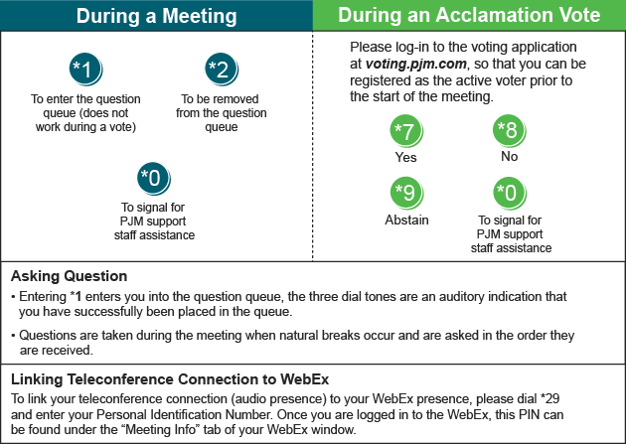

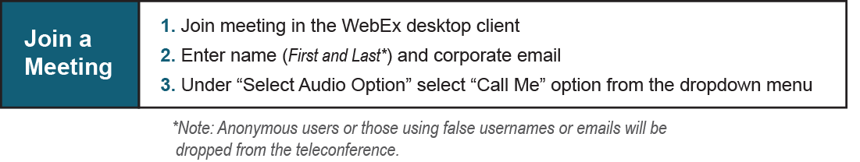

Provide feedback on the progress of this group: Facilitator Feedback Form
Visit learn.pjm.com, an easy-to-understand resource about the power industry and PJM’s role.

