Market Implementation Committee
PJM Conference & Training Center, Audubon, PA
January 10, 2018
9:00 a.m. – 4:00 p.m. EPT

Administration (9:00-9:30)
Ms. Christina Stotesbury and Ms. Chantal Hendrzak will provide announcements, review the Antitrust, Code of Conduct, and Public Meetings/Media Participation Guidelines, and Issue Tracking.

The committee will be asked to approve the draft minutes from the December 13, 2017 Market Implementation Committee meeting.

- Administrative Updates:
A. Mr. Tim Horger, PJM, will provide an update on the FERC’s action to withdrawal its proposal [NOPR RM17-3-000] to amend its regulations to require that each RTO/ISO incorporate market rules to meet certain requirements when pricing fast-start resources.
B. Mr. Horger will also provide an update on the recent notification and recall of Day-Ahead Market LMP re-posting.

Endorsements/Approvals (9:30-10:05)
- FTR Nodal Remapping - Problem Statement & Issue Charge (9:30-9:45)
Mr. Brian Chmielewski, PJM, will review a problem statement and issue charge to address FTR nodal remapping. The committee will be asked to approve the problem statement and issue charge.

- RERRA Review of Energy Efficiency Participation (9:45-10:05)
Mr. Pete Langbein, PJM, will review the Demand Response Subcommittee proposal for the RERRA review of Energy Efficiency resource participation in the Capacity Market. The committee will be asked to endorse the proposal and governing document language.

First Readings (10:05-11:45)
- Revisions to Manual 11: Energy & Ancillary Services Market Operations (10:05-10:20)
Mr. Rami Dirani, PJM, will present a first read of conforming revisions to Manual 11: Energy & Ancillary Services Market Operations to clarify the Energy Offer Verification process. The committee will be asked to endorse the manual 11 revisions at the February meeting.

- Revisions to Manual 12: Balancing Operations (10:20-10:40)
Ms. Nicole Militello, PJM, will present a first read of revisions to Manual 12: Balancing Operations. The committee will be asked to endorse the manual 12 revisions at the February meeting.

- Tariff Revisions to address Overlapping Congestion (10:40-11:00)
Ms. Nicole Militello, PJM, will present a first read of revisions to the PJM Tariff to address overlapping congestion. The committee will be asked to endorse the Tariff revisions at the February meeting.

Break (11:00-11:10)

- Market Path/Interface Pricing Point Alignment (11:10-11:45)
Mr. Tim Horger, PJM, will present a first read of updated proposals to address the Market Path/Interface Pricing Point Alignment issue. The committee will be asked to endorse a proposal at the February MIC meeting.

Working Issues (11:45-12:15)
- Long Term FTR Issue Education (11:45-12:15)
Education will be presented on the Long Term FTR problem statement and issue charge that was approved at the October 11, 2017 MIC meeting.
Lunch (12:15-1:15)

Additional Updates (1:15-2:45)
- Cold Weather Operations (1:15-1:45)
Mr. Joe Ciabattoni, PJM, will provide a summary of operations during the extreme cold weather recently experienced in the PJM region.

- Operationalizing Gas Pipeline Contingencies (1:45-2:15)
Mr. Rich Brown, PJM, will review a draft problem statement and issue charge to address costs associated with the operationalizing gas pipeline contingencies initiative. Stakeholders will be given an opportunity to provide feedback before the problem statement and issue charge are presented for a first read, and possible endorsement, at the January 25 MRC meeting.

- Interregional Coordination Update (2:15-2:30)
Mr. Tim Horger, PJM, will provide an update on interregional coordination activities.

- RTO Wide Black Start RFP Update (2:30-2:45)
Mr. Vincent Stefanowicz, PJM, will provide an update on the Black Start RFP process that impacts operational requirements and compensation for black start generators.

Informational Section
Credit Subcommittee (CS)
Meeting materials will be posted to the CS website.

Demand Response Subcommittee (DRS)
Meeting materials will be posted to the DRS web site.
Intermittent Resources Subcommittee (IRS)
Meeting materials will be posted to the IRS web site.

Market Settlements Subcommittee (MSS)
Meeting materials are posted to the MSS web site.

Report on Market Operations
The Report on Market Operations will be reviewed during the MC Webinar.

Revisions to Manual 02: Transmission Service Request (1:30-1:45)
Manual 02: Transmission Service Request revisions are posted as informational-only. Mr. Jeff McLaughlin, PJM, will be available at the MIC to answer questions. These revisions will be presented at the Planning Committee for endorsement on January 11, 2018.

Future Meeting Dates
February 7, 2018 | 9:00 a.m. | PJM Conference & Training Center/ WebEx
March 7, 2018 | 9:00 a.m. | PJM Conference & Training Center/ WebEx
April 4, 2018 | 9:00 a.m. | PJM Conference & Training Center/ WebEx
May 2, 2018 | 9:00 a.m. | PJM Conference & Training Center/ WebEx
June 6, 2018 | 9:00 a.m. | PJM Conference & Training Center/ WebEx
July 11, 2018 | 9:00 a.m. | PJM Conference & Training Center/ WebEx
August 8, 2018 | 9:00 a.m. | PJM Conference & Training Center/ WebEx
September 12, 2018 | 9:00 a.m. | PJM Conference & Training Center/ WebEx
October 10, 2018 | 9:00 a.m. | PJM Conference & Training Center/ WebEx
November 7, 2018 | 9:00 a.m. | PJM Conference & Training Center/ WebEx
December 12, 2018 | 9:00 a.m. | PJM Conference & Training Center/ WebEx

Author: Christina Stotesbury

Antitrust:
You may not discuss any topics that violate, or that might appear to violate, the antitrust laws including but not limited to agreements between or among competitors regarding prices, bid and offer practices, availability of service, product design, terms of sale, division of markets, allocation of customers or any other activity that might unreasonably restrain competition. If any of these items are discussed the chair will re-direct the conversation. If the conversation still persists, parties will be asked to leave the meeting or the meeting will be adjourned.

Code of Conduct:
As a mandatory condition of attendance at today's meeting, attendees agree to adhere to the PJM Code of Conduct as detailed in PJM Manual M-34 section 4.5, including, but not limited to, participants' responsibilities and rules regarding the dissemination of meeting discussion and materials.

Public Meetings/Media Participation:
Unless otherwise noted, PJM stakeholder meetings are open to the public and to members of the media. Members of the media are asked to announce their attendance at all PJM stakeholder meetings at the beginning of the meeting or at the point they join a meeting already in progress. Members of the Media are reminded that speakers at PJM meetings cannot be quoted without explicit permission from the speaker. PJM Members are reminded that "detailed transcriptional meeting notes" and white board notes from "brainstorming sessions" shall not be disseminated. Stakeholders are also not allowed to create audio, video or online recordings of PJM meetings. PJM may create audio, video or online recordings of stakeholder meetings for internal and training purposes, and your participation at such meetings indicates your consent to the same.

Participant Identification in WebEx:
When logging into the WebEx desktop client, please enter your real first and last name as well as a valid email address. Be sure to select the “call me” option.
PJM support staff continuously monitors WebEx connections during stakeholder meetings. Anonymous users or those using false usernames or emails will be dropped from the teleconference.

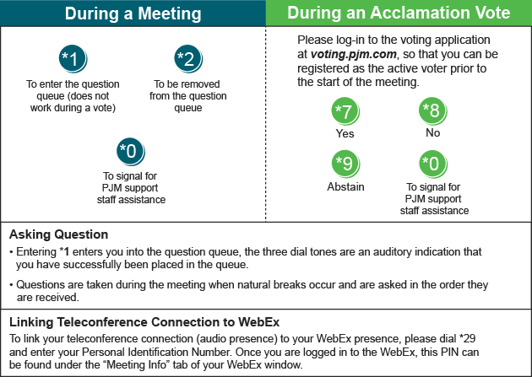

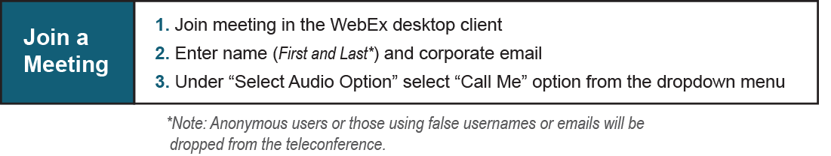

Provide feedback on the progress of this group: Facilitator Feedback Form
Visit learn.pjm.com, an easy-to-understand resource about the power industry and PJM’s role.

