Members Committee – Stakeholder Process Super Forum
PJM Conference and Training Center
April 4, 2019
1:00 p.m. – 4:00 p.m. EPT

Administration (1:00-1:05)
Ms. Christina Stotesbury, PJM, will provide announcements and review the PJM Meeting Guidelines.

Work Plan (1:05-1:15)
- Ms. Becky Carroll, PJM, will review the Stakeholder Process Super Forum work plan.

Stakeholder Education (1:15-2:00)
- Ms. Janell Fabiano, PJM, will provide information associated with stakeholder issues that resulted in no consensus at the MRC and MC.
- Ms. Michele Greening, PJM, will summarize stakeholder issues that were endorsed during the first read at the MRC and MC.
- Ms. Megan McLaverty, PJM, will present sector attendance voting results.
- Ms. Sheila Foley, PJM, will speak to scheduling logistics in the Conference and Training Center.
Break (2:00 -2:15)

Matrix (2:15-4:00)
- Stakeholders will be asked to provide packages and additional solution options for the three key work activities listed in the issue charge.
  - Prioritization of issues to allow stakeholders to manage the volume of issues under consideration and the volume of meetings
  - Develop an additional pathway for vetting issues that are contentious or must be decided quickly.
  - Enhance transparency throughout the PJM stakeholder process and decisional hierarchy.

Future Agenda Items

Future Meeting Dates
May 22, 2019 | 9:00 a.m. – 4:00 p.m. | PJM Conference & Training Center/ WebEx
June 19, 2019 | 9:00 a.m. – 4:00 p.m. | PJM Conference & Training Center/ WebEx

Author: Christina Stotesbury

Antitrust:
You may not discuss any topics that violate, or that might appear to violate, the antitrust laws including but not limited to agreements between or among competitors regarding prices, bid and offer practices, availability of service, product design, terms of sale, division of markets, allocation of customers or any other activity that might unreasonably restrain competition. If any of these items are discussed the chair will re-direct the conversation. If the conversation still persists, parties will be asked to leave the meeting or the meeting will be adjourned.

Code of Conduct:
As a mandatory condition of attendance at today's meeting, attendees agree to adhere to the PJM Code of Conduct as detailed in PJM Manual M-34 section 4.5, including, but not limited to, participants' responsibilities and rules regarding the dissemination of meeting discussion and materials.

Public Meetings/Media Participation:
Unless otherwise noted, PJM stakeholder meetings are open to the public and to members of the media. Members of the media are asked to announce their attendance at all PJM stakeholder meetings at the beginning of the meeting or at the point they join a meeting already in progress. Members of the Media are reminded that speakers at PJM meetings cannot be quoted without explicit permission from the speaker. PJM Members are reminded that "detailed transcriptional meeting notes" and white board notes from "brainstorming sessions" shall not be disseminated. Stakeholders are also not allowed to create audio, video or online recordings of PJM meetings. PJM may create audio, video or online recordings of stakeholder meetings for internal and training purposes, and your participation at such meetings indicates your consent to the same.
Participant Identification in WebEx:
When logging into the WebEx desktop client, please enter your real first and last name as well as a valid email address. Be sure to select the “call me” option.
PJM support staff continuously monitors WebEx connections during stakeholder meetings. Anonymous users or those using false usernames or emails will be dropped from the teleconference.



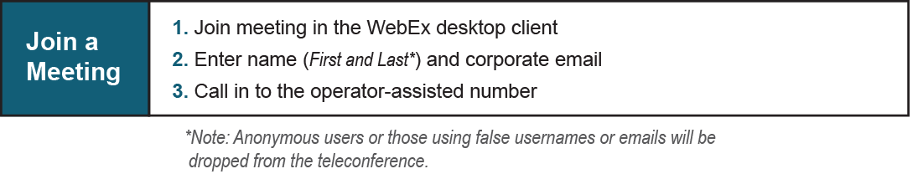

Provide feedback on the progress of this group: Facilitator Feedback Form
Visit learn.pjm.com, an easy-to-understand resource about the power industry and PJM’s role.

