Demand Response Subcommittee
PJM Conference and Training Center
September 25, 2018
9:30 a.m. – 11:55 p.m. EPT

Administration (9:30-9:40)
- Welcome, Announcements and Anti-trust and Code of Conduct announcement
- Roll call: in-person only
- Review prior minutes – 8/30/2018 meeting
- Request for any additional agenda items
- Brief update/discussion of DR related activity in other stakeholder groups – MIC, OC, PC, or other

(9:40 – 9:50) PRD timeline
- Mr. Pete Langbein will provide update on PRD measurement and verification endorsement timing. The overall timeline of SODRSTF proposal endorsement and PRD M&V endorsement are being coordinated.

(9:50 – 10:10) Order 844 (energy market uplift) reporting for DR resources
- Mr. Rami Dirani will provide an update on DR resource information that will be reported based on Order 844. This is a follow up to questions raised at last meeting.

(10:10 – 10:25 ) Summer 2018 5CP and Add Back process dates
- Mr. O’Neill will review the 2018 5CP and add back process dates.

(10:25 – 10:40) 2017/18 LM Report update
- Mr. Jack O’Neill will review the updated 2017/18 Load Management Performance Report. This report was updated for Extended Summer, CP and Annual resources that tested in October and May. All other information in the report remained the same.

(10:40 – 10:50) BREAK

(10:50 – 11:20) DR Hub update for October Production Release
- Mrs. Andrea Yeaton will provide an update for the DR Hub October release and follow up on questions raised as of the last meeting.

(11:20 – 11:30) Review DR Calendar posted on pjm.com
- Mr. James McAnany will review the new DR calendar that is posted on pjm.com. The calendar was requested based on member suggestions through the PJM Bright Ideas effort.

(11:30 – 11:40) 2 factor authentication reminder
- Mr. Foluso Afelumo will provide a reminder of the PJM tool 2 factor authentication.

Future Agenda Items
Participants will have the opportunity to request the addition of any new item(s) to the agenda of a future meeting.

Future Meeting Dates
Wednesday | 10/24/2018 | 9:30 am – 12:00 pm | PJM Conference & Training Center/ Webex
Friday | 11/16/2018 | 9:30 am – 4:00 pm | PJM Conference & Training Center/ Webex
Monday | 12/10/2018 | 9:30 am – 4:00 pm | PJM Conference & Training Center/ Webex

Author: Jack Thomas

Antitrust:
You may not discuss any topics that violate, or that might appear to violate, the antitrust laws including but not limited to agreements between or among competitors regarding prices, bid and offer practices, availability of service, product design, terms of sale, division of markets, allocation of customers or any other activity that might unreasonably restrain competition. If any of these items are discussed the chair will re-direct the conversation. If the conversation still persists, parties will be asked to leave the meeting or the meeting will be adjourned.

Code of Conduct:
As a mandatory condition of attendance at today's meeting, attendees agree to adhere to the PJM Code of Conduct as detailed in PJM Manual M-34 section 4.5, including, but not limited to, participants' responsibilities and rules regarding the dissemination of meeting discussion and materials.

Public Meetings/Media Participation:
Unless otherwise noted, PJM stakeholder meetings are open to the public and to members of the media. Members of the media are asked to announce their attendance at all PJM stakeholder meetings at the beginning of the meeting or at the point they join a meeting already in progress. Members of the Media are reminded that speakers at PJM meetings cannot be quoted without explicit permission from the speaker. PJM Members are reminded that "detailed transcriptional meeting notes" and white board notes from "brainstorming sessions" shall not be disseminated. Stakeholders are also not allowed to create audio, video or online recordings of PJM meetings.

Participant Identification in WebEx:
When logging into the WebEx desktop client, please enter your real first and last name as well as a valid email address. Be sure to select the “call me” option.
PJM support staff continuously monitors WebEx connections during stakeholder meetings. Anonymous users or those using false usernames or emails will be dropped from the teleconference.



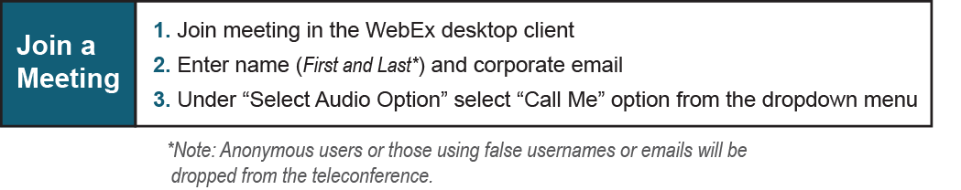

Provide feedback on the progress of this group: Facilitator Feedback Form
Visit learn.pjm.com an easy-to-understand resource about the power industry and PJM’s role.

