Transmission Expansion Advisory Committee
PJM Conference and Training Center
January 10, 2019
1:00 p.m. – 3:00 p.m. EPT (Actual start time will be dependent upon the completion of the Planning Committee meeting)

Administration (1:00-1:10)
- Welcome, announcements and review of the Anti-trust, Code of Conduct, and Media Participation Guidelines
- Review Transmission Expansion Advisory Committee (TEAC) Agenda for this meeting

RTEP Updates (1:10-3:00)
- Market Efficiency Update
Nick Dumitriu will provide an update on the 2018-2019 Long Term Market Efficiency Window and 2018 Re-evaluation analysis.

- Generator Deactivation Notification Update
Phil Yum will discuss analysis results from the most recently received Generation Deactivation notices and provide a summary of the deactivation statistics for 2018.
3. Dominion Supplemental Projects
Ronnie Bailey from Dominion will present needs and proposed solutions for their supplemental projects.
4. Reliability Analysis Update
Aaron Berner will provide an update of the 2018 RTEP analysis including an update on stability analysis. Next steps for the 2019 planning year will also be discussed.
- 2018 Project Statistics
Aaron Berner will review statistics on the number of baseline and supplemental projects identified in 2018.
- 2019 RTEP Assumptions
Aaron Berner will review the assumptions for the upcoming 2019 RTEP.

Informational Posting
- “Supplemental Projects for inclusion in 2018 RTEP” will be posted to the 1.10.2019 meeting materials.

Future Meeting Dates
January 10, 2019 | 1:00 p.m. Transmission Expansion Advisory Committee | PJM Conference & Training Center/ WebEx
February 7, 2019 | 1:00 p.m. Transmission Expansion Advisory Committee | PJM Conference & Training Center/ WebEx
March 7, 2019 | 1:00 p.m. Transmission Expansion Advisory Committee | PJM Conference & Training Center/ WebEx
April 11, 2019 | 1:00 p.m. Transmission Expansion Advisory Committee | PJM Conference & Training Center/ WebEx
May 16, 2019 | 1:00 p.m. Transmission Expansion Advisory Committee | PJM Conference & Training Center/ WebEx
June 13, 2019 | 1:00 p.m. Transmission Expansion Advisory Committee | PJM Conference & Training Center/ WebEx
July 11, 2019 | 1:00 p.m. Transmission Expansion Advisory Committee | PJM Conference & Training Center/ WebEx
August 8, 2019 | 1:00 p.m. Transmission Expansion Advisory Committee | PJM Conference & Training Center/ WebEx
September 12, 2019 | 1:00 p.m. Transmission Expansion Advisory Committee | PJM Conference & Training Center/ WebEx
October 17, 2019 | 1:00 p.m. Transmission Expansion Advisory Committee | PJM Conference & Training Center/ WebEx
November 14, 2019 | 1:00 p.m. Transmission Expansion Advisory Committee | PJM Conference & Training Center/ WebEx
December 12, 2019 | 1:00 p.m. Transmission Expansion Advisory Committee | PJM Conference & Training Center/ WebEx

Lisa Krizenoskas

Antitrust:
You may not discuss any topics that violate, or that might appear to violate, the antitrust laws including but not limited to agreements between or among competitors regarding prices, bid and offer practices, availability of service, product design, terms of sale, division of markets, allocation of customers or any other activity that might unreasonably restrain competition. If any of these items are discussed the chair will re-direct the conversation. If the conversation still persists, parties will be asked to leave the meeting or the meeting will be adjourned.

Code of Conduct:
As a mandatory condition of attendance at today's meeting, attendees agree to adhere to the PJM Code of Conduct as detailed in PJM Manual M-34 section 4.5, including, but not limited to, participants' responsibilities and rules regarding the dissemination of meeting discussion and materials.

Public Meetings/Media Participation:
Unless otherwise noted, PJM stakeholder meetings are open to the public and to members of the media. Members of the media are asked to announce their attendance at all PJM stakeholder meetings at the beginning of the meeting or at the point they join a meeting already in progress. Members of the Media are reminded that speakers at PJM meetings cannot be quoted without explicit permission from the speaker. PJM Members are reminded that "detailed transcriptional meeting notes" and white board notes from "brainstorming sessions" shall not be disseminated. Stakeholders are also not allowed to create audio, video or online recordings of PJM meetings. PJM may create audio, video or online recordings of stakeholder meetings for internal and training purposes, and your participation at such meetings indicates your consent to the same.
Participant Identification in WebEx:
When logging into the WebEx desktop client, please enter your real first and last name as well as a valid email address. Be sure to select the “call me” option.
PJM support staff continuously monitors WebEx connections during stakeholder meetings. Anonymous users or those using false usernames or emails will be dropped from the teleconference.



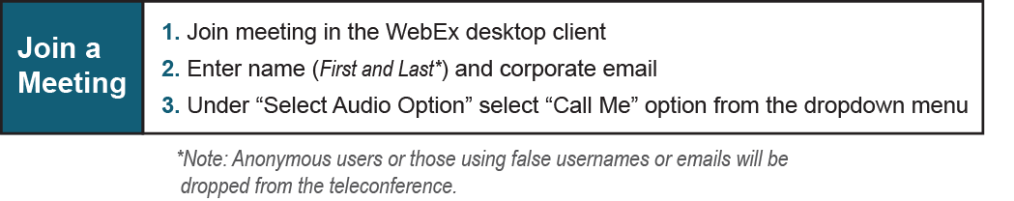

Provide feedback on the progress of this group: Facilitator Feedback Form
Visit learn.pjm.com, an easy-to-understand resource about the power industry and PJM’s role.

