August Planning Committee

**Teleconference / WebEx**

August 9, 2022

9:00 a.m. – 11:00 a.m. EPT

*\*Operator assisted phone lines will be opened 30 minutes prior to the start of the meeting. Due to the high volume of remote participation, stakeholders are asked to connect early to allow additional time for operator queue processing.*

Administration (9:00 – 9:15)

1. Welcome, announcements and review of the Anti-trust, Code of Conduct, and Media Participation Guidelines.
2. Approve Planning Committee (PC) Agenda for this meeting.
3. Approve draft minutes from the July 12, 2022 PC meeting.

Endorsements (9:15 – 9:30)

1. Load Model Selection

Patricio Rocha-Garrido will present the results of the Load Model selection process for the 2022 Reserve Requirement Study. The committee will be requested to endorse this Load Model selection at today’s meeting.

First Reads (9:30 – 10:15)

1. Generator Deliverability Test Update

Jonathan Kern, PJM, will provide a first read of the generator deliverability test contained within Manuals 14A and 14B. The committee will be asked for their concurrence to vote on the proposed changes at the September PC meeting.

Informational Updates (10:15 – 11:00)

1. Reliability Compliance Update  
   Becky Davis, PJM, will provide an update on the activities, issues and items of interest at NERC, SERC, and RF.
2. Interconnection Queue Update

Jason Shoemaker, PJM, will review status of the PJM Interconnection Queues.

1. Illinois Generation Retirement Study

Dave Egan, PJM, will provide an update on the Illinois Generation Retirement Study.

1. Designated Entity Agreement (DEA) Update

Pauline Foley will provide a follow-up to the July 27 MRC meeting regarding a potential 206 filing with respect to the use of DEAs.

Informational Posting

Model Build Activity Update

* EIPC Frequency Response Working Group
  + Dynamics
    - Final case and report completed,
    - Currently running dynamic simulations for most severe single contingency (MSSC) to bench mark the developed case
    - Re-dispatch the generation dispatch to develop 5 year out future case
* MMWG
  + Loadflow
    - PJM submitted Trial 1 updates to PowerTech on July 29, 2022
    - PowerTech will post Trial 2 cases by August 5, 2022
    - Transmission Owners will provide Trial 2 updates by August 12, 2022
    - PJM will submit Trial 2 updates to PowerTech by August 19, 2022
    - PowerTech will post Trial 3 cases by August 26, 2022
* RTEP
  + Dynamics
    - Pre-final 2022 series RTEP dynamic cases have been sent to PJM’s Transmission Planning Department for review
* The Gen Model Window for MOD-032 data submittals for applicable Generator Owners closed on Wednesday, June 15th, 2022

|  |  |  |  |  |
| --- | --- | --- | --- | --- |
| **Future Meeting Dates and Materials** | | | **Materials Due  to Secretary** | **Materials Published** |
| Date | Time | Meeting (Location) |
| Tuesday, September 6, 2022 | 9:00 a.m. – 12:00 p.m. | Planning Committee (TBD) | Thursday, August 25, 2022 | Tuesday, August 30, 2022 |
| Tuesday,  October 4,2022 | 9:00 a.m. – 12:00 p.m. | Planning Committee (TBD) | Thursday,  September 22, 2022 | Tuesday,  September 27, 2022 |
| Tuesday,  November 1, 2022 | 9:00 a.m. – 12:00 p.m. | Planning Committee (TBD) | Thursday,  October 20, 2022 | Tuesday,  October 25, 2022 |
| Tuesday,  December 6,2022 | 9:00 a.m. – 12:00 p.m. | Planning Committee (TBD) | Wednesday  November 23, 2022 | Tuesday,  November 29, 2022 |

Author: Marilyn Jayachandran

Antitrust:

You may not discuss any topics that violate, or that might appear to violate, the antitrust laws including but not limited to agreements between or among competitors regarding prices, bid and offer practices, availability of service, product design, terms of sale, division of markets, allocation of customers or any other activity that might unreasonably restrain competition. If any of these items are discussed the chair will re-direct the conversation. If the conversation still persists, parties will be asked to leave the meeting or the meeting will be adjourned.

Code of Conduct:

As a mandatory condition of attendance at today's meeting, attendees agree to adhere to the PJM Code of Conduct as detailed in PJM Manual M-34 section 4.5, including, but not limited to, participants' responsibilities and rules regarding the dissemination of meeting discussion and materials.

Public Meetings/Media Participation:

Unless otherwise noted, PJM stakeholder meetings are open to the public and to members of the media. Members of the media are asked to announce their attendance at all PJM stakeholder meetings at the beginning of the meeting or at the point they join a meeting already in progress. Members of the Media are reminded that speakers at PJM meetings cannot be quoted without explicit permission from the speaker. PJM Members are reminded that "detailed transcriptional meeting notes" and white board notes from "brainstorming sessions" shall not be disseminated. Stakeholders are also not allowed to create audio, video or online recordings of PJM meetings. PJM may create audio, video or online recordings of stakeholder meetings for internal and training purposes, and your participation at such meetings indicates your consent to the same.

Participant Identification in WebEx:

When logging into the WebEx desktop client, please enter your real first and last name as well as a valid email address. Be sure to select the “call me” option.

PJM support staff continuously monitors WebEx connections during stakeholder meetings. Anonymous users or those using false usernames or emails will be dropped from the teleconference.

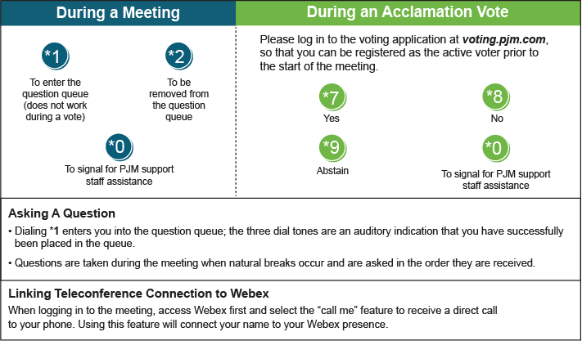

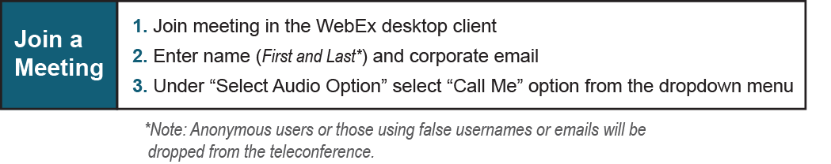

Provide feedback on the progress of this group: *Facilitator Feedback Form*   
Visit [*learn.pjm.com*](http://learn.pjm.com/), an easy-to-understand resource about the power industry and PJM’s role.