July Planning Committee
Teleconference / WebEx
July 7, 2020
9:00 a.m. – 12:15 p.m. EPT

Administration (9:00 – 9:15)
- Welcome, announcements and review of the Anti-trust, Code of Conduct, and Media Participation Guidelines.
- Approve Planning Committee (PC) Agenda for this meeting
- Approve draft minutes from the June 2nd, 2020 PC meeting
- Review of the PC Work Plan

Endorsements (9:15 – 9:45)
- PMU Placement in RTEP Planning Process
Shaun Murphy, PJM, will review the Problem Statement, Issue Charge and proposed solution to address the need for PMU Placement in the RTEP planning process. The committee will be asked to approve the issue charge and endorse the proposed revisions to Manual 14B: PJM Region Transmission Planning Process as part of the Quick Fix process outlined in Section 8.6.1 of Manual 34 at today’s meeting.

First Reads (9:45 – 10:15)
- Load Model Selection
Patricio Rocha-Garrido, PJM, will present the results of the Load Model selection process for the 2020 Reserve Requirement Study. The committee will be requested to endorse this Load Model selection at the August PC meeting.
- Manual 14A, B and G Changes
Onyinye Caven, PJM, will present changes to Manuals 14A, 14B and 14G in relation to the FERC’s Order on PJM’s Order 845 Second Compliance Filing. The committee will be requested to endorse the Manual changes at the August PC meeting.

Informational Updates (10:15 – 12:15)
- Attachment M-3 Update
Aaron Berner, PJM, will provide an Attachment M-3 Update and facilitate a feedback session which will include:
    - Summary of Improvements since 12/2019
    - Review of Action Item List
    - Stakeholder discussion

- Recent Load Impacts
Andrew Gledhill, PJM, will present the estimated Covid-19 impacts on recent loads.

- Manual 14C Update
Mark Sims, PJM, will provide an informational update for anticipated changes to Manual 14C: Generation and Transmission Interconnection Facility Construction, to enhance the cost and status tracking language for baseline and supplemental projects.

- State Agreement Approach
Mark Sims, PJM, will provide will provide an informational discussion on the PJM State Agreement Approach.

- MEPETF Phase 3 – Package C1(Capacity Window)
Nick Dumitriu, PJM, will present proposed language updates for OATT Attachment DD, Section 15.

- FERC Update
Pauline Foley, PJM, will provide an update on the recent FERC order on its section 206 investigation and compliance directive regarding PJM’s immediate-need reliability exemption.

- Reliability Compliance Update
Mark Kuras, PJM, will provide an update on the activities, issues and items of interest at NERC, SERC, and RF.

- Critical Infrastructure Stakeholder Update
Christina Stotesbury, PJM, will discuss the work being done at the most recent Critical Infrastructure Stakeholder Oversight Special Planning Committee sessions.
Issue Tracking: Critical Infrastructure Stakeholder Oversight

- Storage As Transmission Asset Update
Michele Greening, PJM will discuss work being done at the most recent Storage As Transmission Asset Special Planning Committee sessions.
Issue Tracking: Storage As a Transmssion Asset

- Capacity Capability Senior Task Force Update
Andrew Levitt, PJM will discuss work being done at the Capacity Capability Senior Task Force under the Market and Reliability Committee regarding Effective Load Carrying Capability (ELCC).

Informational Posting
Model Build Activity Update
2020 Series MMWG
- Powerflow – The 2020 series MMWG Trial 1 cases were submitted to Powertech on Friday June 26, 2020; Powertech will provide Trial 1 cases by Friday July 17, 2020; the TOs will submit updates for the Trial 1 cases by Friday July 24, 2020; PJM will submit Trial 1 updates to Powertech by Friday July 31, 2020.
- Dynamics – PJM will request dynamic load models and dynamic device models from the TOs for SVCs, STATCOMs, synchronous condensers and FACTs devices on Monday July 13, 2020; to meet their MOD-032 obligation, the TOs will provide requested models by Friday September 25, 2020. PJM will submit dynamics data to Powertech by Friday September 4, 2020.

Future Meeting Dates
Friday, July 17, 2020 | 1:00 p.m. – 3:00 p.m. | Special PC: Critical Infrastructure | PJM Conference & Training Center/ WebEx
Tuesday, August 04, 2020 | 9:00 a.m. – 12:00 p.m. | Planning Committee | PJM Conference & Training Center/ WebEx
Thursday, August 06, 2020 | 1:00 p.m. – 4:00 p.m. | Special PC: Storage As a Transmission Asset | PJM Conference & Training Center/ WebEx
Friday, August 14, 2020 | 1:00 p.m. – 3:00 p.m. | Special PC: Critical Infrastructure | PJM Conference & Training Center/ WebEx
Monday, August 17, 2020 | 1:00 p.m. – 3:00 p.m. | Special PC: Pre Queue Education Session | WebEx
Monday, August 24, 2020 | 1:00 p.m. – 4:00 p.m. | Special PC: Storage As a Transmission Asset | PJM Conference & Training Center/ WebEx
Tuesday, September 01, 2020 | 9:00 a.m. – 12:00 p.m. | Planning Committee | PJM Conference & Training Center/ WebEx
Tuesday, September 22, 2020 | 9:00 a.m. – 12:00 p.m. | Special PC: Critical Infrastructure | PJM Conference & Training Center/ WebEx
Tuesday, September 22, 2020 | 1:00 p.m. – 3:00 p.m. | Special PC: Post ISA Education Session | WebEx
Friday, September 25, 2020 | 9:00 a.m. – 12:00 p.m. | Special PC: Storage As a Transmission Asset | PJM Conference & Training Center/ WebEx
Tuesday, October 06, 2020 | 9:00 a.m. – 12:00 p.m. | Planning Committee | PJM Conference & Training Center/ WebEx
Thursday, October 22, 2020 | 1:00 p.m. – 4:00 p.m. | Special PC: Storage As a Transmission Asset | PJM Conference & Training Center/ WebEx
Wednesday, November 04, 2020 | 9:00 a.m. – 12:00 p.m. | Planning Committee | PJM Conference & Training Center/ WebEx
Tuesday, December 01, 2020 | 9:00 a.m. – 12:00 p.m. | Planning Committee | PJM Conference & Training Center/ WebEx
Author: Molly Mooney

Antitrust:
You may not discuss any topics that violate, or that might appear to violate, the antitrust laws including but not limited to agreements between or among competitors regarding prices, bid and offer practices, availability of service, product design, terms of sale, division of markets, allocation of customers or any other activity that might unreasonably restrain competition. If any of these items are discussed the chair will re-direct the conversation. If the conversation still persists, parties will be asked to leave the meeting or the meeting will be adjourned.

Code of Conduct:
As a mandatory condition of attendance at today's meeting, attendees agree to adhere to the PJM Code of Conduct as detailed in PJM Manual M-34 section 4.5, including, but not limited to, participants' responsibilities and rules regarding the dissemination of meeting discussion and materials.

Public Meetings/Media Participation:
Unless otherwise noted, PJM stakeholder meetings are open to the public and to members of the media. Members of the media are asked to announce their attendance at all PJM stakeholder meetings at the beginning of the meeting or at the point they join a meeting already in progress. Members of the Media are reminded that speakers at PJM meetings cannot be quoted without explicit permission from the speaker. PJM Members are reminded that "detailed transcriptional meeting notes" and white board notes from "brainstorming sessions" shall not be disseminated. Stakeholders are also not allowed to create audio, video or online recordings of PJM meetings. PJM may create audio, video or online recordings of stakeholder meetings for internal and training purposes, and your participation at such meetings indicates your consent to the same.
Participant Identification in WebEx:
When logging into the WebEx desktop client, please enter your real first and last name as well as a valid email address. Be sure to select the “call me” option.
PJM support staff continuously monitors WebEx connections during stakeholder meetings. Anonymous users or those using false usernames or emails will be dropped from the teleconference.

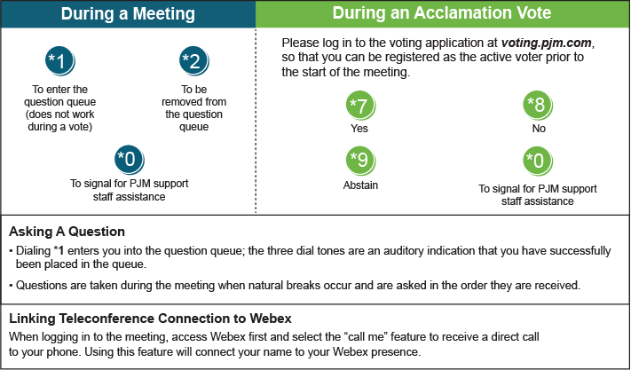

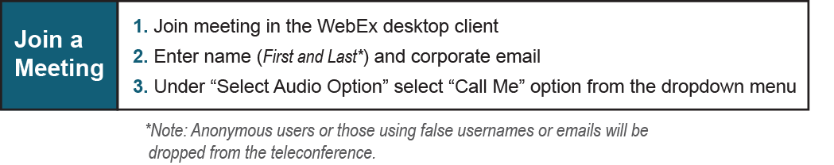

Provide feedback on the progress of this group: Facilitator Feedback Form
Visit learn.pjm.com, an easy-to-understand resource about the power industry and PJM’s role.

