Planning Committee
PJM Conference and Training Center
October 17, 2019
9:00 a.m. – 12:00 p.m. EPT

Administration (9:00-9:15)
- Welcome, announcements and review of the Anti-trust, Code of Conduct, and Media Participation Guidelines.
- Approve Planning Committee (PC) Agenda for this meeting
- Approve draft minutes from the September 12th, 2019 PC meeting
- Review of the PC Work Plan
- Communication & Subscription Improvements
Ms. Monica Burkett, PJM, will provide an update on PJM’s new communication tool.

Endorsements (9:15-9:45)
- 2019 Installed Reserve Margin Study Results
Mr. Patricio Rocha Garrido, PJM, will review the 2019 Reserve Requirement Study results (IRM, FPR). The Committee will be requested to endorse the study results at today’s meeting.
- Critical Infrastructure Stakeholder Problem Statement and Issue Charge
Mr. Erik Heinle, Office of the Peoples Counsel for the District of Columbia, and Greg Poulus, CAPS, will present a Problem Statement and Issue Charge related to Critcal Infrastructure Stakeholder Oversight. The Committee will be requested to endorse the Issue Charge at today’s meeting.

First Reads (9:45-11:00)
- Relay Subcommittee Charter Revisions
Mr. Mark Kuras, PJM, will present modifications to the Relay Subcommittee Charter related to the addition of data gathering requirement for compliance with TPL-001-4 category P5. The Committee will be asked to endorse the proposed revisions at its next meeting.
- Competitive Transmission Proposal Fee Restructuring Update
Mr. Mark Sims, PJM, will present a second first read on the competitive transmission proposal fee restructuring efforts and updated Operating Agreement language in response to and incorporating feedback received from stakeholders. The Committee will be requested to endorse the Operating Agreement language at its next meeting.

- Manual 14F Revisions
Mr. Mark Sims, PJM, will present further revisions to PJM Manual 14F Competitive Planning Process related to the cost containment process. The Committee will be requested to endorse these revisions at its next meeting.
Issue Tracking: Cost Containment
- Manual 19 Revisions
Mr. John Reynolds, PJM, will present revisions to PJM Manual 19 related to a periodic review and forecast documentation. The Committee will be requested to endorse these revisions at its next meeting.

Informational Updates (11:00-12:00)
- Update on FERC 715 Filing
Ms. Pauline Foley, PJM, will give an update on the recent FERC 715 filing.
- Manual 14G Revisions Update
Mr. Jason Connell, PJM, will present proposed changes to Manual 14G, Section 2.2 regarding projects applying for interconnection under Attachment Y. These changes were approved by the Distributed Energy Resources Subcommittee.
- DER Ride Through Task Force Update
Ms. Susan McGill, PJM, will present a white paper drafted at the DER Ride Through Task Force.
- Dayton Power and Light Transmission Planning Criteria Update
Mr. Michael Russ, Dayton Power and Light, will provide an overview of the updated transmission planning criteria.
- DEOK Transmission Planning Criteria Update
Mr. Jeff Gindling, Duke Energy, will provide an overview of the updated transmission planning criteria.
- PPL Update to Bulk Power Line Ratings
Mr. Jeff Daniels, PPL, will provide an update on bulk power line ratings.
- ELCC Education
Mr. Patricio Rocha Garrido, PJM, will review the ELCC-based method to determine the UCAP value of wind and solar resources and discuss potential steps going forward.
- Project Status & Cost Allocation Page Update
Ms. Tawnya Luna, PJM, will provide an update on the beta launch of the project status and cost allocation page on PJM.com.

Informational Posting
PJM/MISO JOA Update
On September 19, FERC issued an Order in response to a Complaint filed by EDF Renewable Energy against PJM, MISO and SPP and the Commission’s technical conference on Affected System Studies in the interconnection process. In that Order the Commission directed PJM, MISO and SPP to modify their respective JOAs, as well as their individual tariffs, to provide additional transparency related to their Affected System Studies in the Interconnection Process. Specifically, PJM and MISO are required to include information related to screening criteria to identify potential Affected System impacts, modeling standards for energy and capacity rights (referred to as ERIS and NRIS in the Order), and cost allocation rules. FERC requires a Compliance Filing within 60 days of the date of the Order. PJM expects to join MISO and SPP in a request for extension of time. (Reference Dockets EL18-26-000 and AD18-8-000).
Model Build Activity Update
The final 2019 series MMWG powerflow cases will be approved and posted by October 11, 2019. The Trial 1 2020 series RTEP powerflow cases will be posted for the TOs by October 4, 2019; the TOs will have until November 8, 2019 to provide their case updates via Model on Demand. All TOs have submitted there updates for the Trial 1 2020 RTEP short circuit case, PJM will provide the case to the TOs for review by January 3, 2020.
Manual 03 Updates
Mr. Lagy Mathew, PJM, will be available to answer questions on updates to Manual 03 – Transmission Operations. Materials are posted as Information Only.
Market Efficiency Process Enhancement Task Force Update
The MEPETF is concluding solution package formulation and draft poll construction. Non-binding polls will commence on October 21. The next MEPETF will occur on October 26 and the final MEPETF meeting will occur on December 3. An update will be provided to the PC stakeholders on November 14 and MEPETF recommendations will be turned over shortly thereafter. It is necessary to conclude PC 1st and 2nd reads and endorsements to permit timely filings (if any) and finalize expectations for the execution of the 2020 Market Efficiency Window. Assuming no additional new work by the PC, the MEPETF will be sunset.

Future Meeting Dates
October 24, 2019 | 9:00 a.m. – 12:00 p.m. | Special PC: Merchant Transmission and Off-Shore Wind | PJM Conference & Training Center/ WebEx
November 14, 2019 | 9:00 a.m. – 12:00 p.m. | Planning Committee | PJM Conference & Training Center/ WebEx
November 15, 2019 | 9:00 a.m. – 12:00 p.m. | Special PC: Merchant Transmission and Off-Shore Wind | PJM Conference & Training Center/ WebEx
December 12, 2019 | 9:00 a.m. – 12:00 p.m. | Planning Committee | PJM Conference & Training Center/ WebEx
December 13, 2019 | 9:00 a.m. – 12:00 p.m. | Special PC: Merchant Transmission and Off-Shore Wind | PJM Conference & Training Center/ WebEx
Author: Molly Mooney

Antitrust:
You may not discuss any topics that violate, or that might appear to violate, the antitrust laws including but not limited to agreements between or among competitors regarding prices, bid and offer practices, availability of service, product design, terms of sale, division of markets, allocation of customers or any other activity that might unreasonably restrain competition. If any of these items are discussed the chair will re-direct the conversation. If the conversation still persists, parties will be asked to leave the meeting or the meeting will be adjourned.

Code of Conduct:
As a mandatory condition of attendance at today's meeting, attendees agree to adhere to the PJM Code of Conduct as detailed in PJM Manual M-34 section 4.5, including, but not limited to, participants' responsibilities and rules regarding the dissemination of meeting discussion and materials.

Public Meetings/Media Participation:
Unless otherwise noted, PJM stakeholder meetings are open to the public and to members of the media. Members of the media are asked to announce their attendance at all PJM stakeholder meetings at the beginning of the meeting or at the point they join a meeting already in progress. Members of the Media are reminded that speakers at PJM meetings cannot be quoted without explicit permission from the speaker. PJM Members are reminded that "detailed transcriptional meeting notes" and white board notes from "brainstorming sessions" shall not be disseminated. Stakeholders are also not allowed to create audio, video or online recordings of PJM meetings. PJM may create audio, video or online recordings of stakeholder meetings for internal and training purposes, and your participation at such meetings indicates your consent to the same.
Participant Identification in WebEx:
When logging into the WebEx desktop client, please enter your real first and last name as well as a valid email address. Be sure to select the “call me” option.
PJM support staff continuously monitors WebEx connections during stakeholder meetings. Anonymous users or those using false usernames or emails will be dropped from the teleconference.

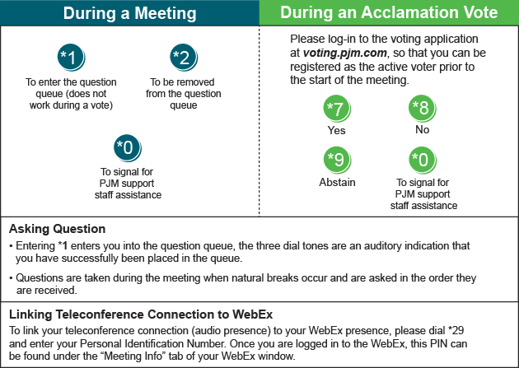

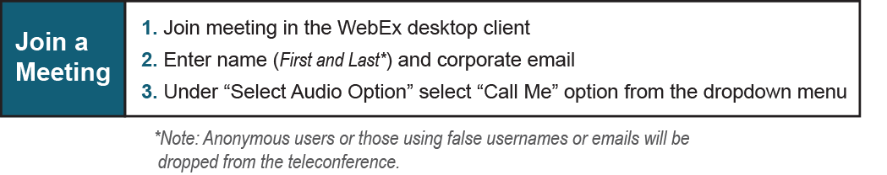
Provide feedback on the progress of this group: Facilitator Feedback Form
Visit learn.pjm.com, an easy-to-understand resource about the power industry and PJM’s role.

