Planning Committee
PJM Conference and Training Center
July 12, 2018
9:00 a.m. – 12:00 p.m. EPT

Administration (9:00-9:15)
- Welcome, announcements and review of the Anti-trust, Code of Conduct, and Media Participation Guidelines
- Approve Planning Committee (PC) Agenda for this meeting
- Approve draft minutes from the June 7th, 2018 PC meeting
- Review of the PC Work Plan

Endorsements (9:15-9:45)
- Manual 14A-14G Division
Ms. Lisa Krizenoskas, PJM, will present the division of Manual 14A into revised Manual 14A New Services Requests Study Process and new Manual 14G Generation Interconnection Requests. The committee will be requested to endorse these revisions.
- Load Model Selection
Mr. Patricio Rocha-Garrido, PJM, will present the results of the Load Model selection process for the 2018 Reserve Requirement Study. The committee will be requested to endorse the Load Model selection.

First Reads (9:45-10:45)
- Manual 14B Updates
Mr. Jonathan Kern, PJM, will present updates to Manual 14B Regional Transmission Planning Process. The committee will be requested to endorse these revisions at the next meeting.
- PJM Relay Philosophy Document Revisions
Mr. Jeffrey Barsch, AEP, will present revisions made to the PJM Relay Philosophy document. The committee will be requested to endorse these revisions at the next meeting.
- Manual 14C Updates
Mr. Art Wolfe, PJM, will present general changes being made to Manual 14C Generation & Transmission Interconnection Facility Construction. The committee will be requested to endorse these revisions at the next meeting.
- Market Efficiency Process Enhancement Proposal
Mr. Brian Chmielewski, PJM, will present a first read on the Market Efficiency phase 1 proposal developed at the Market Efficiency Process Enhancement Task Force (MEPETF), and the associated OATT revisions. The committee will be requested to endorse the proposal and Tariff revisions at the next meeting.
- Manual 14F Updates
A) Mr. Brian Chmielewski, PJM, will present a first read on proposed changes to Manual 14F, Competitive Planning Process, including market efficiency process documentation regarding the evaluation both regional and interregional projects.
B) Mr. Jason Shoemaker, PJM, will present proposed changes to Manual 14F Competitive Planning Process to incorporate the use of the new project proposal template, capture recently accepted FERC filings and include some changes that have come out of the Cost Containment discussions. The committee will be requested to endorse these revisions at the next meeting.

Informational Updates (10:45-12:00)
Cost Commitment Status and Next Steps
Mr. Mark Sims, PJM, will discuss the status and next steps for the Consideration of Cost Commitment for Evaluation of Competitive Transmission Proposals.
Security Initiatives High Level Overview
Mr. Colin Brisson, PJM, will provide an overview of security initiatives, including the two factor authentication that will be implemented later this year in order to enhance security of PJM’s web based, member facing tools.
Transmission Expansion Advisory Committee (TEAC) and Sub-regional RTEP (SRRTEP) Meeting Information
Mr. Aaron Berner, PJM, will discuss information relating to TEAC and Sub-regional RTEP Committee meetings and the presentations of materials.
Planning Resilience
Mr. Aaron Berner, PJM, will provide an update on the efforts to begin formulation of principles associated with resilience in PJM’s transmission planning studies.
Revised Supplemental Planning Process
Mr. Chip Richardson, PPL, will discuss revisions to the Supplemental Planning Process.
FERC Order 845 Update
Ms. Pauline Foley, PJM, will provide an update on FERC Order 845.
Removal of Carolina 54 Remedial Action Scheme
Mr. Ronnie Bailey, Dominion Energy, will present information related to the removal of the Carolina 54 Remedial Action Scheme.
Reliability Compliance Update
Mr. Preston Walker, PJM, provides an update on the activities, issues and items of interest at NERC, SERC, and RFC.

Recorded Updates
- Model Build Activity Update
Link to recording: https://videos.pjm.com/media/2018+July+System+Planning+Update/0_93eecoh3/57735481
Mr. Jonathan Thompson, PJM, provides an update regarding current model build activities, including the 2018 series MMWG/MOD-032 cases.

Future Meeting Dates
August 9, 2018 | 9:00 a.m. | PJM Conference & Training Center/ WebEx
September 13, 2018 | 9:00 a.m. | PJM Conference & Training Center/ WebEx
October 11, 2018 | 9:00 a.m. | PJM Conference & Training Center/ WebEx
November 8, 2018 | 9:00 a.m. | PJM Conference & Training Center/ WebEx
December 13, 2018 | 9:00 a.m. | PJM Conference & Training Center/ WebEx
Author: Anisha Fernandes

Antitrust:
You may not discuss any topics that violate, or that might appear to violate, the antitrust laws including but not limited to agreements between or among competitors regarding prices, bid and offer practices, availability of service, product design, terms of sale, division of markets, allocation of customers or any other activity that might unreasonably restrain competition. If any of these items are discussed the chair will re-direct the conversation. If the conversation still persists, parties will be asked to leave the meeting or the meeting will be adjourned.

Code of Conduct:
As a mandatory condition of attendance at today's meeting, attendees agree to adhere to the PJM Code of Conduct as detailed in PJM Manual M-34 section 4.5, including, but not limited to, participants' responsibilities and rules regarding the dissemination of meeting discussion and materials.

Public Meetings/Media Participation:
Unless otherwise noted, PJM stakeholder meetings are open to the public and to members of the media. Members of the media are asked to announce their attendance at all PJM stakeholder meetings at the beginning of the meeting or at the point they join a meeting already in progress. Members of the Media are reminded that speakers at PJM meetings cannot be quoted without explicit permission from the speaker. PJM Members are reminded that "detailed transcriptional meeting notes" and white board notes from "brainstorming sessions" shall not be disseminated. Stakeholders are also not allowed to create audio, video or online recordings of PJM meetings. PJM may create audio, video or online recordings of stakeholder meetings for internal and training purposes, and your participation at such meetings indicates your consent to the same.
Participant Identification in WebEx:
When logging into the WebEx desktop client, please enter your real first and last name as well as a valid email address. Be sure to select the “call me” option.
PJM support staff continuously monitors WebEx connections during stakeholder meetings. Anonymous users or those using false usernames or emails will be dropped from the teleconference.



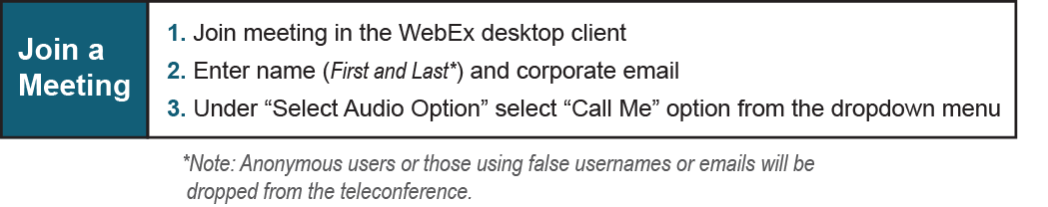

Provide feedback on the progress of this group: Facilitator Feedback Form
Visit learn.pjm.com, an easy-to-understand resource about the power industry and PJM’s role.

