Operating Committee
WebEx Only
May 12, 2022
9:00 a.m. – 2:00 p.m. EDT

*Operator assisted phone lines will be opened 30 minutes prior to the start of the meeting. Due to the high volume of remote participation, stakeholders are asked to connect early to allow additional time for operator queue processing.

Administration (9:00-9:15)
Jeff McLaughlin, PJM, will provide announcements; review the Antitrust, Code of Conduct, Public Meetings/Media Participation, and the WebEx Participant Identification Requirement.
  - Review and approve draft minutes from the April 14th OC meeting.

  - Review of the OC work plan.

  - Endorsement of the OC Charter.
The Operating committee will be asked to endorse the Charter at today’s meeting.

  - Michele Greening, PJM, will provide an update on the return to campus plan for stakeholder meetings.

Review of Operations (9:15-9:30)
Review of Operating Metrics
Stephanie Schwarz, PJM, will review the April 2022 PJM operating metrics slides. Metrics will include PJM’s load forecast error, BAAL performance, and transmission / generation outage statistics.

2B. Security Update
Joe Callis, PJM, will provide a security briefing.

Endorsements/Approvals (9:30-10:30)
- Manual 03: Transmission Operations
Dean Manno, PJM, will review Manual 03 changes as a part of the periodic review.
The Operating Committee will be asked to endorse these changes at today’s meeting.

- Manual 36: System Restoration
Rich Brown, PJM, will review Manual 36 changes as a part of the periodic review.
The Operating Committee will be asked to endorse these changes at today’s meeting.

- Manual 12: Balancing Operations
Mike Handlin, PJM, will review conforming changes to Manual 12: Balancing Operations as a part of the Stability Limits and Intelligent Reserve Deployment in Markets and Operation Issue Charge and Problem Statement being worked through the Markets Implementation Committee.
The Operating Committee will be asked to endorse these changes at today’s meeting.
Stability Limits in Markets and Operation

- Outage Coordination Issue Charge and Problem Statement
Paul McGlynn, PJM, will review a proposed Issue Charge and Problem Statement that will enhance outage coordination processes and procedures.
The Operating Committee will be asked to approve the Issue Charge at today’s meeting.

- RSCS Charter
Monica Burkett, PJM, will review changes made to the Reliability Standards & Compliance Subcommittee Charter.
The Operating Committee will be asked to approve the changes to the Charter at today’s meeting.

First Reading (10:30 -10:35)
- Manual 01: Control Center and Data Exchange Requirements
Jack O’Neill, PJM, will review conforming changes to Manual 01: Control Center and Data Exchange Requirements as a part of the Load Management Testing Requirements Issue Charge and Problem Statement.
The Operating Committee will be asked to endorse these changes at its next meeting.
Load Management Testing Requirements

Additional Items (10:35-11:15)
- OATF Review
Todd Bickel, PJM, will review the results of the summer 2022 Operations Assessment Task Force study.

- Managing Transmission Line Ratings Order No. 881 Compliance Filing (RM20-16-000) Update
David Hislop, PJM, and Bilge Derin, PJM, will provide an informational update regarding PJM’s FERC Order No. 881 compliance efforts relating to ambient adjusted ratings. PJM continues to provide updates and solicit stakeholder input at Operating Committee meetings as it prepares its compliance filing, which is due July 12, 2022.
Order 881

- PPL Dynamic Line Rating Implementation Update
Dave Hislop, PJM, will provide an update on the implementation of the PPL Dynamic Line Rating.

Working Items (11:15-2:00)
- IROL-CIP Cost Recovery
Darlene Phillips, PJM, will facilitate a discussion to review solution packages on the IROL-CIP Cost Recovery matrix as part of the Consensus Based Issue Resolution process.
Issue Tracking: IROL-CIP Cost Recovery

LUNCH (11:45 – 12:00)

- Renewable Dispatch
Darlene Phillips, PJM, will facilitate a discussion to review and identify solution options on the Renewable Dispatch matrix as part of the Consensus Based Issue Resolution process.
Issue Tracking: Renewable Dispatch

- Max Emergency Changes for Resource Limitation Reporting
Darlene Phillips, PJM, will facilitate a discussion to identify design components and solution options on the Max Emergency Changes for Resource Limitation Reporting matrix as a part of the Consensus Based Issue Resolution Lite process.
Issue Tracking: Max Emergency Changes for Resource Limitation Reporting

Informational Only Postings
- System Operations Subcommittee (SOS)
Donnie Bielak, PJM, will provide a summary of the most recent SOS meeting.

- NERC Lessons Learned
Kevin Hatch, PJM, will review the recently posted NERC Lessons Learned reports.

- Reliability Compliance Update
Becky Davis, PJM, will provide an update on NERC, SERC, RF, and NAESB standards, and other pertinent regulatory and compliance information, and solicit feedback from the members on Reliability Compliance efforts.

- Administrative Update to Manual 13: Emergency Operations
An administrative update will be made to the manual load dump data tables found in Manual 13: Emergency Operations under:
- Attachment E: Manual Load Dump Allocation Tables
- Attachment F: PJM Manual Load Dump Capability, Exhibit 7
The data is updated on an annual basis to reflect the peak load forecast for the upcoming summer.

OC Subcommittee/ Task Force Informational Section
System Operations Subcommittee (SOS): SOS Website
Data Management Subcommittee (DMS): DMS Website
DER & Inverter-Based Resources Subcommittee (DIRS): DIRS Website
Fuel Requirements for Black Start Resources: Fuel Reqt. for Black Start Resources Issue Tracker
Synchronous Reserve Deployment Task Force: SRDTF Website
IROL – CIP Cost Recovery: IROL – CIP Cost Recovery Issue Tracker

Future Meeting Dates and Materials |  |  | Materials Due  to Secretary | Materials Published
Date | Time | Location | 5 p.m. | 4 p.m.
June 9, 2022 | 9 a.m. | PJM Conference & Training Center and WebEx | May 30, 2022 | June 2, 2022
July 14, 2022 | 9 a.m. | PJM Conference & Training Center and WebEx | July 1, 2022 | July 7, 2022
August 11, 2022 | 9 a.m. | PJM Conference & Training Center and WebEx | August 1, 2022 | August 4, 2022
September 8, 2022 | 9 a.m. | PJM Conference & Training Center and WebEx | August 29, 2022 | September 1, 2022
October 7, 2022 | 9 a.m. | PJM Conference & Training Center and WebEx | September 27, 2022 | September 30, 2022
November 3, 2022 | 9 a.m. | PJM Conference & Training Center and WebEx | October 24, 2022 | October 27, 2022
December 8, 2022 | 9 a.m. | PJM Conference & Training Center and WebEx | November 28, 2022 | December 1, 2022

Author: L. Strella Wahba

Antitrust:
You may not discuss any topics that violate, or that might appear to violate, the antitrust laws including but not limited to agreements between or among competitors regarding prices, bid and offer practices, availability of service, product design, terms of sale, division of markets, allocation of customers or any other activity that might unreasonably restrain competition. If any of these items are discussed the chair will re-direct the conversation. If the conversation still persists, parties will be asked to leave the meeting or the meeting will be adjourned.

Code of Conduct:
As a mandatory condition of attendance at today's meeting, attendees agree to adhere to the PJM Code of Conduct as detailed in PJM Manual M-34 section 4.5, including, but not limited to, participants' responsibilities and rules regarding the dissemination of meeting discussion and materials.
Public Meetings/Media Participation:
Unless otherwise noted, PJM stakeholder meetings are open to the public and to members of the media. Members of the media are asked to announce their attendance at all PJM stakeholder meetings at the beginning of the meeting or at the point they join a meeting already in progress. Members of the Media are reminded that speakers at PJM meetings cannot be quoted without explicit permission from the speaker. PJM Members are reminded that "detailed transcriptional meeting notes" and white board notes from "brainstorming sessions" shall not be disseminated. Stakeholders are also not allowed to create audio, video or online recordings of PJM meetings. PJM may create audio, video or online recordings of stakeholder meetings for internal and training purposes, and your participation at such meetings indicates your consent to the same.
Participant Identification in WebEx:
When logging into the WebEx desktop client, please enter your real first and last name as well as a valid email address. Be sure to select the “call me” option.
PJM support staff continuously monitors WebEx connections during stakeholder meetings. Anonymous users or those using false usernames or emails will be dropped from the teleconference.

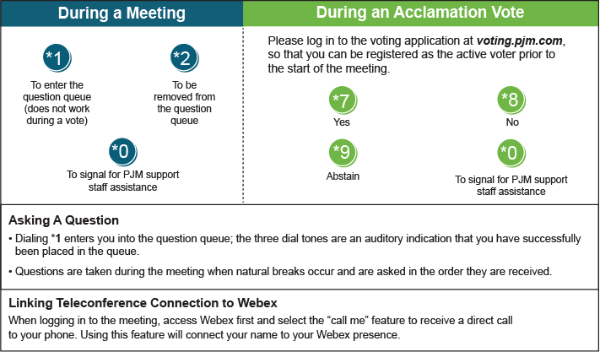

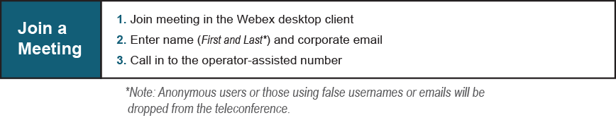

Provide feedback on the progress of this group: Facilitator Feedback Form
Visit learn.pjm.com, an easy-to-understand resource about the power industry and PJM’s role.

