Operating Committee
WebEx Only
August 12, 2021
9:00 a.m. – 12:00 p.m. EDT

Administration (9:00-9:15)
Lauren Strella Wahba, PJM, will provide announcements; review the Antitrust, Code of Conduct, Public Meetings/Media Participation, and the WebEx Participant Identification Requirement.
  - Review and approve draft minutes from the July 15th OC meeting.

  - Review of the OC work plan.

Review of Operations (9:15-9:35)
PJM COVID-19 Update
Paul McGlynn, PJM, will provide an update on PJM’s operations plan in response to COVID-19. https://pjm.com/committees-and-groups/pandemic-coordination.aspx

Review of Operating Metrics
Mike Zhang, PJM, will review the July 2021 PJM operating metrics slides. Metrics will include PJM’s load forecast error, BAAL performance, and transmission / generation outage statistics.

Endorsements/Approvals (9:35 – 9:55)
- Sunset of Non-Retail Behind the Meter Generation Business Rules Issue
Terri Esterly, PJM, will review the status of the Non-Retail Behind the Meter Generation Business Rules issue worked in the OC. The Operating Committee will be asked to approve the issue sunset at this meeting.

- Manual 03A: Energy Management System (EMS) Model Updates and Quality Assurance
Suzie Fahr, PJM, will review Manual 03A changes. The Operating Committee will be asked to endorse these changes at today’s meeting.

First Reading (9:55-10:05)
- Manual 14D: Generator Operational Requirements
Terri Esterly, PJM, will review Manual 14D changes related to Behind the Meter Generation (BTMG) Business Rules on Status Changes developed in MIC Special Sessions.
The Operating Committee will be asked to endorse these changes at its next meeting.

Issue Tracking: Behind the Meter Generation Business Rules on Status Changes

Informational Updates (10:05-12:00)
- System Operations Subcommittee (SOS) Report
Becky Carroll, PJM, will provide a summary of the most recent SOS meeting.

- System Resilience Update
Chris Pilong, PJM, will provide an update on System Resilience.

- 2021 Generator Cold Weather Operating Limitations Survey Update
Dan Bennett, PJM, will provide a status update on the 2021 Generator Cold Weather Operating Limitations Survey in eDART.

- Reliability Compliance Update
Becky Davis, PJM, will provide an update on NERC, SERC and RFC standards, and other pertinent regulatory and compliance information, and solicit feedback from the members on Reliability Compliance efforts.

Working Items

Informational Only Postings
11. PJM Manual 03 Attachment E Automatic Sectionalizing Schemes
The PJM Manual 03 Attachment E Automatic Sectionalizing Schemes Pending Approval and Recent
Changes document has been posted as an Information Only item to the August OC meeting website.

OC Subcommittee/ Task Force Informational Section
System Operations Subcommittee (SOS): SOS Website
Data Management Subcommittee (DMS): DMS Website
DER & Inverter-Based Resources Subcommittee (DIRS): DIRS Website
Fuel Requirements for Black Start Resources: Fuel Reqt. for Black Start Resources Issue Tracker
Synchronous Reserve Deployment Task Force: SRDTF Website
IROL – CIP Cost Recovery: IROL – CIP Cost Recovery Issue Tracker

Future Meeting Dates and Materials |  |  | Materials Due  to Secretary | Materials Published
Date | Time | Location | 5 p.m. | 4 p.m.
September 10, 2021 | 9 a.m. | WebEx | August 31, 2021 | September 3, 2021
October 07, 2021 | 9 a.m. | WebEx | September 27, 2021 | September 30, 2021
November 04, 2021 | 9 a.m. | WebEx | October 25, 2021 | October 28, 2021
December 02, 2021 | 9 a.m. | WebEx | November 22, 2021 | November 24, 2021

Author: L. Strella Wahba

Antitrust:
You may not discuss any topics that violate, or that might appear to violate, the antitrust laws including but not limited to agreements between or among competitors regarding prices, bid and offer practices, availability of service, product design, terms of sale, division of markets, allocation of customers or any other activity that might unreasonably restrain competition. If any of these items are discussed the chair will re-direct the conversation. If the conversation still persists, parties will be asked to leave the meeting or the meeting will be adjourned.

Code of Conduct:
As a mandatory condition of attendance at today's meeting, attendees agree to adhere to the PJM Code of Conduct as detailed in PJM Manual M-34 section 4.5, including, but not limited to, participants' responsibilities and rules regarding the dissemination of meeting discussion and materials.

Public Meetings/Media Participation:
Unless otherwise noted, PJM stakeholder meetings are open to the public and to members of the media. Members of the media are asked to announce their attendance at all PJM stakeholder meetings at the beginning of the meeting or at the point they join a meeting already in progress. Members of the Media are reminded that speakers at PJM meetings cannot be quoted without explicit permission from the speaker. PJM Members are reminded that "detailed transcriptional meeting notes" and white board notes from "brainstorming sessions" shall not be disseminated. Stakeholders are also not allowed to create audio, video or online recordings of PJM meetings. PJM may create audio, video or online recordings of stakeholder meetings for internal and training purposes, and your participation at such meetings indicates your consent to the same.
Participant Identification in WebEx:
When logging into the WebEx desktop client, please enter your real first and last name as well as a valid email address. Be sure to select the “call me” option.
PJM support staff continuously monitors WebEx connections during stakeholder meetings. Anonymous users or those using false usernames or emails will be dropped from the teleconference.

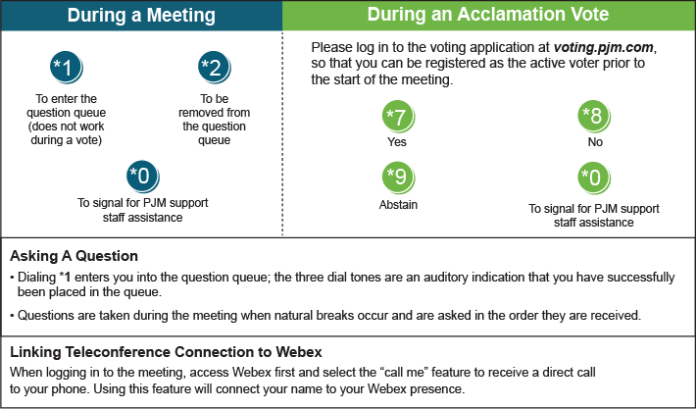

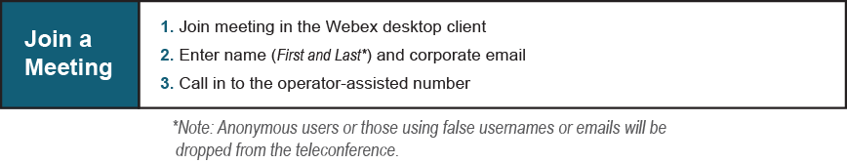
Provide feedback on the progress of this group: Facilitator Feedback Form
Visit learn.pjm.com, an easy-to-understand resource about the power industry and PJM’s role.

