Markets & Reliability Committee
PJM Conference and Training Center / WebEx
August 24, 2022
9:00 a.m. – 12:35 p.m. EPT
*Operator assisted phone lines will be opened 30 minutes prior to the start of the meeting. Due to the high volume of remote participation, stakeholders are asked to connect early to allow additional time for operator queue processing.

Administration (9:00-9:05)
Welcome, announcements and Anti-trust, Code of Conduct, and Public Meetings/Media Participation – Stu Bresler and Dave Anders

Consent Agenda (9:05-9:10)
- Approve minutes of the July 27, 2022 meeting of the Markets and Reliability Committee (MRC).
- Endorse proposed revisions to Manual 6: Financial Transmission Rights as part of the periodic review and ARR FTR Market Task Force-based conforming changes (Docket No. ER22-797-000).

Endorsements (9:10-10:15)
- Variable Environmental Costs and Credits (9:10-9:35)
Melissa Pilong will review a proposed solution including corresponding revisions to Manual 15: Cost Development Guidelines and Operating Agreement Schedule 2 to provide detailed guidance and updates to rules related to variable environmental charges and/or credits and their inclusion in cost-based energy offers. The committee will be asked to endorse the proposal and corresponding Manual 15 and OA revisions.
Issue Tracking: Variable Environmental Costs and Credits
- 2022 Quadrennial Review (9:35-10:15)
Melissa Pilong will review the proposed Quadrennial Review packages. The committee will be asked to provide advisory votes on each package for the PJM Board of Managers consideration. Same day advisory votes will be sought at the MRC and the Special MC – Quadrennial Review meetings.
Issue Tracking: 2022 Quadrennial Review

First Readings (10:15-12:35)
- Bankruptcy Protections (10:15-10:40)
Eric Scherling will review a solution package and corresponding Tariff revisions addressing bankruptcy protections. The committee will be asked to endorse the proposed solution and corresponding Tariff revisions at its next meeting.
Issue Tracking: Bankruptcy Protections

- Market Seller Offer Cap (10:40-11:15)
Dave Anders will provide an update regarding Market Seller Offer Cap activities at the Resource Adequacy Senior Task Force (RASTF). Pat Bruno will review PJM’s proposed solution as the Main Motion. Tom Hoatson, LS Power, will review a proposed Alternative Motion. The committee will be asked to endorse a proposed solution at its next meeting.
Issue Tracking: Capacity Market Reform
- Reserve Price Formation Manual Revisions (11:15-11:45)
- David Kimmel will review proposed revisions to Manual 10: Pre-Scheduling Operations, Manual 12: Balancing Operations, and Manual 13: Emergency Operations to address the Reserve Price Formation implementation.
- Ilyana Dropkin will review proposed revisions to Manual 15: Cost Development Guidelines to address the Reserve Price Formation implementation and to address changes resulting from the Manual’s periodic review process.
- Rebecca Stadelmeyer will review proposed revisions to Manual 27: Open Access Transmission Tariff Accounting, Manual 28: Operating Agreement Accounting, and Manual 29: Billing, and Damon Fereshetian and Michael Olaleye will provide a first read of conforming revisions to Manual 11: Energy & Ancillary Services Market Operations to address the Reserve Price Formation implementation.
The committee will be asked to endorse the proposed Manual revisions at its next meeting. Same day endorsement may be sought at the MRC and MC meetings for Manual 15 revisions.
Issue Tracking: Energy Price Formation
- Manuals (11:45-12:35)
- Andrew Levitt will review conforming revisions to Manual 10: Pre-Scheduling Operations, Manual 14D: Generator Operational Requirements, and Manual 18: PJM Capacity Market to support the recent hybrid resources FERC filing (Docket No. ER22-1420). The committee will be asked to endorse the proposed Manual 10, 14D, and 18 revisions at its next meeting.
Issue Tracking: Solar-Battery Hybrid Resources
- Theresa Esterly will review proposed revisions to Manual 18: PJM Capacity Market and Manual 18B: Energy Efficiency Measurement & Verification resulting from the periodic review process. The committee will be asked to endorse the proposed Manual 18 and 18B revisions at its next meeting.
- Vince Stefanowicz will review proposed revisions to Manual 14D: Generator Operational Requirements and Manual 13: Emergency Operation as associated with NERC standards EOP-011 – Emergency Preparedness and Operations, IRO-010 – Reliability Coordinator Data Specification and Collection, and TOP-003 – Operational Reliability Data will be performed. The committee will be asked to endorse the proposed Manual 13 and 14D revisions at its next meeting.

Future Agenda Items (12:35)

Future Meeting Dates and Materials |  |  |  | Materials Due  to Secretary | Materials Published
Date | Time | Location
September 21, 2022 | 9:00 a.m. |  | PJM Conference & Training Center and WebEx | September 9, 2022 | September 14, 2022
October 24, 2022 | 1:00 p.m. |  | Hyatt Regency Chesapeake Bay Golf Resort, Spa and Marina in Cambridge, MD | October 12, 2022 | October 17, 2022
November 16, 2022 | 9:00 a.m. |  | PJM Conference & Training Center and WebEx | November 4, 2022 | November 9, 2022
December 21, 2022 | 9:00 a.m. |  | PJM Conference & Training Center and WebEx | December 9, 2022 | December 14, 2022

Author: M. Greening

Antitrust:
You may not discuss any topics that violate, or that might appear to violate, the antitrust laws including but not limited to agreements between or among competitors regarding prices, bid and offer practices, availability of service, product design, terms of sale, division of markets, allocation of customers or any other activity that might unreasonably restrain competition. If any of these items are discussed the chair will re-direct the conversation. If the conversation still persists, parties will be asked to leave the meeting or the meeting will be adjourned.

Code of Conduct:
As a mandatory condition of attendance at today's meeting, attendees agree to adhere to the PJM Code of Conduct as detailed in PJM Manual M-34 section 4.5, including, but not limited to, participants' responsibilities and rules regarding the dissemination of meeting discussion and materials.

Public Meetings/Media Participation:
Unless otherwise noted, PJM stakeholder meetings are open to the public and to members of the media. Members of the media are asked to announce their attendance at all PJM stakeholder meetings at the beginning of the meeting or at the point they join a meeting already in progress. Members of the Media are reminded that speakers at PJM meetings cannot be quoted without explicit permission from the speaker. PJM Members are reminded that "detailed transcriptional meeting notes" and white board notes from "brainstorming sessions" shall not be disseminated. Stakeholders are also not allowed to create audio, video or online recordings of PJM meetings. PJM may create audio, video or online recordings of stakeholder meetings for internal and training purposes, and your participation at such meetings indicates your consent to the same.
Participant Identification in Webex:
When logging into the Webex desktop client, please enter your real first and last name as well as a valid email address. Be sure to select the “call me” option.
PJM support staff continuously monitors Webex connections during stakeholder meetings. Anonymous users or those using false usernames or emails will be dropped from the teleconference.

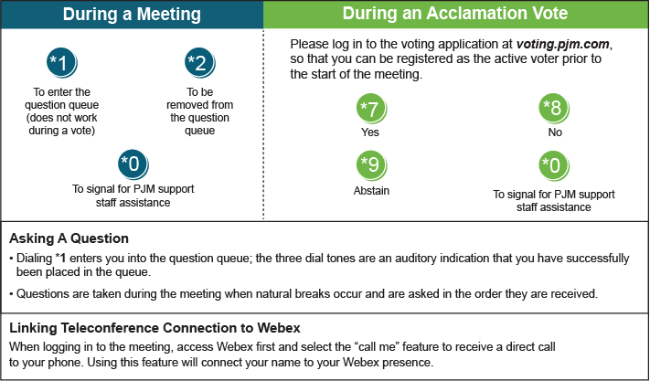

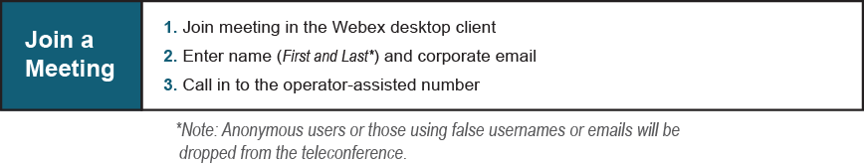
Provide feedback on the progress of this group: Facilitator Feedback Form
Visit learn.pjm.com, an easy-to-understand resource about the power industry and PJM’s role.

