Markets & Reliability Committee
Webex Only
April 27, 2022
9:00 a.m. – 12:45 p.m. EPT
*Operator assisted phone lines will be opened 30 minutes prior to the start of the meeting. Due to the high volume of remote participation, stakeholders are asked to connect early to allow additional time for operator queue processing.

Administration (9:00-9:15)
Welcome, announcements and Anti-trust, Code of Conduct, and Public Meetings/Media Participation – Stu Bresler and Dave Anders
Dave Anders will provide an update on the voting protocols for Board elections at the May Members Committee meeting.

Consent Agenda (9:15-9:20)
- Approve minutes of the March 23, 2022 meeting of the Markets and Reliability Committee (MRC).
- Endorse proposed revisions to Manual 01: Control Center and Data Exchange Requirements resulting from its periodic review.
- Endorse proposed revisions to Manual 14F: Competitive Planning Process resulting from its periodic review.
- Endorse Operating Agreement (OA) revisions to appropriately document the underfrequency relay requirements applicable to EKPC.
- Approve revisions to the EPFSTF Charter.
Issue Tracking: Operating Reserve Demand Curve (ORDC) & Transmission Constraint Penalty Factors

Endorsements (9:20-10:50)
- Deactivation Process Timing (9:20-9:45)
Dave Egan will review a proposed solution to update the process timing for generation deactivations. The committee will be asked to endorse the proposed revisions and corresponding Tariff revisions.
Issue Tracking: Deactivation Analysis Period
- Interconnection Process Reform (9:45-10:30)
  - Jack Thomas will review proposed solutions to reform the interconnection process and address a transition to the new rules.
  - John Wieland, Leeward Renewable Energy, will review a proposed amendment on behalf of the PJM Interconnection Customers Coalition.
  - Jim Davis, Dominion Energy, and Alex Stern, PSEG, will review a proposed amendment.
  - Amber Thomas, Exelon, will review a proposed amendment.
  - Brian Kauffman, Enel North America, will review a proposed amendment.
The committee will be asked to endorse the proposed solution and corresponding Tariff revisions. Same day endorsement may be sought at the Members Committee for the Tariff revisions.
Issue Tracking: Interconnection Process Reform
- Resource Adequacy (10:30-10:50)
  - Dave Anders, Walter Graf, and Matthew Bernstein will review a proposed RASTF Issue Charge addressing the procurement of clean resource attributes.
  - Denise Foster Cronin, EKPC, will review a proposed friendly amendment to the Issue Charge.
The committee will be asked to approve the Issue Charge.
  - Chris Pilong and Alex Scheirer will provide an update on the Operating Committee’s recommendation regarding Additional Reliability Products and Services.
Issue Tracking: Capacity Market Reform

First Readings (10:50-12:30)
- Start-Up Cost Offer Development (10:50-11:05)
Tom Hauske will review the Revised PJM/IMM Proposal addressing Start-Up Cost Offer Development developed through the Cost Development Subcommittee. The committee will be asked to endorse the proposal at this meeting.
Issue Tracking: Start-up Cost Offer Development
- Dynamic Rating Issue (11:05-11:30)
Chris Callaghan and Bilge Derin will review a proposed solution and corresponding revisions to Manual 01: Control Center and Data Exchange Requirements, Manual 03: Transmission Operations, and Manual 03A: Energy Management System (EMS) Model Update and Quality Assurance (QA) to address the Interim Measures to Facilitate the Integration of Dynamic Ratings into PJM Operations (Phase 1). The committee will be asked to endorse the proposed solution and corresponding Manual 01, Manual 03, and Manual 03A revisions proposed.

- Application of Designated Entity Agreement (11:30-11:55)
Augustine Caven will review a proposed solution to address the application of Designated Entity Agreement. The committee will be asked to endorse the proposed solution and corresponding Operating Agreement (OA) revisions at its next meeting.
- Manuals (11:55-12:30)
  - Dean Manno will review proposed revisions to Manual 03: Transmission Operations resulting from its periodic review. The committee will be asked to endorse the proposed Manual 03 revisions at its next meeting.
  - Damon Fereshetian, Mike Handlin, and Rebecca Stadelmeyer will review proposed revisions to Manual 11: Energy & Ancillary Services Market Operations, Manual 12: Balancing Operations, and Manual 28: Operating Agreement Accounting addressing changes for Intelligent Reserve Deployment (IRD). The committee will be asked to endorse the proposed Manual 11 and Manual 28 revisions at its next meeting.
Issue Tracking: Synchronized Reserve Event Actions and Expectations
  - Zhenyu Fan, Mike Handlin, and Rebecca Stadelmeyer will review proposed revisions to Manual 11: Energy & Ancillary Services Market Operations, Manual 12: Balancing Operations, and Manual 28: Operating Agreement Accounting addressing conforming changes for stability limits in markets and operations. The committee will be asked to endorse the proposed Manual 11, Manual 12, and Manual 28 revisions at its next meeting.
Issue Tracking: Stability Limits in Markets and Operations
  - Joshua Bruno will review proposed revisions to Manual 21A: Determination of Accredited UCAP Using Effective Load Carrying Capability Analysis addressing an ELCC model run timing update and changes to reflect the continuation of the current method to provide unit specific backcasts only as requested. The committee will be asked to endorse the proposed Manual 21A revisions at its next meeting.
  - Rich Brown will review proposed revisions to Manual 36: System Restoration resulting from its periodic review. The committee will be asked to endorse the proposed Manual 36 revisions at its next meeting.

Informational Report (12:30-12:45)
- Grid of the Future – PJM RTEP Perspective (12:30-12:45)
Sue Glatz will discuss PJM’s report on planning for the grid of the future and the planning perspective.

Future Agenda Items (12:45)

Future Meeting Dates and Materials |  |  |  | Materials Due  to Secretary | Materials Published
Date | Time | Location
May 25, 2022 | 9:00 a.m. |  | PJM Conference & Training Center and WebEx | May 13, 2022 | May 18, 2022
June 29, 2022 | 9:00 a.m. |  | PJM Conference & Training Center and WebEx | June 17, 2022 | June 22, 2022
July 27, 2022 | 9:00 a.m. |  | PJM Conference & Training Center and WebEx | July 15, 2022 | July 20, 2022
August 24, 2022 | 9:00 a.m. |  | PJM Conference & Training Center and WebEx | August 12, 2022 | August 17, 2022
September 21, 2022 | 9:00 a.m. |  | PJM Conference & Training Center and WebEx | September 9, 2022 | September 14, 2022
* October 24, 2022 *tentative dates & time | * 1:00 p.m. |  | Off-site TBD | * October 12, 2022 | * October 17, 2022
November 16, 2022 | 9:00 a.m. |  | PJM Conference & Training Center and WebEx | November 4, 2022 | November 9, 2022
December 21, 2022 | 9:00 a.m. |  | PJM Conference & Training Center and WebEx | December 9, 2022 | December 14, 2022

Author: M. Greening

Antitrust:
You may not discuss any topics that violate, or that might appear to violate, the antitrust laws including but not limited to agreements between or among competitors regarding prices, bid and offer practices, availability of service, product design, terms of sale, division of markets, allocation of customers or any other activity that might unreasonably restrain competition. If any of these items are discussed the chair will re-direct the conversation. If the conversation still persists, parties will be asked to leave the meeting or the meeting will be adjourned.

Code of Conduct:
As a mandatory condition of attendance at today's meeting, attendees agree to adhere to the PJM Code of Conduct as detailed in PJM Manual M-34 section 4.5, including, but not limited to, participants' responsibilities and rules regarding the dissemination of meeting discussion and materials.

Public Meetings/Media Participation:
Unless otherwise noted, PJM stakeholder meetings are open to the public and to members of the media. Members of the media are asked to announce their attendance at all PJM stakeholder meetings at the beginning of the meeting or at the point they join a meeting already in progress. Members of the Media are reminded that speakers at PJM meetings cannot be quoted without explicit permission from the speaker. PJM Members are reminded that "detailed transcriptional meeting notes" and white board notes from "brainstorming sessions" shall not be disseminated. Stakeholders are also not allowed to create audio, video or online recordings of PJM meetings. PJM may create audio, video or online recordings of stakeholder meetings for internal and training purposes, and your participation at such meetings indicates your consent to the same.
Participant Identification in Webex:
When logging into the Webex desktop client, please enter your real first and last name as well as a valid email address. Be sure to select the “call me” option.
PJM support staff continuously monitors Webex connections during stakeholder meetings. Anonymous users or those using false usernames or emails will be dropped from the teleconference.

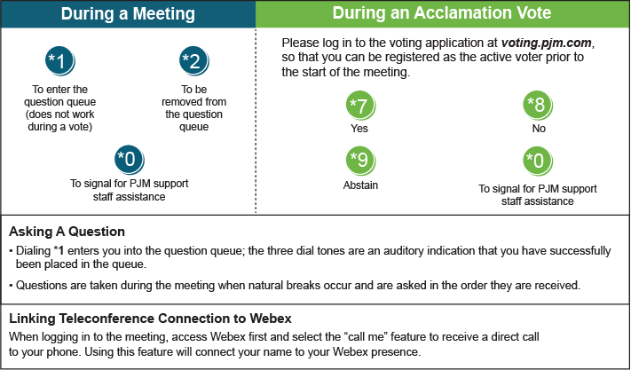

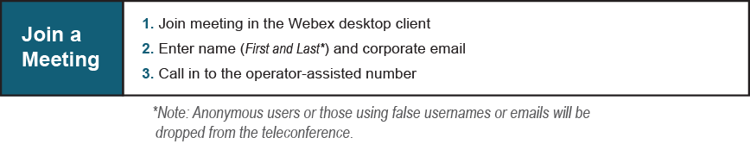
Provide feedback on the progress of this group: Facilitator Feedback Form
Visit learn.pjm.com, an easy-to-understand resource about the power industry and PJM’s role.

