Markets and Reliability Committee
Webex Only
December 17, 2020
9:00 a.m. – 12:4535 p.m.
*Operator assisted phone lines will be opened 30 minutes prior to the start of the meeting. Due to the high volume of remote participation, stakeholders are asked to connect early to allow additional time for operator queue processing.

Administration (9:00-9:05)
Welcome, announcements and Anti-trust, Code of Conduct, and Public Meetings/Media Participation – Stu Bresler and Dave Anders

Consent Agenda (9:05-9:10)
- Approve minutes of the November 19, 2020 meeting of the Markets and Reliability Committee (MRC).
- Endorse proposed revisions to Manual 14C: Generation and Transmission Interconnection Facility Construction as part of the biennial cover-to-cover review.
- Endorse proposed revisions to Manual 28: Operating Agreement Accounting conforming with the changes to FERC Order EL-14-37-000 and addressing the allocation of real-time uplift and day-ahead uplift to UTCs.

Endorsements/Approvals
None

First Readings (9:10-12:2030)
- Real Time Values Market Rules (9:10-9:45)
Laura Walter will review a solution package addressing Real Time Values Market Rules as endorsed by the Market Implementation Committee. The committee will be asked to endorse the package at its next meeting.
Issue Tracking: Real Time Market Values
- PRD Credits Disposition (9:45-10:05)
Pete Langbein will review a proposed solution package addressing the disposition of PRD credits. The committee will be asked to endorse the package at its next meeting.
Issue Tracking: Price Responsive Demand (PRD) Credits Disposition

- Black Start Unit Testing, CRF, Involuntary Termination, MTSL and Substitution Rules (10:05-10:4050)
Becky Davis will review proposed solution packages addressing Black Start Unit Involuntary Termination, Substitution Rules, Capital Recovery Factor (CRF) and Minimum Tank Suction Level (MTSL) and corresponding revisions to the Tariff, Manual 12: Balancing Operations, and Manual 15: Cost Development Guidelines. The committee will be asked to endorse a proposed solution at its next meeting.
Black Start Unit Involuntary Termination & Substitution Rules

X. Black Start Unit Testing, CRF, Involuntary Termination, MTSL and Substitution Rules including Existing Resources (10:40-11:00)
Greg Poulos, on behalf of Delaware Division of the Public Advocate, will review a proposed solution package addressing Black Start Unit Involuntary Termination, Substitution Rules, Capital Recovery Factor (CRF) and Minimum Tank Suction Level (MTSL) that includes existing resources.
- Stability Limits in Markets and Operations (10:50-11:35 11:00-11:45)
- Lisa Morelli will provide an overview of the MIC’s work activities and related procedural history for the Stability Limits in Markets and Operations issue.
- Joe Ciabattoni will review a proposed Capacity Constraint solution package and corresponding Operating Agreement (OA) and Tariff revisions.
- Paul Sotkiewicz, on behalf of JPower, will review a proposed Opportunity Cost solution package.
The committee will be asked to endorse a proposed solution at its next meeting.
Issue Tracking: Stability Limits in Markets and Operations
- PJM Manuals (11:35-12:20 11:45-12:30)
  - Brian Chmielewski will review proposed revisions to Manual 6: Financial Transmission Rights addressing the enforcement of FTR Bid Limits at the corporate entity level. The committee will be asked to endorse the revisions at its next meeting.
  - Natalie Tacka will review proposed revisions to Manual 11: Energy & Ancillary Services Market Operations, Manual 14D: Generator Operational Requirements and Manual 18: PJM Capacity Market addressing Public Distribution Microgrids. The committee will be asked to endorse the revisions at its next meeting.
  - Kevin Hatch will review proposed revisions to Manual 12: Balancing Operations resulting from the periodic review. The committee will be asked to endorse the revisions at its next meeting.
  - Kevin Hatch will review proposed revisions to Manual 13: Emergency Operations resulting from the periodic review. The committee will be asked to endorse the revisions at its next meeting.
  - Jeff Bastian will review proposed revisions to Manual 18: PJM Capacity Market conforming to the FERC-ordered rule changes in the Minimum Offer Price Rule and Forward Energy & Ancillary Services Offset dockets (Docket Nos. EL16-49-003, EL18-178-003, ER18- 1314-006 and EL19-58). The committee will be asked to endorse these revisions at its next meeting.
Issue Tracking: Capacity Market Minimum Offer Price Rule (MOPR) Order
  - Liem Hoang will review proposed revisions to Manual 38: Operations Planning resulting from the periodic review. The committee will be asked to endorse these revisions at its next meeting.

Informational Reports
- Capital Recover Factors Used In APIR (12:20-12:35 12:30-12:45)
Jeff Bastian will provide an informational update regarding the Capital Recovery Factor for Avoidable Project Investment Rate Determinations as issued in a PJM Statement on Monday, December 7, 2020.
PJM Statement on the Capital Recovery Factor for Avoidable Project Investment Rate Determinations

Informational Posting Only
- Informational Posting - Manual 01, Attachment F Changes
Revisions to Manual 01: Control Center and Data Exchange Requirements, Attachment F: Overview and Requirements for Remote Operations of Market Operations Centers during the COVID-19 Pandemic have been posted with the meeting materials. The change extends the expiration date to June 30, 2021 given the current state of the COVID-19 Pandemic.

Future Agenda Items (12:3545)

Future Meeting Dates
January 27, 2021 | 9:00 a.m. | WebEx
February 24, 2021 | 9:00 a.m. | WebEx
March 24, 2021 | 9:00 a.m. | WebEx
April 21, 2021 | 9:00 a.m. | WebEx
May 26, 2021 | 9:00 a.m. | WebEx
June 23, 2021 | 9:00 a.m. | WebEx
July 28, 2021 | 9:00 a.m. | TBD
August 25, 2021 | 9:00 a.m. | TBD
September 29, 2021 | 9:00 a.m. | TBD
October 20, 2021 | 9:00 a.m. | TBD
November 17, 2021 | 9:00 a.m. | TBD
December 15, 2021 | 9:00 a.m. | TBD

Author: M. Greening

Antitrust:
You may not discuss any topics that violate, or that might appear to violate, the antitrust laws including but not limited to agreements between or among competitors regarding prices, bid and offer practices, availability of service, product design, terms of sale, division of markets, allocation of customers or any other activity that might unreasonably restrain competition. If any of these items are discussed the chair will re-direct the conversation. If the conversation still persists, parties will be asked to leave the meeting or the meeting will be adjourned.

Code of Conduct:
As a mandatory condition of attendance at today's meeting, attendees agree to adhere to the PJM Code of Conduct as detailed in PJM Manual M-34 section 4.5, including, but not limited to, participants' responsibilities and rules regarding the dissemination of meeting discussion and materials.

Public Meetings/Media Participation:
Unless otherwise noted, PJM stakeholder meetings are open to the public and to members of the media. Members of the media are asked to announce their attendance at all PJM stakeholder meetings at the beginning of the meeting or at the point they join a meeting already in progress. Members of the Media are reminded that speakers at PJM meetings cannot be quoted without explicit permission from the speaker. PJM Members are reminded that "detailed transcriptional meeting notes" and white board notes from "brainstorming sessions" shall not be disseminated. Stakeholders are also not allowed to create audio, video or online recordings of PJM meetings. PJM may create audio, video or online recordings of stakeholder meetings for internal and training purposes, and your participation at such meetings indicates your consent to the same.
Participant Identification in WebEx:
When logging into the WebEx desktop client, please enter your real first and last name as well as a valid email address. Be sure to select the “call me” option.
PJM support staff continuously monitors WebEx connections during stakeholder meetings. Anonymous users or those using false usernames or emails will be dropped from the teleconference.

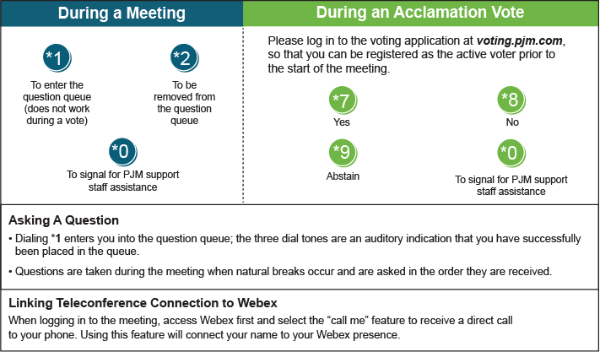

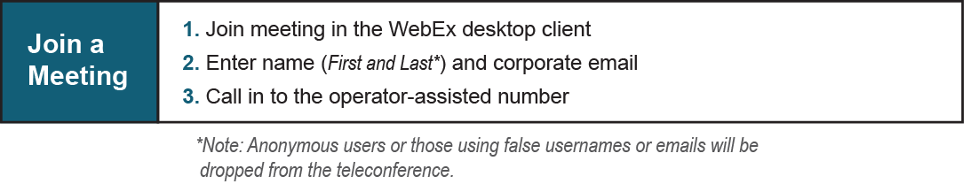
Provide feedback on the progress of this group: Facilitator Feedback Form
Visit learn.pjm.com, an easy-to-understand resource about the power industry and PJM’s role.

