Market Implementation Committee

WebEx Only

January 12, 2022

9:00 a.m. – 12:15 p.m. EPT

Administration (9:00 – 9:50)

Nicholas DiSciullo will review the Antitrust, Code of Conduct, Public Meetings/Media Participation and the WebEx Participant Identification Requirements.

The Committee will be asked to approve the draft minutes from the December 1, 2021 Market Implementation Committee.

Pennsylvania Generators Regional Greenhouse Gas Initiative (RGGI) Update.

1. **Weak Encryption Retirement (9:05 – 9:10)**

Amanda Egan will provide an update on the retirement of Weak Encryption and its impact to the Voting Application.

1. **FERC Order on Voluntary Remand (Reserve Price Formation) (9:10 – 9:50)**

PJM will provide an overview of the FERC’s December 22, 2021 order on voluntary remand (Reserve Price Formation – dockets EL19-58-006, ER19-1486-003) and next steps for the required compliance filings.

Endorsements/Approvals (9:50 – 10:50)

1. **De-Energized Bus Replacement (9:50 – 10:05)**

Vijay Shah will review revisions to Manual 11: Energy and Ancillary Services Market Operations as part of 5 Minute Dispatch and Pricing. The changes address enhancements to the Dead Bus Replacement logic for assigning prices to de-energized pricing nodes.

**The committee will be asked to endorse the Manual revisions at this meeting.**

1. **Capacity Offer Opportunities for Generation with Co-Located Load (10:05 – 10:20)**

Jason Barker, Exelon, will review a problem statement and issue charge addressing the treatment of generation with co-located load.

**The committee will be asked to approve the issue charge at this meeting.**

1. **Pseudo Modeled Combined Cycle Minimum Run Time Guidance (10:20 – 10:50)**

Tom Hauske will review education and a Problem Statement and Issue Charge addressing Pseudo Modeled Combined Cycle Minimum Run Time Guidance.

**The committee will be asked to approve the issue charge as part of the “CBIR Lite” process outlined in Section 8.6.2 of Manual 34 at this meeting.** If the issue charge is approved, the committee will begin interest identification and the development of design components and solution options on the matrix.

First Readings (10:50 – 11:05)

1. **~~Manual 18 Revisions – MOPR and MSOC (10:50 – 11:05)~~**

~~Jeff Bastian will provide a first read of revisions to Manual 18: PJM Capacity Market conforming with PJM’s 7/30/21 filing to reform application of the MOPR and PJM’s 10/21 compliance filing made in accordance with FERC’s 9/2/21 Order to amend the default MSOC.~~

1. **Manual 27 Revisions – PJM Administrative Rate (10:50 – 11:05)**

Rebecca Stadelmeyer will provide a first read of conforming revisions to Manual 27: Open Access Transmission Tariff Accounting resulting from PJM’s recent formula rate filing (Docket No. ER2-26).

Working Items (11:05 – 12:00)

1. Market Suspension (11:05 – 12:00)
2. Stefan Starkov will provide an overview of the marginal price method addressing Market Suspension.
3. Joe Bowring, IMM, will provide an overview of alternative approaches addressing Market Suspension.
4. Lisa Morelli will facilitate a discussion to develop proposals on the Market Suspension matrix as part of the Consensus Based Issue Resolution process.

[Issue Tracking: Rules Related to Market Suspension](https://www.pjm.com/committees-and-groups/issue-tracking/issue-tracking-details.aspx?Issue=214df9c5-db87-4a02-84be-b917c118d6ed)

Additional Items (12:00 – 12:15)

1. **Unit Specific Parameter Adjustment Process (12:00 – 12:05)**

Lauren Strella Wahba will provide an update on the Unit Specific Parameter Adjustment Process.

1. Cost Development Subcommittee Update (12:05 – 12:15)

Nicole Scott will provide an informational update on the work to be performed at the Cost Development Subcommittee.

Informational Section

**Fast Start Pricing Monthly Metrics Update**

Materials are posted as informational only.

**ARR FTR Market Task Force (AFMTF)**   
Meeting materials are posted to the [AFMTF website](https://www.pjm.com/committees-and-groups/task-forces/afmtf).

**Reactive Power Compensation Task Force (RPCTF)**   
Meeting materials are posted to the [RPCTF website.](https://www.pjm.com/committees-and-groups/task-forces/rpctf)

**Cost Development Subcommittee (CDS)**   
Meeting materials are posted to the [CDS website](https://www.pjm.com/committees-and-groups/subcommittees/cds).

**Demand Response Subcommittee (DRS)**   
Meeting materials are posted to the [DRS website](http://www.pjm.com/committees-and-groups/subcommittees/drs.aspx).

**DER & Inverter-based Resources Subcommittee (DIRS)**

Meeting materials are posted to the [DIRS website.](https://www.pjm.com/committees-and-groups/subcommittees/dirs.aspx)

**Market Settlements Subcommittee (MSS)**

Meeting materials are posted to the [MSS website](http://www.pjm.com/committees-and-groups/subcommittees/mss.aspx).

Report on Market Operations

The Report on Market Operations will be reviewed during the [MC Webinar](http://www.pjm.com/committees-and-groups/committees/mc.aspx).

|  |  |  |  |  |  |  |  |  |  |
| --- | --- | --- | --- | --- | --- | --- | --- | --- | --- |
| **Future Meeting Dates and Materials** | | | | | | **Materials Due  to Secretary** | | **Materials Published** | |
| Date | | Time | | Location | 5 p.m. | | 4 p.m. | |
| February 9 | 9 a.m. | | WebEx | | January 28 | | February 2 | |
| March 9 | 9 a.m. | | WebEx | | February 25 | | March 2 | |
| April 13 | 9 a.m. | | WebEx | | April 1 | | April 6 | |
| May 11 | 9 a.m. | | WebEx | | April 29 | | May 4 | |
| June 8 | 9 a.m. | | WebEx | | May 26 | | June 1 | |

Author: Nicholas DiSciullo

Antitrust:

You may not discuss any topics that violate, or that might appear to violate, the antitrust laws including but not limited to agreements between or among competitors regarding prices, bid and offer practices, availability of service, product design, terms of sale, division of markets, allocation of customers or any other activity that might unreasonably restrain competition. If any of these items are discussed the chair will re-direct the conversation. If the conversation still persists, parties will be asked to leave the meeting or the meeting will be adjourned.

Code of Conduct:

As a mandatory condition of attendance at today's meeting, attendees agree to adhere to the PJM Code of Conduct as detailed in PJM Manual M-34 section 4.5, including, but not limited to, participants' responsibilities and rules regarding the dissemination of meeting discussion and materials.

Public Meetings/Media Participation:

Unless otherwise noted, PJM stakeholder meetings are open to the public and to members of the media. Members of the media are asked to announce their attendance at all PJM stakeholder meetings at the beginning of the meeting or at the point they join a meeting already in progress. Members of the Media are reminded that speakers at PJM meetings cannot be quoted without explicit permission from the speaker. PJM Members are reminded that "detailed transcriptional meeting notes" and white board notes from "brainstorming sessions" shall not be disseminated. Stakeholders are also not allowed to create audio, video or online recordings of PJM meetings. PJM may create audio, video or online recordings of stakeholder meetings for internal and training purposes, and your participation at such meetings indicates your consent to the same.

Participant Identification in WebEx:

When logging into the WebEx desktop client, please enter your real first and last name as well as a valid email address. Be sure to select the “call me” option.

PJM support staff continuously monitors WebEx connections during stakeholder meetings. Anonymous users or those using false usernames or emails will be dropped from the teleconference.

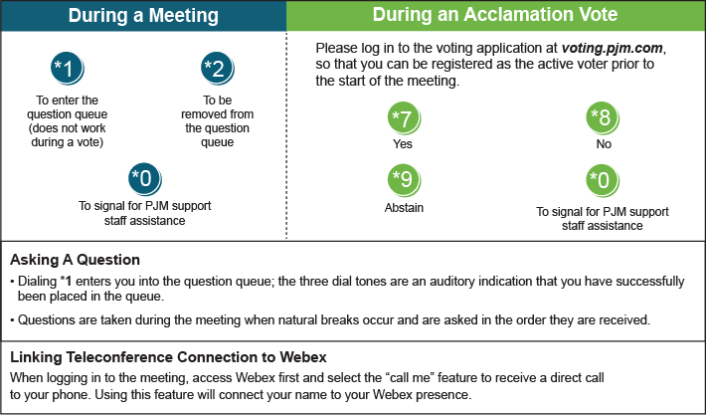

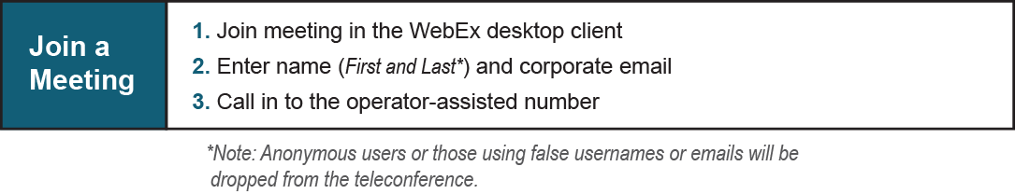

Provide feedback on the progress of this group: [*Facilitator Feedback Form*](https://www.pjm.com/committees-and-groups/committees/form-facilitator-feedback.aspx)   
Visit [*learn.pjm.com*](https://learn.pjm.com/), an easy-to-understand resource about the power industry and PJM’s role.