Market Implementation Committee

WebEx Only

November 3, 2021

9:00 a.m. – 12:00 p.m. EPT

Administration (9:00 – 9:10)

Nicholas DiSciullo will review the Antitrust, Code of Conduct, Public Meetings/Media Participation and the WebEx Participant Identification Requirements.

The Committee will be asked to approve the draft minutes from the October 6, 2021 Market Implementation Committee.

First Readings (9:10 – 10:35)

1. Start-Up Cost Offer Development (9:10 – 9:50)
2. Nicole Scott and Tom Hauske will provide a second first read of the two Packages addressing Start-Up Cost Offer Development developed through the Cost Development Subcommittee.
3. Tom Hyzinski, GT Power Group, will provide additional information of the Clarification Package addressing Start-Up Cost Offer Development developed through the Cost Development Subcommittee.

The committee will be asked to endorse the proposals at its next meeting.

1. **Fuel Cost Policy Standards and Schedule 2 Penalties (9:50 – 10:10)**

Melissa Pilong will provide a first read of the PJM/IMM Package elaborating upon and addressing clarifications to Fuel Cost Policy standards and Schedule 2 Penalty language developed through the Cost Development Subcommittee. The committee will be asked to endorse the proposal at its next meeting.

[Issue Tracking: Fuel Cost Policy](https://www.pjm.com/committees-and-groups/issue-tracking/issue-tracking-details.aspx?Issue=507b0c86-d058-4d4b-8f8f-79008c49126b)

1. **Manual 6 Revisions (10:10 – 10:20)**

Emmy Messina will present conforming changes to Manual 6 resulting from the endorsement of the AFMTF PJM/Joint Stakeholder package at the October MRC. The committee will be asked to endorse the revisions at its next meeting.

[Issue Tracking: ARR/FTR Market Review](https://www.pjm.com/committees-and-groups/issue-tracking/issue-tracking-details.aspx?Issue=83fce36d-af05-4ed7-8231-ee8f41c74e0c)

1. **Regulation for Virtual Combined Cycles (10:20 – 10:35)**

Michael Olaleye will provide a first read of Package A addressing Regulation for Virtual Combined Cycles. The committee will be asked to endorse the proposals at its next meeting.

[Issue Tracking: Regulation for Virtual Combined Cycles](https://www.pjm.com/committees-and-groups/issue-tracking/issue-tracking-details.aspx?Issue=4156560d-cfb4-45e6-aacd-33ec5c9447ed)

Working Items (10:35 – 11:40)

1. Undefined Regulation Mileage Ratio (10:35 – 11:05)
2. Adam Keech will discuss next steps of the Undefined Regulation Mileage Ratio proposal in light of the failed vote at the October MRC.
3. Danielle Croop will review the Problem Statement and Issue Charge addressing broader Regulation Market redesign and will solicit feedback from the committee.

[Issue Tracking: Undefined Regulation Mileage Ratio](https://www.pjm.com/committees-and-groups/issue-tracking/issue-tracking-details.aspx?Issue=8f567a45-cd61-4d1c-97dd-cc2d3bd772ee)

1. Market Suspension (11:05 – 11:40)

Stefan Starkov, PJM, and David Scarpignato, Calpine, will provide an update on the additional considerations related to the Market Suspension issue.

[Issue Tracking: Rules Related to Market Suspension](https://www.pjm.com/committees-and-groups/issue-tracking/issue-tracking-details.aspx?Issue=214df9c5-db87-4a02-84be-b917c118d6ed)

Additional Items (11:40 – 12:00)

1. **Unit Specific Parameter Adjustment Process (11:40 – 11:50)**

Lauren Strella Wahba will provide an update on the Unit Specific Parameter Adjustment Process for the 2022/2023 Delivery Year.

1. Cost Development Subcommittee Update (11:50 – 12:00)

Nicole Scott will provide an informational update on the work performed at the Cost Development Subcommittee.

Informational Section

**Q3 2021 Net Energy Injections Quarterly Report**

Materials are posted as informational only.

**RMC – FTR Bilateral Transactions Review and Reporting Requirements**

Please refer to the [RMC Meeting Materials](https://pjm.com/committees-and-groups/committees/rmc) for past materials and upcoming discussions regarding [FTR Bilateral Transactions Review and Reporting Requirements](https://pjm.com/committees-and-groups/issue-tracking/issue-tracking-details.aspx?Issue=b2c1be66-9571-4332-b5b0-7984d40d67a0).

**Fast Start Pricing Monthly Metrics Update**

Materials are posted as informational only.

**ARR FTR Market Task Force (AFMTF)**   
Meeting materials are posted to the [AFMTF website](https://www.pjm.com/committees-and-groups/task-forces/afmtf).

**Cost Development Subcommittee (CDS)**   
Meeting materials are posted to the [CDS website](https://www.pjm.com/committees-and-groups/subcommittees/cds).

**Demand Response Subcommittee (DRS)**   
Meeting materials are posted to the [DRS website](http://www.pjm.com/committees-and-groups/subcommittees/drs.aspx).

**DER & Inverter-based Resources Subcommittee (DIRS)**

Meeting materials are posted to the [DIRS website.](https://www.pjm.com/committees-and-groups/subcommittees/dirs.aspx)

**Market Settlements Subcommittee (MSS)**

Meeting materials are posted to the [MSS website](http://www.pjm.com/committees-and-groups/subcommittees/mss.aspx).

Report on Market Operations

The Report on Market Operations will be reviewed during the [MC Webinar](http://www.pjm.com/committees-and-groups/committees/mc.aspx).

|  |  |  |  |  |
| --- | --- | --- | --- | --- |
| **Future Meeting Dates and Materials** | | | **Materials Due  to Secretary** | **Materials Published** |
| Date | Time | Location | 5 p.m. | 4 p.m. |
| December 1 | 9 a.m. | WebEx | November 19 | November 24 |

Author: Nicholas DiSciullo

Antitrust:

You may not discuss any topics that violate, or that might appear to violate, the antitrust laws including but not limited to agreements between or among competitors regarding prices, bid and offer practices, availability of service, product design, terms of sale, division of markets, allocation of customers or any other activity that might unreasonably restrain competition. If any of these items are discussed the chair will re-direct the conversation. If the conversation still persists, parties will be asked to leave the meeting or the meeting will be adjourned.

Code of Conduct:

As a mandatory condition of attendance at today's meeting, attendees agree to adhere to the PJM Code of Conduct as detailed in PJM Manual M-34 section 4.5, including, but not limited to, participants' responsibilities and rules regarding the dissemination of meeting discussion and materials.

Public Meetings/Media Participation:

Unless otherwise noted, PJM stakeholder meetings are open to the public and to members of the media. Members of the media are asked to announce their attendance at all PJM stakeholder meetings at the beginning of the meeting or at the point they join a meeting already in progress. Members of the Media are reminded that speakers at PJM meetings cannot be quoted without explicit permission from the speaker. PJM Members are reminded that "detailed transcriptional meeting notes" and white board notes from "brainstorming sessions" shall not be disseminated. Stakeholders are also not allowed to create audio, video or online recordings of PJM meetings. PJM may create audio, video or online recordings of stakeholder meetings for internal and training purposes, and your participation at such meetings indicates your consent to the same.

Participant Identification in WebEx:

When logging into the WebEx desktop client, please enter your real first and last name as well as a valid email address. Be sure to select the “call me” option.

PJM support staff continuously monitors WebEx connections during stakeholder meetings. Anonymous users or those using false usernames or emails will be dropped from the teleconference.

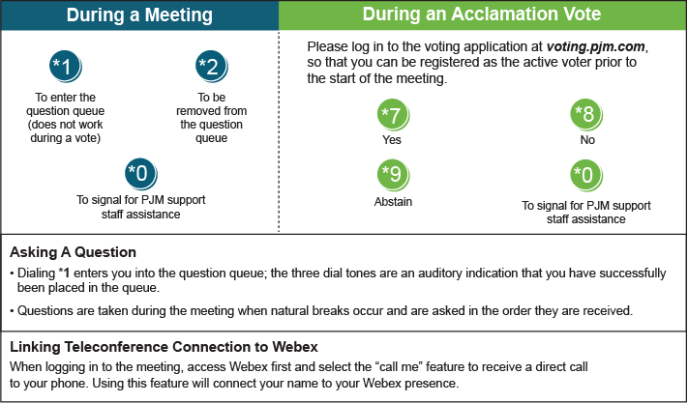

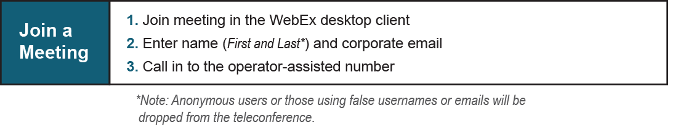

Provide feedback on the progress of this group: [*Facilitator Feedback Form*](https://www.pjm.com/committees-and-groups/committees/form-facilitator-feedback.aspx)   
Visit [*learn.pjm.com*](https://learn.pjm.com/), an easy-to-understand resource about the power industry and PJM’s role.