Market Implementation Committee
WebEx Only
August 5 2020
9:00 a.m. – 4:00 p.m. EPT

Administration (9:00-9:05)
Nicholas DiSciullo will review the Antitrust, Code of Conduct, Public Meetings/Media Participation and the WebEx Participant Identification Requirements.

The Committee will be asked to approve the draft minutes from the July 8, 2020 Market Implementation Committee meeting.

Endorsements/Approvals (9:05 – 9:30)
- Manual 14D and Manual 27 revisions (9:05 – 9:20)
Ray Fernandez will review updates to Manual 14D: Generator Operational Requirements and Manual 27: Open Access Transmission Tariff Accounting related to changes to deadlines for adjustments associated with finalizing the zonal network service peak load values. The Manual 14D revisions will be presented for endorsement at the August 6, 2020 Operating Committee meeting.
The committee will be asked to endorse the Manual 27 revisions at this meeting.

- ARR FTR Market Task Force Poll (9:20 – 9:30)
Dave Anders will review the results of the ARR FTR Market Task Force Poll and discuss the recommendation to go on hiatus during the independent consultant’s review.
The committee will be asked to vote at first read to put the AFMTF on hiatus.

First Readings (9:30 - 10:50)
- Market Suspension (9:30 – 9:50)
Tim Horger, PJM, will provide a first read of a Problem Statement and Issue Charge addressing opportunities to develop enhanced business rules surrounding the event of a market suspension. The committee will be asked to approve the Issue Charge at the September MIC meeting.

- Stability Limits in Markets and Operations (9:50 – 10:50)
- Joe Ciabattoni will provide an overview of the Capacity Constraint package and highlight minor modifications that have been made since the last meeting.
- Monitoring Analytics will provide education on the frequency of stability events.
The committee will be asked to vote on the proposed package at the September MIC meeting.

Issue Tracking: Stability Limits in Markets and Operations

Additional Items (10:50 - 11:45)
- MOPR Subsidy Guidance (10:50 – 11:10)
Alexandra Salaneck, Monitoring Analytics and Paul Scheidecker will provide an overview of the MOPR subsidy process to provide guidance to participants as to which programs constitute a state subsidy.
- FERC Order on PJM's Order No. 841 Compliance Filing (11:10 – 11:25)
Thomas DeVita and Andrew Levitt will provide an update on the FERC Order on PJM’s Order No. 841 Compliance Filing.

- Allocation of Uplift to UTC Transactions (11:25 – 11:40)
Thomas DeVita will provide an update on the FERC Order directing PJM to allocate uplift to Up To Congestion (UTC) transactions (Docket EL14-37) and the associated PJM compliance filing.
Ray Fernandez will provide an update on the settlements impacts of the order.

- Load Reconciliation Problem Statement/Issue Charge Update (11:40 – 11:45)
Ray Fernandez will provide an update on the Load Reconciliation Problem Statement and Issue Charge that was worked through the Market Settlements Subcommittee.

Informational Section
Q2 2020 Net Energy Injections Quarterly Report
Materials are posted as informational only.

Credit Subcommittee (CS)
Meeting materials will be posted to the CS website.

Demand Response Subcommittee (DRS)
Meeting materials will be posted to the DRS web site.

DER & Inverter-based Resources Subcommittee (DIRS)
Meeting materials will be posted to the DIRS web site.

Market Settlements Subcommittee (MSS)
Meeting materials are posted to the MSS web site.

Report on Market Operations
The Report on Market Operations will be reviewed during the MC Webinar.

Future Meeting Dates
September 2, 2020 | 9:00 a.m. | WebEx
October 7, 2020 | 9:00 a.m. | WebEx
November 5, 2020 | 9:00 a.m. | WebEx
December 2, 2020 | 9:00 a.m. | WebEx

Author: Nick DiSciullo

Antitrust:
You may not discuss any topics that violate, or that might appear to violate, the antitrust laws including but not limited to agreements between or among competitors regarding prices, bid and offer practices, availability of service, product design, terms of sale, division of markets, allocation of customers or any other activity that might unreasonably restrain competition. If any of these items are discussed the chair will re-direct the conversation. If the conversation still persists, parties will be asked to leave the meeting or the meeting will be adjourned.

Code of Conduct:
As a mandatory condition of attendance at today's meeting, attendees agree to adhere to the PJM Code of Conduct as detailed in PJM Manual M-34 section 4.5, including, but not limited to, participants' responsibilities and rules regarding the dissemination of meeting discussion and materials.

Public Meetings/Media Participation:
Unless otherwise noted, PJM stakeholder meetings are open to the public and to members of the media. Members of the media are asked to announce their attendance at all PJM stakeholder meetings at the beginning of the meeting or at the point they join a meeting already in progress. Members of the Media are reminded that speakers at PJM meetings cannot be quoted without explicit permission from the speaker. PJM Members are reminded that "detailed transcriptional meeting notes" and white board notes from "brainstorming sessions" shall not be disseminated. Stakeholders are also not allowed to create audio, video or online recordings of PJM meetings. PJM may create audio, video or online recordings of stakeholder meetings for internal and training purposes, and your participation at such meetings indicates your consent to the same.
Participant Identification in WebEx:
When logging into the WebEx desktop client, please enter your real first and last name as well as a valid email address. Be sure to select the “call me” option.
PJM support staff continuously monitors WebEx connections during stakeholder meetings. Anonymous users or those using false usernames or emails will be dropped from the teleconference.

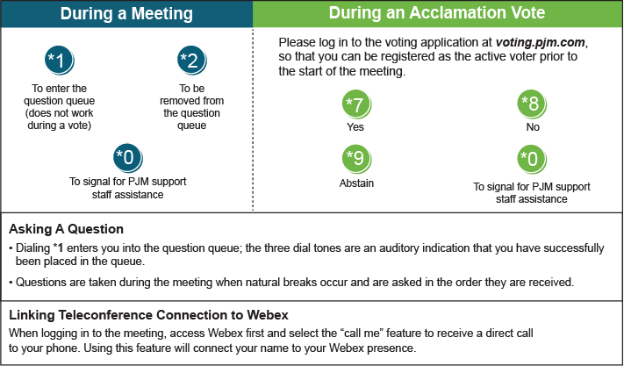

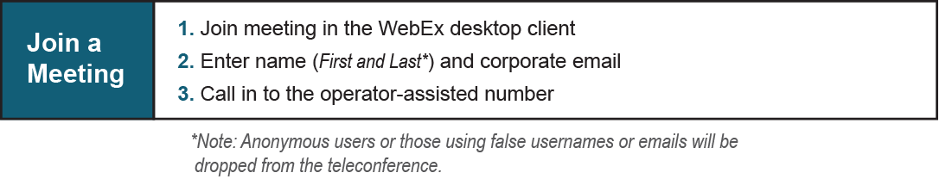
Provide feedback on the progress of this group: Facilitator Feedback Form
Visit learn.pjm.com, an easy-to-understand resource about the power industry and PJM’s role.

