Market Implementation Committee
PJM Conference & Training Center, Audubon, PA
March 7, 2018
8:30 a.m. – 12:00 p.m. EPT

Administration (8:30-8:45)
Ms. Christina Stotesbury and Ms. Chantal Hendrzak will provide announcements; review the Antitrust, Code of Conduct, and Public Meetings/Media Participation Guidelines, and Issue Tracking.

The committee will be asked to approve the draft minutes from the February 7, 2018 Market Implementation Committee meeting.

Administrative Updates
- Mr. Ray Fernandez, PJM, will provide an update on the 5-minute settlements implementation scheduled for April 1, 2018.
- Mr. Hal Loomis, PJM, will provide an update on behalf of the Credit Subcommittee.

Endorsements/Approvals (8:45-9:30)
- FTR Forfeiture Rule - Problem Statement & Issue Charge (8:45-9:10)
- Ms. Sharon Midgley, Exelon, will present a problem statement and issue charge to address the FTR Forfeiture Rule. The committee will be asked to approve the problem statement and issue charge.
- Dr. Joseph Bowring, Monitoring Analytics, will present an alternate problem statement for discussion.

- Must Offer Exemption Process - Problem Statement & Issue Charge (9:10-9:30)
Ms. Midgley, Exelon, will also present a problem statement and issue charge to address the Must Offer Exemption process. The committee will be asked to approve the problem statement and issue charge.

First Readings (9:30-9:50)
- Variable Operations & Maintenance Packages (9:30-9:50)
Mr. Tom Hauske, PJM, will provide a first read of the solution packages to address Variable Operations & Maintenance (VOM) Costs that were proposed in the VOM Special Session meetings. The committee will be asked to endorse a package at April meeting.
Issue Tracking: Variable Operations & Maintenance

Working Issues (9:50-11:00)
- FTR Nodal Remapping (9:50-10:15)
Mr. Brian Chmielewski, PJM, will provide an overview of the FTR Nodal Remapping issue that was approved at the January MIC, and stakeholders will be given an opportunity to provide interests and design components.
Issue Tracking: FTR Nodal Remapping

- Long Term FTR Auction (10:15-10:40)
- Dr. Joe Bowring, Monitoring Analytics, will present follow-up analysis requested at the February MC Webinar on the revenue discrepancy between the Long-Term FTRs and Annual FTRs.
- Mr. Brian Chmielewski, PJM, will provide an overview on the Long Term FTR issue and stakeholders will be given an opportunity to provide interests and design components.
Issue Tracking: Long Term FTR Auction

- Market Seller Offer Cap Balancing Ratio (10:40-11:00)
Mr. Pat Bruno, PJM, will provide an overview on the Offer Cap Balancing Ratio issue and stakeholders will be given an opportunity to provide interests and design components.
Issue Tracking: Balancing Ratio Determination

Additional Updates (11:00-12:00)
- SPS Retirement Notification – Davis Creek (11:00-11:15)
Mr. Mohit Singh, ComEd, will present the Davis Creek Special Protection Scheme retirement.

- System Restoration Drill Update (11:15-11:25)
Ms. Alpa Jani, PJM, will provide an update on the upcoming System Restoration Drill planned for May 15-16, 2018. Invitations for participation will be sent on March 16, 2018.

- CPL-DOM Reactive Transfer Interface (11:25-11:35)
Mr. Chris Callaghan, PJM, will present the CPL-DOM Reactive Transfer Interface.

- VOM Calculation Error (11:35-12:00)
Dr. Joseph Bowring, Monitoring Analytics, will provide an update on an error found in some units VOM calculation.

Informational Section
Credit Subcommittee (CS)
Meeting materials will be posted to the CS website.

Demand Response Subcommittee (DRS)
Meeting materials will be posted to the DRS web site.

Intermittent Resources Subcommittee (IRS)
Meeting materials will be posted to the IRS web site.

Interregional Coordination Update
Materials are posted as informational only.

Market Settlements Subcommittee (MSS)
Meeting materials are posted to the MSS web site.
Report on Market Operations
The Report on Market Operations will be reviewed during the MC Webinar.

Future Meeting Dates
April 4, 2018 | 9:00 a.m. | PJM Conference & Training Center/ WebEx
May 2, 2018 | 9:00 a.m. | PJM Conference & Training Center/ WebEx
June 6, 2018 | 9:00 a.m. | PJM Conference & Training Center/ WebEx
July 11, 2018 | 9:00 a.m. | PJM Conference & Training Center/ WebEx
August 8, 2018 | 9:00 a.m. | PJM Conference & Training Center/ WebEx
September 12, 2018 | 9:00 a.m. | PJM Conference & Training Center/ WebEx
October 10, 2018 | 9:00 a.m. | PJM Conference & Training Center/ WebEx
November 7, 2018 | 9:00 a.m. | PJM Conference & Training Center/ WebEx
December 12, 2018 | 9:00 a.m. | PJM Conference & Training Center/ WebEx

Author: Christina Stotesbury

Antitrust:
You may not discuss any topics that violate, or that might appear to violate, the antitrust laws including but not limited to agreements between or among competitors regarding prices, bid and offer practices, availability of service, product design, terms of sale, division of markets, allocation of customers or any other activity that might unreasonably restrain competition. If any of these items are discussed the chair will re-direct the conversation. If the conversation still persists, parties will be asked to leave the meeting or the meeting will be adjourned.

Code of Conduct:
As a mandatory condition of attendance at today's meeting, attendees agree to adhere to the PJM Code of Conduct as detailed in PJM Manual M-34 section 4.5, including, but not limited to, participants' responsibilities and rules regarding the dissemination of meeting discussion and materials.

Public Meetings/Media Participation:
Unless otherwise noted, PJM stakeholder meetings are open to the public and to members of the media. Members of the media are asked to announce their attendance at all PJM stakeholder meetings at the beginning of the meeting or at the point they join a meeting already in progress. Members of the Media are reminded that speakers at PJM meetings cannot be quoted without explicit permission from the speaker. PJM Members are reminded that "detailed transcriptional meeting notes" and white board notes from "brainstorming sessions" shall not be disseminated. Stakeholders are also not allowed to create audio, video or online recordings of PJM meetings. PJM may create audio, video or online recordings of stakeholder meetings for internal and training purposes, and your participation at such meetings indicates your consent to the same.

Participant Identification in WebEx:
When logging into the WebEx desktop client, please enter your real first and last name as well as a valid email address. Be sure to select the “call me” option.
PJM support staff continuously monitors WebEx connections during stakeholder meetings. Anonymous users or those using false usernames or emails will be dropped from the teleconference.

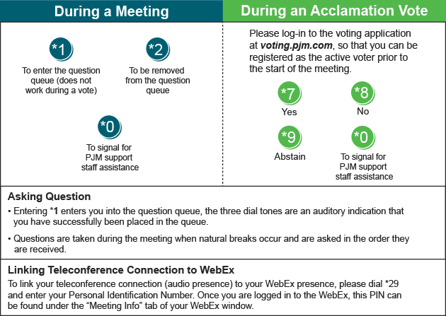

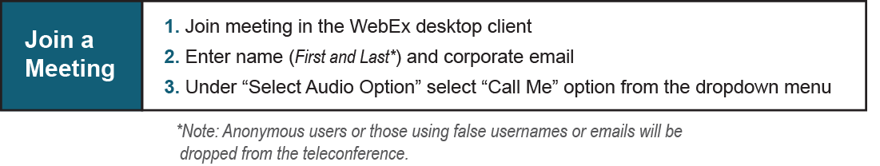

Provide feedback on the progress of this group: Facilitator Feedback Form
Visit learn.pjm.com, an easy-to-understand resource about the power industry and PJM’s role.

